**I Only Want To Be With You (Ivor Raymonde / Mike Hawker) Key C**

**C Am**

I don't kno w what it is that makes me love you so

**C Am**

I only know I never want to let you go

**F**  **G**

'Cause you started something, can't you see

**C Am**

That ever since we met you've had a hold on me

**F G F G C**

I happens to be true, I only want to be with you

**C Am**

It doesn't matter where you go or what you do

**C Am**

I want to spend each mom ent of the day with you

**F G**

Look what has happened with just one kiss

**C Am**

I never knew that I could be in love like this

**F G F G C**

It's crazy but it's true, I only want to be with you

**Bridge:**

**Fm**

You stopped and smiled at me

**C**

Asked me if I cared to dance

**G**

I fell into your arms

**D7 G7**

I didn't stand a chance

**C**

Now, listen, honey, I just want to be beside you

**Am**

everywhere

**C Am**

As long as we're together, honey, I don't care

**F G**

'Cause you started something, can't you see

**C Am**

That ever since we met you've had a hold on me

**F G F G C**

No matter what you do, I only want to be with you

**(Chorus)**

**C**

Now hear me darling, I just want to be beside you

**Am**

everywhere

**C Am**

As long as we're together, honey, I don't care

**F G**

'Cause you started something, can't you see

**C Am**

That ever since we met you've had a hold on me

**F G F G C**

No matter what you do, I only want to be with you

**F G F**

I said, no matter, no matter what you do, I only want to

**G C**

be with you



G

F

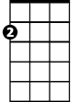

Am



C

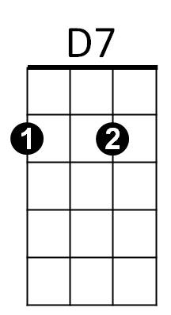

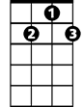

G7

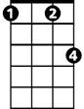

Fm

**BARITONE**



F



G

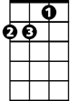

Am

C

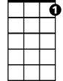

G7



D7

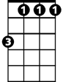

Fm

**I Only Want To Be With You (Ivor Raymonde / Mike Hawker) Key F**

**F Dm**

I don't know what it is that makes me love you so

**F Dm**

I only know I never want to let you go

**Bb C**

'Cause you started something, can't you see

**F Dm**

That ever since we met you've had a hold on me

**Bb C Bb C F**

I happens to be true, I only want to be with you

**F Dm**

It doesn't matter where you go or what you do

**F Dm**

I want to spend each moment of the day with you

**Bb C**

Look what has happened with just one kiss

F



**F Dm**

I never knew that I could be in love like this

**Bb C Bb C F**

It's crazy but it's true, I only want to be with you

**Bridge:**

**Bbm**

You stopped and smiled at me



Bb m



G7

**F**

Asked me if I cared to dance

**C**

I fell into your arms

**G7 C7**

I didn't stand a chance

**F**

Now, listen, honey, I just want to be beside you

C

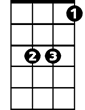

Bb

**Dm**

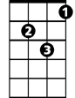

Dm



F

everywhere

**F Dm**

As long as we're together, honey, I don't care

**Bb C**

'Cause you started something, can't you see

**F Dm**

That ever since we met you've had a hold on me

**Bb C Bb C F**

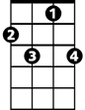

C7



G7

No matter what you do, I only want to be with you

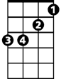

Bb m

**(Chorus)**

**F**

Now hear me darling, I just want to be beside you

**Dm**

everywhere

**F Dm**

As long as we're together, honey, I don't care

**Bb C**

'Cause you started something, can't you see

**F Dm**

That ever since we met you've had a hold on me

**Bb C Bb C F**

No matter what you do, I only want to be with you

**Bb C Bb**

I said, no matter, no matter what you do, I only want to

**C F**

be with you



Bb



Dm



C

**BARITONE**