I Put A Spell On You (Jalacy "Screamin' Jay" Hawkins, 1956) (Am)
I Put A Spell On You by Bette Midler from “Hocus Pocus” (1993) (Official Music Video)

Am Dm Am A7  I put a spell on you, and now you're mine  Dm E7 E  You can't stop the things I do, I ain't lyin'  Am A7  It's been three hundred years, right down to the day  Dm F  Now the witch is back and there's Hell to pay  Am E7 Am  I put a spell on you, and now you're mine  Hello, Salem, my name is Winifred, what's yours?  Am Dm Am  I put a spell on you, and now you're gone  (gone, gone, gone, so long)  Dm E7  My whammy fell on you and it was strong  E  (So strong, so strong, so strong!)  Am A7  Your wretched little lives have all been cursed  Dm F  Because of all the witches working, I'm the worst  Am E7 Am  I put a spell on you, and now you're mine  F  Watch out, watch out, Watch out, watch out!  Am A7  If you don't believe, you'd better get superstitious  Dm F  Ask my sisters: "Ooh, she's viscious"!  Am E7 Am E7  I put a spell on you I put a spell on you  Sisters:  E7  Ah say ento pi, alpha mabi, upendi Ah say ento pi, alpha mabi, upendi  Inna comma coriyama, inna comma coriyama  Hey, hey, high, high say bye, bye  E7 Am F Am// E7// Am (High)  Say bye, bye eye eye. | 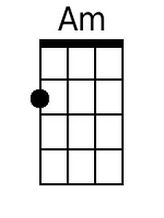 | 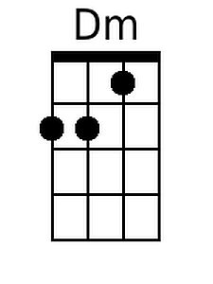
 | 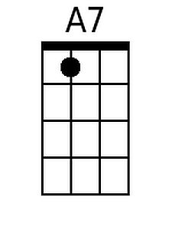 | 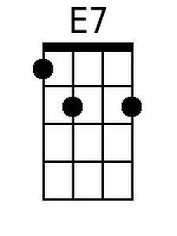
 | 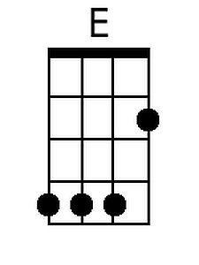 | 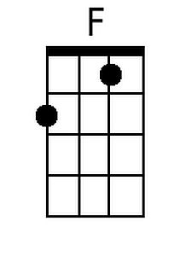
 | 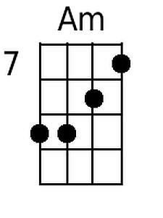
 | Baritone
 | 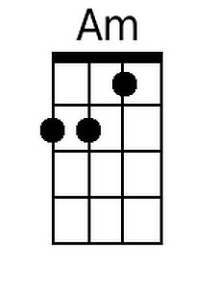 | 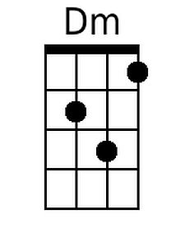
 | 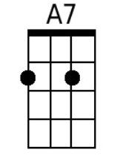 | 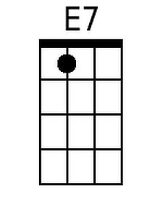
 | 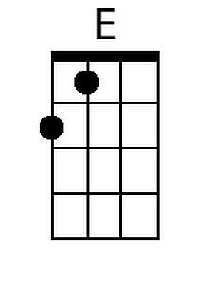 | 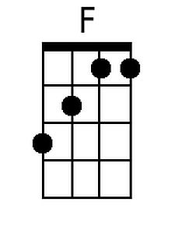
 | 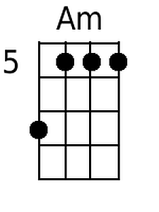

I Put A Spell On You (Jalacy "Screamin' Jay" Hawkins, 1956) (Em)
I Put A Spell On You by Bette Midler from “Hocus Pocus” (1993) (Official Music Video)

Em Am Em E7  I put a spell on you, and now you're mine  Am B7 B  You can't stop the things I do, I ain't lyin'  Em E7  It's been three hundred years, right down to the day  Am C  Now the witch is back and there's Hell to pay  Em B7 Em  I put a spell on you, and now you're mine  Hello, Salem, my name is Winifred, what's yours?  Em Am Em  I put a spell on you, and now you're gone  (gone, gone, gone, so long)  Am B7  My whammy fell on you and it was strong  B  (So strong, so strong, so strong!)  Em E7  Your wretched little lives have all been cursed  Am C  Because of all the witches working, I'm the worst  Em B7 Em  I put a spell on you, and now you're mine.  C  Watch out, watch out, Watch out, watch out!  Em E7  If you don't believe, you'd better get superstitious  Am C  Ask my sisters: "Ooh, she's viscious"!  Em B7 Em B7  I put a spell on you I put a spell on you  Sisters:  B7  Ah say ento pi, alpha mabi, upendi Ah say ento pi, alpha mabi, upendi  Inna comma coriyama, inna comma coriyama  Hey, hey, high, high say bye bye  B7 Em C Em// B7// Em (High)  Say bye, bye eye eye. | 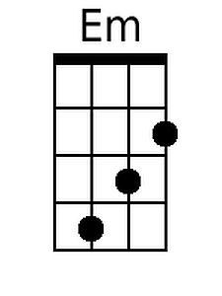
 |  | 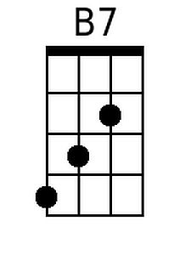
 | 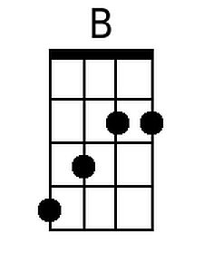 | 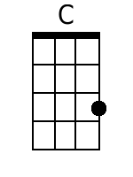
 | 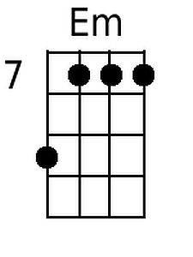
 | Baritone
 | 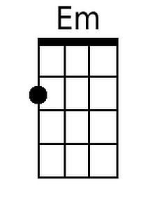
 |  | 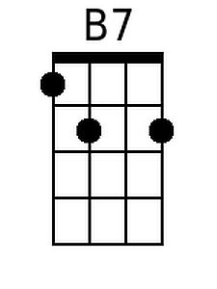
 | 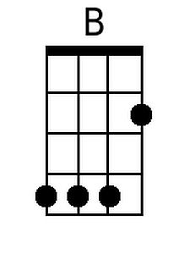 | 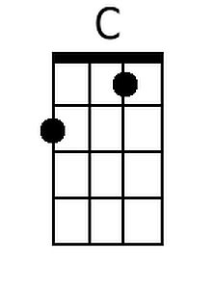
 | 