**I Saw Her Standing There (John Lennon / Paul McCartney)**

**Intro: 1 – 2- 3 – FIRE! G**

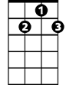

G7



C



G

**G**

Well she was just seventeen

**C G**

You know what I mean

**G7 D D7**

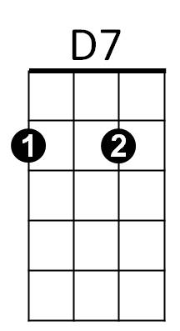And the way she looked was way beyond compare

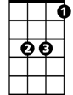

Eb

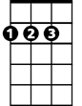

D

**G G7 C Eb**

So how could I dance with another, Oh,

**G D G**

When I saw her standing there

**C G**

Well she looked at me, and I, I could see

**G7 D D7**

That before too long, I'd fall in love with her

**G G7 C Eb**

She wouldn't dance with another Oh,

**G D G**

When I saw her standing there

**Chorus:**

**C C7**Well my heart went boom - When I crossed that room

**D C**

**BARITONE**

And I held her hand in mine

C

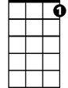

G7



G

**G**

Oh we danced through the night

**C G**

And we held each other tight

**G7 D D7**



D7



D

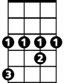

Eb

And before too long, I fell in love with her

**G G7 C Eb**

Now I'll never dance with another - Oh,

**G D G**

When I saw her standing there

**(Repeat from Chorus)**

**D G**

Oh, since I saw her standing there

**D G**

Yeah, well since I saw - her – stan-ding there