
I Saw Mommy Kissing Santa Claus
C46 C
(Tommy Connor, 1952)

Intro Chords of Outro  C Em Am  I saw Mommy kissing Santa Claus  C G  Underneath the mistletoe last night.  G G7  She didn't see me creep  C  Down the stairs to have a peep,  D D7  She thought that I was tucked up  G G7  In my bedroom fast asleep.  C Em Am  Then I saw Mommy tickle Santa Claus,  C C7 F A7  Underneath his beard so snowy white.  F B7  Oh, what a laugh it would have been,  C A7 Dm  If Daddy had only seen  ____________________________________  │ G7 C F G7 C G7  │ 1. Mommy kissing Santa Claus last night.  │ Repeat From Top  ____________________________________  │ G7 C F G7 C C7  │ 2. Mommy kissing Santa Claus last night.  Outro  F B7  Oh, what a laugh it would have been,  C A7 Dm  If Daddy had only seen  G7 C F G7 C  Mommy kissing Santa Claus last night. | 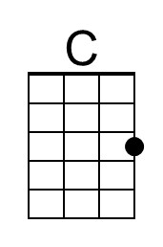 | 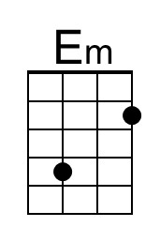 | 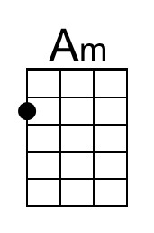 | 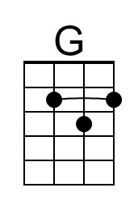
 | 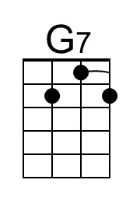 | 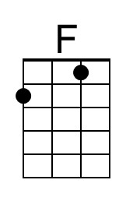 | 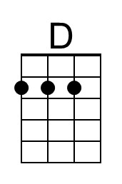 | 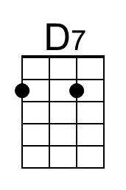
 | 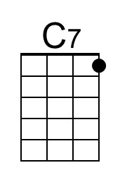 | 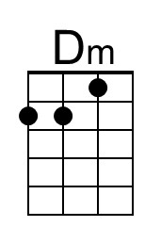 | 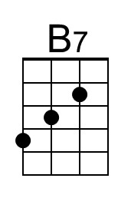 | 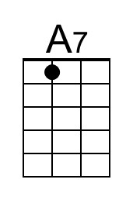
 | Baritone
 | 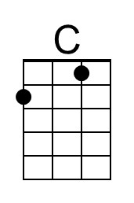 | 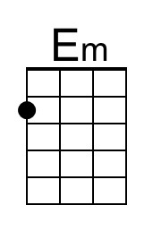 | 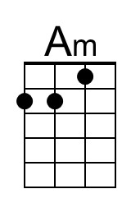 | 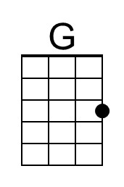
 | 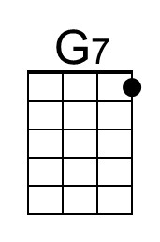 | 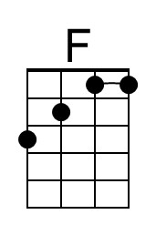 | 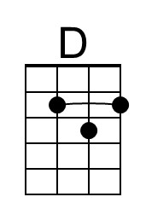 | 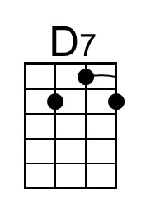
 | 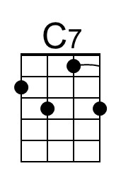 | 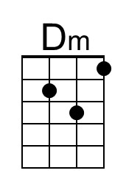 | 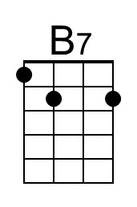 | 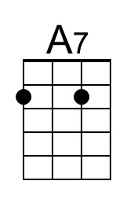

I Saw Mommy Kissing Santa Claus
C46 G
(Tommy Connor, 1952)

Intro Chords of Outro  G Bm Em  I saw Mommy kissing Santa Claus  G D  Underneath the mistletoe last night.  D D7  She didn't see me creep  G  Down the stairs to have a peep,  A A7  She thought that I was tucked up  D D7  In my bedroom fast asleep.  G Bm Em  Then I saw Mommy tickle Santa Claus,  G G7 C E7  Underneath his beard so snowy white.  C F#7  Oh, what a laugh it would have been,  G E7 Am  If Daddy had only seen  ____________________________________  │ D7 G C D7 G D7  │ 1. Mommy kissing Santa Claus last night.  │ Repeat From Top  ____________________________________  │ D7 G C D7 G G7  │ 2. Mommy kissing Santa Claus last night.  Outro  C F#7  Oh, what a laugh it would have been,  G E7 Am  If Daddy had only seen  D7 G C D7 G  Mommy kissing Santa Claus last night. |  | 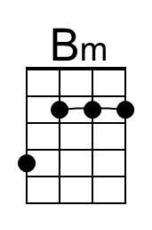
 |  |  | 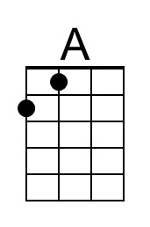
 |  |  | 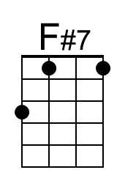 | 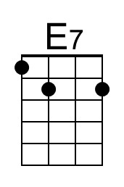
 | Baritone
 |  | 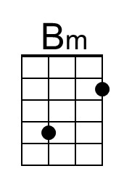
 |  |  | 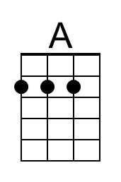
 |  |  | 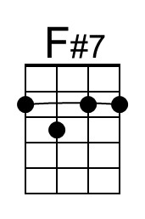 | 