
I Saw Mommy Kissing Santa Claus
C46 C
(Tommy Connor, 1952)
I Saw Mommy Kissing Santa Claus by Jimmy Boyd (1952) (Bb @ 116)
I Saw Mommy Kissing Santa Claus by The Jackson Five (1970) (Eb @ 129)

Intro Same as Outro  C Em Am  I saw Mommy kissing Santa Claus  C G G7  Underneath the mistletoe last night.  G G7  She didn't see me creep  C  Down the stairs to have a peep,  D D7  She thought that I was tucked up  G G7  In my bedroom fast a-sleep.  C Em Am  Then I saw Mommy tickle Santa Claus,  C C7 F A7  Underneath his beard so snowy white.  F B7  Oh, what a laugh it would have been,  C A7 Dm  If Daddy had only seen  ____________________________________  │ G7 C F G7 C G7  │ 1. Mommy kissing Santa Claus last night.  │ Repeat From Top  ____________________________________  │ G7 C F G7 C - C7  │ 2. Mommy kissing Santa Claus last night.  Outro  │ F B7  │ Oh, what a laugh it would have been,  │ C A7 Dm  │ If Daddy had only seen  │ G7 C F G7 C | C  │ Mommy kissing Santa Claus last night. | 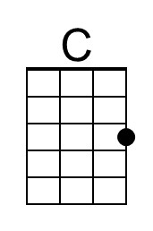 | 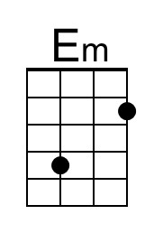 | 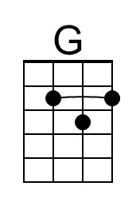 | 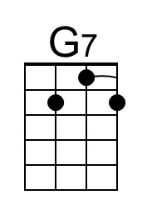
 | 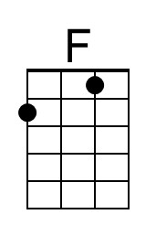 | 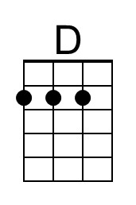 | 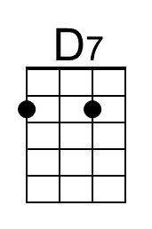 | 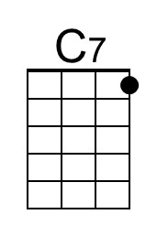
 | 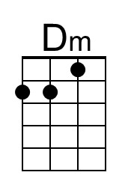 | 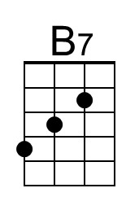 | 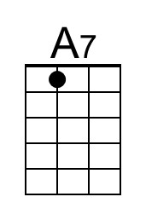 | 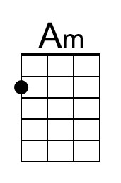
 | Baritone
 | 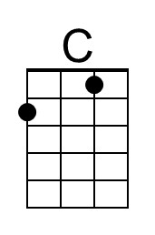 | 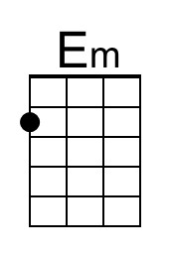 | 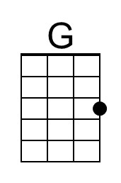 | 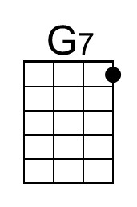
 | 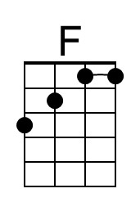 | 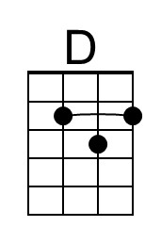 | 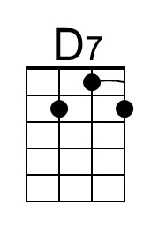 | 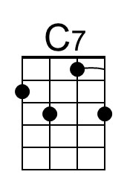
 | 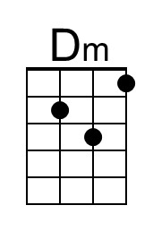 | 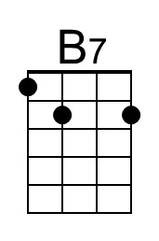 | 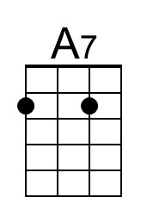 | 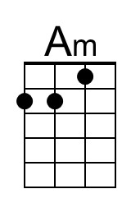

I Saw Mommy Kissing Santa Claus
C46 G
(Tommy Connor, 1952)
I Saw Mommy Kissing Santa Claus by Jimmy Boyd (1952) (Bb @ 116)
I Saw Mommy Kissing Santa Claus by The Jackson Five (1970) (Eb @ 129)

Intro Same as Outro  G Bm Em  I saw Mommy kissing Santa Claus  G D D7  Underneath the mistletoe last night.  D D7  She didn't see me creep  G  Down the stairs to have a peep,  A A7  She thought that I was tucked up  D D7  In my bedroom fast a-sleep.  G Bm Em  Then I saw Mommy tickle Santa Claus,  G G7 C E7  Underneath his beard so snowy white.  C F#7  Oh, what a laugh it would have been,  G E7 Am  If Daddy had only seen  ____________________________________  │ D7 G C D7 G D7  │ 1. Mommy kissing Santa Claus last night.  │ Repeat From Top  ____________________________________  │ D7 G C D7 G - G7  │ 2. Mommy kissing Santa Claus last night.  Outro  │ C F#7  │ Oh, what a laugh it would have been,  │ G E7 Am  │ If Daddy had only seen  │ D7 G C D7 G | G  │ Mommy kissing Santa Claus last night. |  | 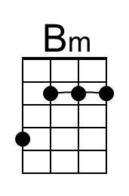
 |  | 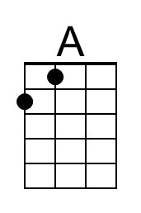
 |  | 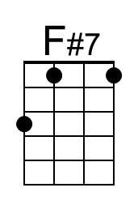 | 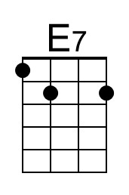
 | Baritone
 |  | 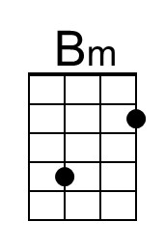
 |  | 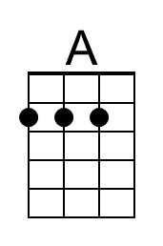
 |  | 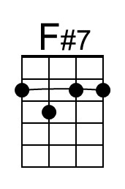 | 