**I Want You, I Need You, I Love You (Maurice Mysels and Ira Kosloff)**

**Intro: F A7 D7 G (hold)**

**C Am**

Hold me close, hold me tight,

**Dm G7**

Make me thrill with delight

**C C7 F**

Let me know where I stand from the start

**Fm7 A7**

I want you, I need you, I love you

**D7 G**

With all my heart

F



**C Am**

Every time that you're near,

**Dm G7**

All my cares disappear

**C C7 F**

Darling you're all that I'm living for

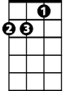

Dm

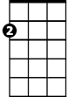

Am

**Fm7 A7**

I want you, I need you, I love you

**D7 G C**

More and more

**Chorus:**

**Gm7 C7 F**

I thought I could live without romance

**Gm7 C7 F**

U-u-until you came to me

**Am7 D G Em**

But now I know, that I will go on

**Am7 D G G7**

**BARITONE**

Loving you eternally



F

**C Am**

Won't you please by my own,

**Dm G7**

Never leave me alone

**C C7 F**

‘Cause I die every time we're apart

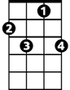

C7

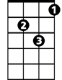

Dm

**Fm7 A7**

I want you, I need you, I love you

**D7 G C**

With all my heart

**(CHORUS)**

**C Am**

Won't you please by my own,

**Dm G7**

Never leave me alone

**C C7 F**

‘Cause I die every time we're apart

**Fm7 A7**

I want you, I need you, I love you

**D7 G C**

With all - my - heart

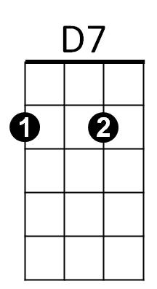

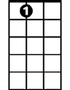

A7



C



G

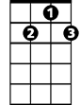

G7

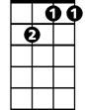

Gm7

Fm7

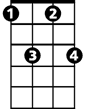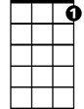

C7

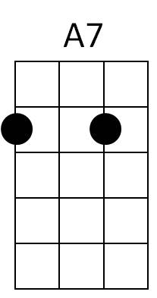



D7

C



G

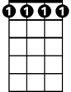

Fm7



G7



Am

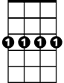

Gm7