I Washed My Hands In Muddy Water (Joe Babcock) - Key C

Intro: C G7 C G7 tacet  tacet C G7 C  I was born in Macon Georgia. They kept my dad in the Macon jail  C7 F  Dad said “Son, if you keep your hands clean.  C G7 C G7/  You won't hear them bloodhounds on your trail”  tacet C G7 C  But I fell in with bad com-panions. We robbed a man in Tennessee  C7 F  The sheriff caught me way up in Nashville  C G7 C G7/  They locked me up and threw away the key  Chorus  tacet C G7  I washed my hands in muddy water  C  I washed my hands but they didn't come clean  C7 F  I tried to do like Daddy told me  C G7 C G7/  But I must have washed my hands in a muddy stream  tacet C G7 C  I asked the jailor ‘”When's my time up”? He said “Son, we won't forget.”  C7 F  And if you try to keep your hands clean.  C G7 C G7/  We may make a good man of you yet”!  tacet C G7 C  I couldn't wait to do my sentence. I broke out of the Nashville jail.  C7 F  I just crossed the line of Georgia  C G7 C G7/  And I can hear them bloodhounds on my trail. Chorus  Outro  C G7 C G7 C  I must have washed my hands in a muddy stream. |  |  |  |  |  |  | 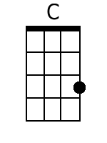
 |  |  |  |  |  |  | 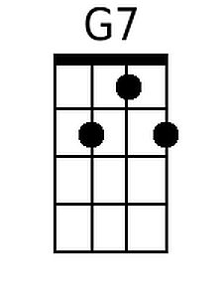
 |  |  |  |  |  |  | 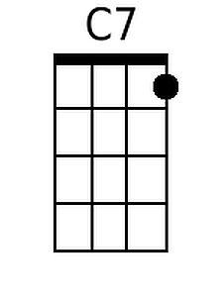
 |  |  |  |  |  |  | 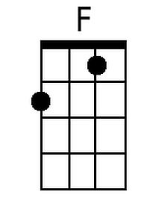
Baritone
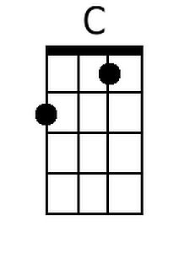 | 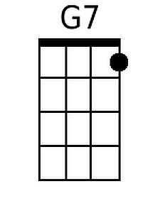 | 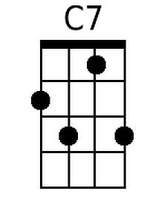 | 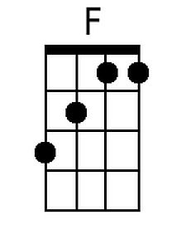

I Washed My Hands In Muddy Water (Joe Babcock) Key G
I Washed My Hands In Muddy Water by Stonewall Jackson

G D7 G  I was born in Macon Georgia. They kept my dad in the Macon jail.  G7 C  Dad said Son if you keep your hands clean.  G D7 G  You won't hear them bloodhounds on your trail.  D7 G  But I fell in with bad companions. We robbed a man in Tennessee.  G7 C  The sheriff caught me way up in Nashville.  G D7 G  They locked me up and threw away the key  Chorus  D7  I washed my hands in muddy water  G  I washed my hands but they didn't come clean  G7 C  I tried to do like Daddy told me  G D7 G  But I must have washed my hands in a muddy stream  D7 G  I asked the jailor ‘When's my time up?” He said, “Son we won't forget.”  G7 C  And if you try to keep your hands clean,  G D7 G  We may make a good man of you yet.  D7 G  I couldn't wait to do my sentence. I broke out of the Nashville jail  G7 C  I just crossed the line of Georgia.  G D7 G  And I can hear them bloodhounds on my trail. Chorus  Outro:  G D7 G  I must have washed my hands in a muddy stream |  |  |  |  |  |  | 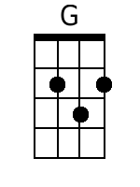
 |  |  |  |  |  |  | 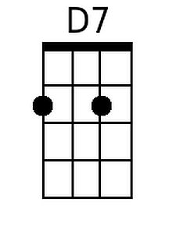
Baritone
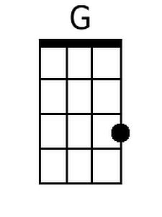 | 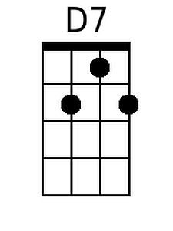

I Washed My Hands In Muddy Water (Joe Babcock) Key F
I Washed My Hands In Muddy Water by Elvis Presley

F C7 F
I was born in Macon Georgia. They kept my dad in the Macon jail.
F7 Bb
Dad said Son if you keep your hands clean
F C7 F
You won't hear them bloodhounds on your trail

C7 F
But I fell in with bad companions. We robbed a man in Tennessee
F7 Bb
The sheriff caught me way up in Nashville
F C7 F
They locked me up and threw away the key

Chorus
F C7
I washed my hands in muddy water
F
I washed my hands but they didn't come clean
F7 Bb
I tried to do like Daddy told me
F C7 F
But I must have washed my hands in a muddy stream

C7 F
I asked the jailor “When's my time up?” He said “Son we won't forget.”
F7 Bb
And if you try to keep your hands clean
F C7 F
We may make a good man of you yet

F C7 F
I couldn't wait to do my sentence. I broke out of the Nashville jail
F7 Bb
I just crossed the line of Georgia
F C7 F
And I can hear them bloodhounds on my trail. Chorus

Outro
F C7 F
I must have washed my hands in a muddy stream

 |  |  |  |  |  |  | 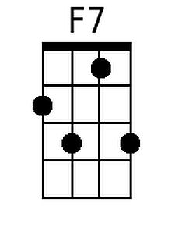
 |  |  |  |  |  |  | 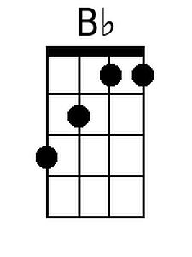
Baritone
 |  | 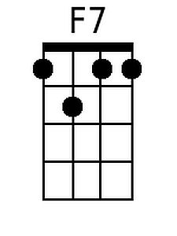 | 