**I Will (Lennon / McCartney)**

**Intro: F G7 Am Em Dm G7 C G7**

**C Am F G7**

Who knows how long I've loved you

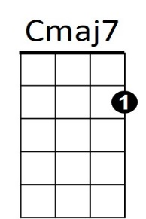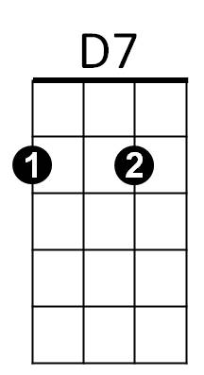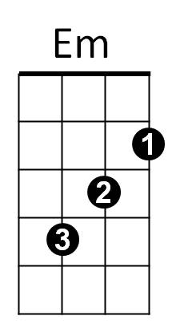 **C Am Em C7**

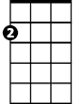

Am

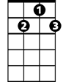

G7

F

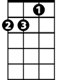

Dm

You know I love you still

**F G7 C C7**

Will I wait a lonely lifetime

**F G7 C**

If you want me to, I will



C

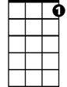

C7

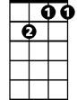

Gm7

**C Am F G7**

For if I ever saw you

**C Am Em C7**

I didn't catch your name

**F G7 C C7**

But it never really mattered

**F G7 C C7**

I will always feel the same

**Reprise:**

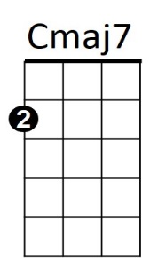

C

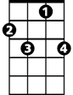

C7

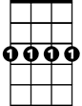

Gm7



D7



F

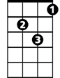

Dm



Em



Am



G7

**BARITONE**

**F Em Am**

Love you forever and forever

**F G7 C C7**

Love you with all my heart

**F Em Am**

Love you whenever we're together

**D7 Dm G7**

Love you when we're apart

**C Am F G7**

And when at last I find you

**C Am Em C7**

Your song will fill the air

**F G7 C Em Am**

Sing it loud so I can hear you

**F G7 C Em Am**

Make it easy to be near you

**F G7 Am Em**

For the things you do endear you to me

**Dm G7 Gm7 C C7**

Oh, you know I will - I will

**F G7 Am Em Dm G7 Cmaj7**

Mm mm mm mm mm mm mmm