**I Will Always Love You (Dolly Parton)**

**C G / C G/ Em C D**



C



G

Em

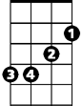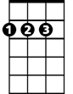

D

**C G D G**

If - I should stay

**Em D C D**

Well I would only be in your way

**G D G**

And so I'll go and but I know

**Em D C D**

That I'll think of you each step of my way

**Chorus:**

**G Em C D G Em C**

**BARITONE**

And I will al - ways love you

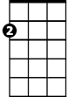

Em

C



D

**D G C G**



G

I will al- ways love you

**D G**

Bitter sweet memo-ries

**Em D C D**

That's all I'm taking with me

**G D G**

Good-bye oh please don't cry

**Em D C D**

Cause we both know that I'm not what you ne - ed

**(Chorus)**

**C G D G**

And I hope life will treat you kind

**Em D C D**

And I hope that you have all that you ever dreamed of

**G D G**

And I wish you joy, and happiness

**Em D C D**

Oh, but above all of this I wish you love

**G**, **Em C D G Em C**

I, I will al-ways love you

**D G**

I will al- ways love you

**Em**  **C D C G**

Ohh I will al-ways love you - ou