**I Will Remember You (Sarah McLachlan, Séamus Egan & Dave Merenda, early 1990s) (Key C)**

**Intro: C-F-G (2x)**

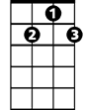

G7



G

F



C

**Chorus-**

**C F G7**

I will remember you,

**C F G**

Will you remember me?

**C F C F**

Don’t let your life pass you by,

**C F G C**

Weep not for the me - mories

**C F G C**

I’m so tired but I can’t sleep

**F G C**

Standing on the edge of something much too deep

**F G C**

It’s funny how we feel so much but we cannot say a word

**F G C**

We are screaming inside, but we can’t be heard

**(Chorus)**

**C F G C**

I’m so afraid to love you, but more afraid to lose

**F G C**

Clinging to a past that doesn’t let me choose

**F G C**

Once there was a darkness, deep and endless night

**F G C**

You gave me everything you had, oh, you gave me life

**(Chorus 2x)**

**BARITONE**

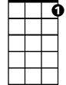

G7



G



F

C



**Outro:**

**C F G C**

Weep not for the me - mories

**I Will Remember You (Sarah McLachlan, Séamus Egan & Dave Merenda, early 1990s) (Key G)**

**Intro: G-C-D (2x)**

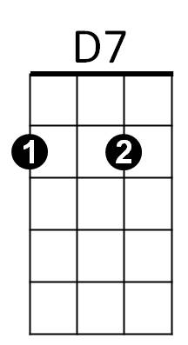



G

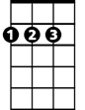

D



C

**Chorus-**

**G C D7**

I will remember you,

**G C D**

Will you remember me?

**G C G C**

Don’t let your life pass you by,

**G C D G**

Weep not for the me - mories

**G C D G**

I’m so tired but I can’t sleep

**C D G**

Standing on the edge of something much too deep

**C D G**

It’s funny how we feel so much but we cannot say a word

**C D G**

We are screaming inside, but we can’t be heard

**(Chorus)**

**G C D G**

I’m so afraid to love you, but more afraid to lose

**C D G**

Clinging to a past that doesn’t let me choose

**C D G**

Once there was a darkness, deep and endless night

**C D G**

You gave me everything you had, oh, you gave me life

**(Chorus 2x)**

**BARITONE**



D7



D

C



G

**Outro:**

**G C D G**

Weep not for the me - mories