**I Will Survive (Freddie Perren, Dino Fekaris) (Am)**

[**I Will Survive**](https://www.youtube.com/watch?v=ARt9HV9T0w8) **by Gloria Gaynor (1978 Official Video, 3:17)**

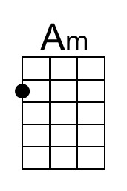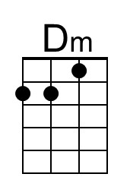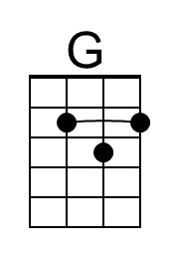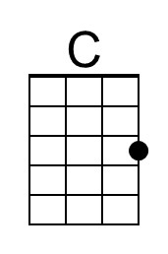

**Intro (2 measures) Am Dm**

**Am Dm**

**1.** First I was afraid, I was petrified.

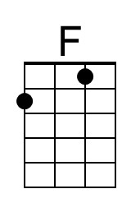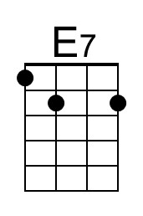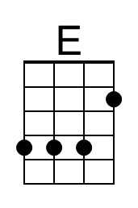**G C**

Kept thinking I could never live without you by my side.

**F Dm**

But then I spent so many nights thinking how you did me wrong.

**E E7**

And I grew strong, and I learned how to get along.

**Am Dm**

**2.** And so you're back back from outer space.

**G C**

I just walked in to find you here with that sad look upon your face.

**F Dm**

I should have changed that stupid lock, I should have made you leave your key,

**E E7**

If I had known for just second you'd be back to bother me.

**Am Dm G C**

**3.** Go on now go, walk out the door. Just turn around now, cause you're not welcome anymore.

**F Dm**

Weren't you the one who tried to hurt me with goodbyes?

**E E7**

Did you think I'd crumble? Did you think I'd lay down and die?

**Am Dm G C**

**4.** Oh no not I! I will survive. Oh, as long as I know how to love I know I'll stay alive.

**F Dm E E7**

I've got all my life to live, I've got all my love to give. And I'll survive, I will survive – hey, hey.

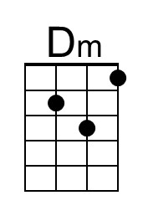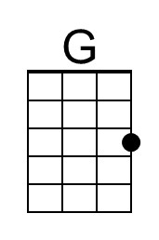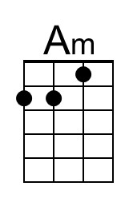

**Instrumental Verse**

**Am Dm**

**5.** It took all the strength I had not to fall apart.

**G C**

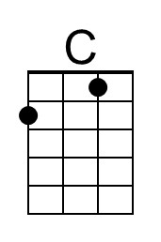Kept trying hard to mend the pieces of my broken heart.

**F Dm**

And I spent oh so many nights just feeling sorry for myself.

**E E7**

I used to cry, but now I hold my head up high.

**Am Dm G C**

**6.** And you see me, somebody new. I'm not that chained up little person still in love with you.

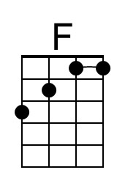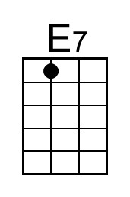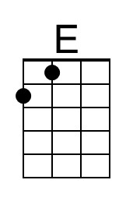**F Dm**

And so you felt like dropping in, and just expect me to be free.

**E E7**

And now I'm savin' all my lovin' for someone who's lovin' me.

**Repeat Verses 3 and 4 (2x)**

**I Will Survive (Freddie Perren, Dino Fekaris) (Em)**

[**I Will Survive**](https://www.youtube.com/watch?v=ARt9HV9T0w8) **by Gloria Gaynor (1978 Official Video, 3:1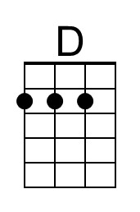7)**

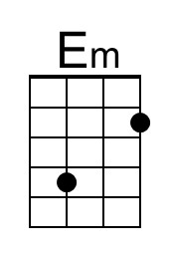

**Intro (2 measures) Em Am**

**Em Am**

**1.** First I was afraid, I was petrified.

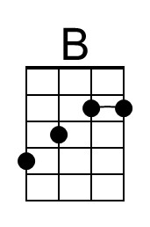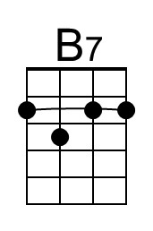**D G**

Kept thinking I could never live without you by my side.

**C Am**

But then I spent so many nights thinking how you did me wrong.

**B B7**

And I grew strong, and I learned how to get along.

**Em Am**

**2.** And so you're back back from outer space.

**D G**

I just walked in to find you here with that sad look upon your face.

**C Am**

I should have changed that stupid lock, I should have made you leave your key,

**B B7**

If I had known for just second you'd be back to bother me.

**Em Am D G**

**3.** Go on now go, walk out the door. Just turn around now, cause you're not welcome anymore.

**C Am**

Weren't you the one who tried to hurt me with goodbyes?

**B B7**

Did you think I'd crumble? Did you think I'd lay down and die?

**Em Am D G**

**4.** Oh no not I! I will survive. Oh, as long as I know how to love I know I'll stay alive.

**C Am B B7**

I've got all my life to live, I've got all my love to give. And I'll survive, I will survive - hey, hey.

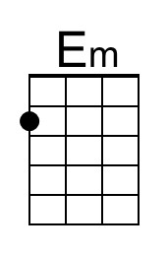

**Instrumental Verse**

**Em Am**

**5.** It took all the strength I had not to fall apart.

**D G**

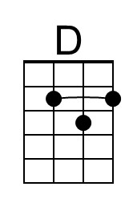Kept trying hard to mend the pieces of my broken heart.

**C Am**

And I spent oh so many nights just feeling sorry for myself.

**B B7**

I used to cry, but now I hold my head up high.

**Em Am D G**

**6.** And you see me, somebody new. I'm not that chained up little person still in love with you.

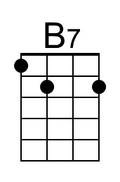**C Am**

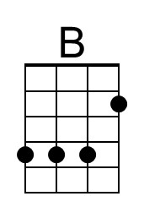And so you felt like dropping in, and just expect me to be free.

**B B7**

And now I'm savin' all my lovin' for someone who's lovin' me.

**Repeat Verses 3 and 4 (2x)**