**I Wish You Love (Paul Young)**

**Bm C**

Goodbye, no use leading with our chins

**Bm Em**

This is how our story ends

**Am D**

Never lovers, ever friends

**Bm C**

Goodbye, let our hearts call it a day

**Bm Em**

But before you walk away

**Am D**

I sincerely want to say -

**D C D**

I wish you blue birds in the spring

**G Em**

To give your heart a song to sing

**C D**

And then a kiss, but more than this

**G G7**

I wish you love

**C D**

And in July a lemonade

**G Em**

To cool you in some leafy glade

**C D**

I wish you health, and more than wealth,

**G7**

I wish you love

B7

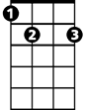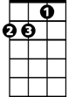

Am

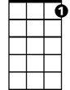

G7

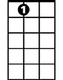

E7

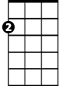

Em

C



G



D

**BARITONE**

Bm

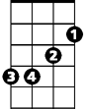

**Bridge:**

**C B7**

My breaking heart and I agree

**G E7**

That you and I could never be

**C E7**

So, with my best, my very best

**Dsus D**

I set you free

**C D**

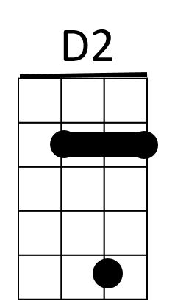I wish you shelter from the storm

B7



E7

**G Em**

A cozy fire to keep you warm

**C D**

But most of all, when snowflakes fall

**G7**

I wish you love

**(Repeat from Bridge)**

**C D**

But most of all, when snowflakes fall

**G**

I wish you love



Am

E7



G

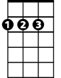

D

Em



C

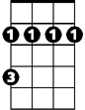

Bm

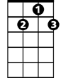

G7

