I Wonder Where My Little Hula Girl Has Gone
(Johnny Noble, Treva Bluett & Walter Donaldson, 1938) (G)

Intro G D7 | C D7  G E7 A7  I ... wonder where... my little hula girl has gone.  D7 G D7 | C D7 |  She’s no longer on the beach at Waiki-ki.  G E7  I ... comb the beach ...  A7  And watch the surf that she rode upon  D7 G G7  And I looked around as far as I can see  C Am G E7  She flew to the East, and she flew to the West  A7  But, I’ll... get no rest  D7 Gdim7 D7  Until I find her back in my little grass shack, oh  G E7 A7  I ... wonder where ... my little hula girl has gone  D7 G D7 | C D7 |  She’s no longer on the beach at Waiki-ki.  Repeat first verse  C Am G E7  She flew to the East, and she flew to the West  A7  But, I’ll... get no rest  D7 Gdim7 D7  Until I find her back in my little grass shack, oh  G E7 A7  I ... wonder where ... my little hula girl has gone  D7 G | E7  She’s no longer on the beach at Waiki-ki.  A7 D7 G | G | Gdim7 | G  She’s no longer on the beach at Waiki-ki. |  |  |  |  |  | 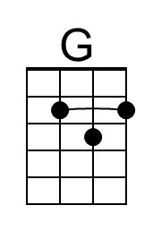 | 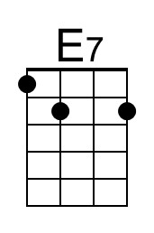
 |  |  |  |  |  | 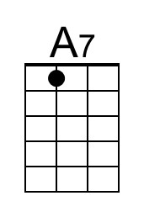 | 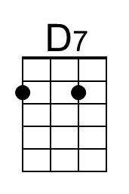
 |  |  |  |  |  | 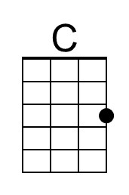 | 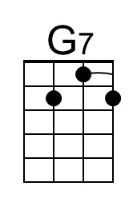
 |  |  |  |  |  | 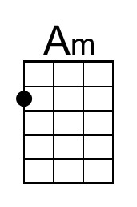 | 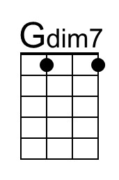
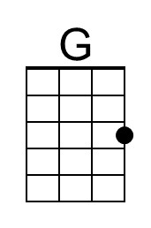 | 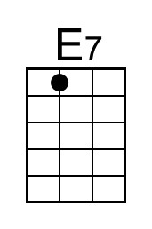 | 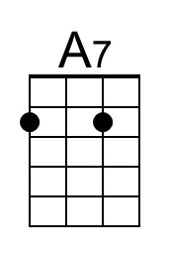 | 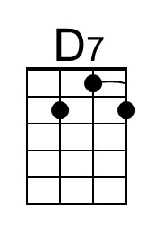 | 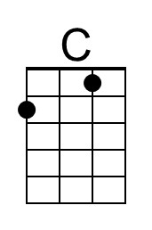 | 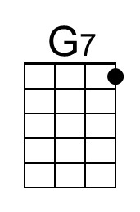 | 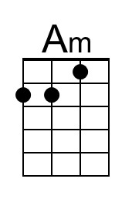 | 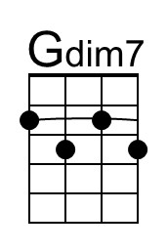

I Wonder Where My Little Hula Girl Has Gone
(Johnny Noble, Treva Bluett & Walter Donaldson, 1938) (C)

Intro C G7 | F G7 |

C A7 D7
I ... wonder where... my little hula girl has gone.
G7 C G7 | F G7
She’s no longer on the beach at Waiki-ki.
C A7
I ... comb the beach ...
D7
And watch the surf that she rode upon
G7 C | C7
And I looked around as far as I can see

F Dm C A7
She flew to the East, and she flew to the West
D7
But, I’ll ... get no rest
G7 Cdim7 G7
Until I find her back in my little grass shack, oh
C A7 D7
I ... wonder where ... my little hula girl has gone
G7 C G7 | F G7 |
She’s no longer on the beach at Waiki-ki.

Repeat First Verse

F Dm C A7
She flew to the East, and she flew to the West
D7
But, I’ll ... get no rest
G7 Cdim7 G7
Until I find her back in my little grass shack, oh
C A7 D7
I ... wonder where ... my little hula girl has gone
G7 C | A7
She’s no longer on the beach at Waiki-ki.
D7 G7 C | C | Cdim7 | C
She’s no longer on the beach at Waiki-ki.

 |  |  |  |  |  | 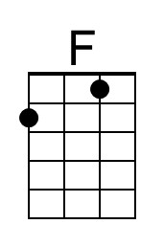 | 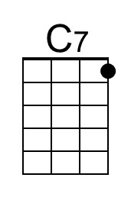
 |  |  |  |  |  | 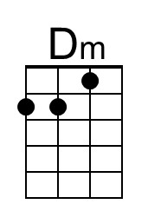 | 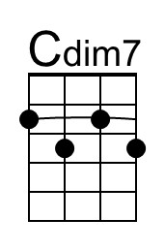
 |  |  |  | 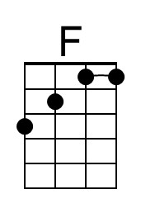 | 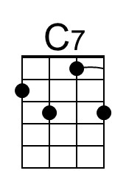 | 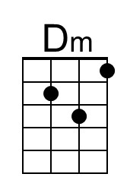 | 