**I Wonder Where My Little Hula Girl Has Gone**

**G E7 A7**

E7

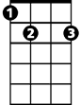

G

I... wonder where... my little hula girl has gone.

**D7 G D7 C D7**

She’s no longer on the beach at Waiki-ki.

**G E7**

I... comb the beach...

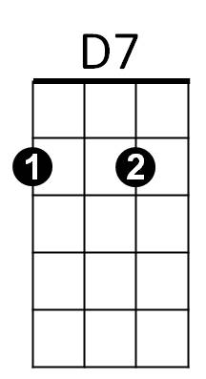 **A7**

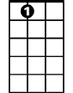

A7

And watch the surf that she rode upon

**D7 G G7**

And I looked around as far as I can see

**C Am G E7**

She flew to the East, and she flew to the West

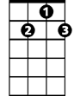

G7



C

**A7**

But, I’ll... get no rest

**D7 Gdim D7**

Until I find her back in my little grass shack, oh

**G E7 A7**

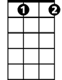

Gdim

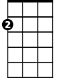

Am

I... wonder where... my little hula girl has gone

**D7 G D7 C D7**

She’s no longer on the beach at Waiki-ki.

**(Repeat first verse)**

**C Am G E7**

She flew to the East, and she flew to the West

**A7**

But, I’ll... get no rest

**D7 Gdim D7**

Until I find her back in my little grass shack, oh

**G E7 A7**

I... wonder where... my little hula girl has gone

**D7 G E7**

She’s no longer on the beach at Waiki-ki.

**A7 D7 G G Gdim G**

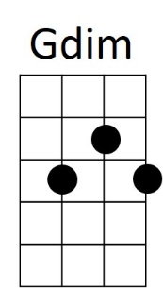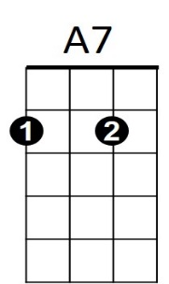She’s no longer on the beach at Waikiki.

**BARITONE**

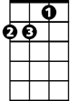

Am

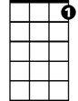

G7

C



D7



E7



G