I’d Like To Teach The World To Sing (C, B, A, & G)
(B. Backer, B. Davis, R. Cook, R. Greenaway, 1971)
As Recorded by the The New Seekers (1971) (Alt.) (B)

Transpositions in A and G are provided in the event that any players have difficulty with the version in B, a key that we rarely play.
I’d Like To Teach The World To Sing (C)
(B. Backer, B. Davis, R. Cook, R. Greenaway, 1971)
As Recorded by the The New Seekers (1971) (Alt.) (B)
4/4 Time – Tempo 132 bpm

Intro (2 measures) C  C D7  I'd like to build a world a home, and furnish it with love.  G G7 F C  Grow apple trees and honey bees, and snow white turtles doves.  C D7  I'd like to teach the world to sing, in perfect harmony.  (Echo) perfect harmony  G G7 F C  I'd like to hold it in my arms, and keep it compan-y.  C D7  I'd like to see the world for once, all standing hand in hand.  G G7 F C  And hear them echo through the hills for peace throughout the land.  (Echo) that’s the song I hear  Bridge  C D7 | D7  That’s the song I hear, let the world sing to-day.  G7 F C  I'd like to teach the world to sing, in perfect harmon-y.  (Echo) peace and love.  G7 F C  I'd like to teach the world to sing, in perfect harmon-y.  (Echo) peace and love.  Instrumental Verse |  |  |  |  |  | 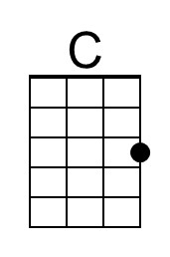
 |  |  |  |  |  | 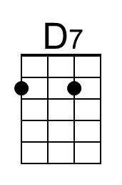
 |  |  |  |  |  | 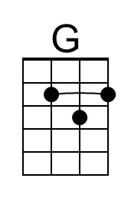
 |  |  |  |  |  | 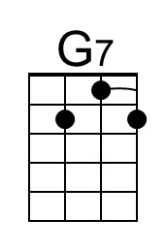
 |  |  |  |  |  | 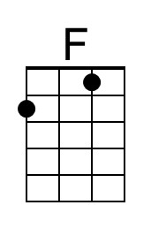
Bari
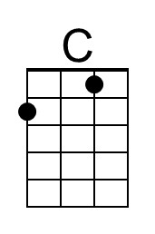 | 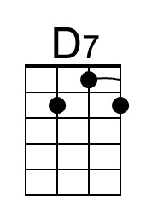 | 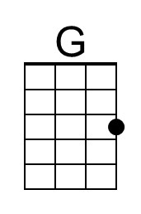 | 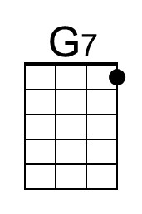 | 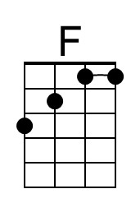

I’d Like To Teach The World To Sing (The New Seekers) (C) – Page 2

C D7
I'd like to build a world a home, and furnish it with love.
G G7 F C
Grow apple trees and honey bees, and snow white turtles doves.
(Echo) that’s the song I hear

C D7
I'd like to teach the world to sing, in perfect harmony.
(Echo) standing hand in hand
G G7 F C
I'd like to hold it in my arms, and keep it compan-y.
(Echo) that’s the song I hear

C D7
I'd like to see the world for once, all standing hand in hand.
(Echo) hand in hand
G G7 F C
And hear them echo through the hills for peace throughout the land.
(Echo) that’s the song I hear

C D7 G
I'd like to teach the world to sing, in perfect harmon-y.
(Echo) perfect harmony
C D7 G
I'd like to teach the world to sing, in perfect harmon-y.
(Echo) perfect harmony

C D7
I'd like to teach the world to sing in perfect harmon-y
(Echo) perfect harmony
G G7 F C
A song of peace that echos on, and never goes a-way.
( Ritard. )
G G7 F C | C (Hold)
A song of peace that echos on, and never goes a-way.

Note: This is the Outro of the Hillside Singers version, pasted on here because it seems to be a better ending than the New Seekers Outro, which is multiple repetitions of “I’d like to teach the world . . . “, with complex harmonies, eventually just petering out. The chords are largely the same both the version by the Hillside Singers and the version by the New Seekers, although there are some slight differences.

I’d Like To Teach The World To Sing (B)
(B. Backer, B. Davis, R. Cook, R. Greenaway, 1971)
As Recorded by the The New Seekers (1971) (Alt.) (B)
4/4 Time – Tempo 132 bpm

Intro (2 measures) B  B C#7  I'd like to build a world a home, and furnish it with love.  F# F#7 E B  Grow apple trees and honey bees, and snow white turtles doves.  B C#7  I'd like to teach the world to sing, in perfect harmony.  (Echo) perfect harmony  F# F#7 E B  I'd like to hold it in my arms, and keep it compan-y.  B C#7  I'd like to see the world for once, all standing hand in hand.  F# F#7 E B  And hear them echo through the hills for peace throughout the land.  (Echo) that’s the song I hear  Bridge  B C#7 | C#7  That’s the song I hear, let the world sing to-day.  F#7 E B  I'd like to teach the world to sing, in perfect harmon-y.  (Echo) peace and love.  F#7 E B  I'd like to teach the world to sing, in perfect harmon-y.  (Echo) peace and love.  Instrumental Verse |  |  |  |  |  | 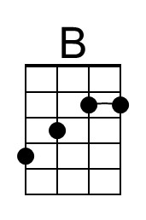
 |  |  |  |  |  | 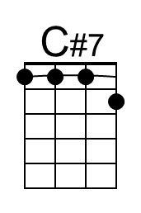
 |  |  |  |  |  | 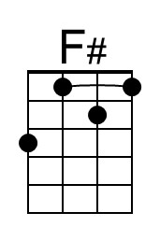
 |  |  |  |  |  | 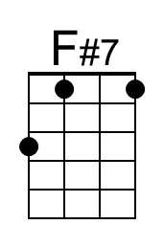
 |  |  |  |  |  | 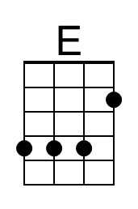
Bari
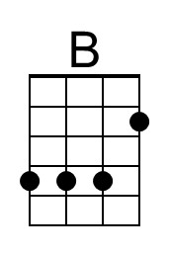 | 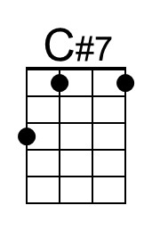 | 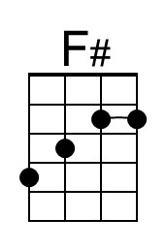 | 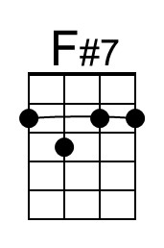 | 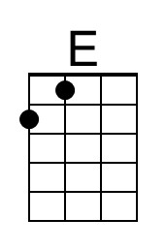

I’d Like To Teach The World To Sing (The New Seekers) (B) – Page 2

B C#7
I'd like to build a world a home, and furnish it with love.
F# F#7 E B
Grow apple trees and honey bees, and snow white turtles doves.
(Echo) that’s the song I hear

B C#7
I'd like to teach the world to sing, in perfect harmony. (Echo) standing hand in hand
F# F#7 E B
I'd like to hold it in my arms, and keep it compan-y. (Echo) that’s the song I hear

B C#7
I'd like to see the world for once, all standing hand in hand. (Echo) hand in hand
F# F#7 E B
And hear them echo through the hills for peace throughout the land.
(Echo) that’s the song I hear

B C#7 F#
I'd like to teach the world to sing, in perfect harmon-y.
(Echo) perfect harmony
B C#7 F#
I'd like to teach the world to sing, in perfect harmon-y.
(Echo) perfect harmony

B C#7
I'd like to teach the world to sing in perfect harmon-y
(Echo) perfect harmony
F# F#7 E B
A song of peace that echos on, and never goes a-way.
( Ritard. )
F# F#7 E B | B (Hold)
A song of peace that echos on, and never goes a-way.

Note: This is the Outro of the Hillside Singers version, pasted on here because it seems to be a better ending than the New Seekers Outro, which is multiple repetitions of “I’d like to teach the world . . . “, with complex harmonies, eventually just petering out. The chords are largely the same both the version by the Hillside Singers and the version by the New Seekers, although there are some slight differences.

I’d Like To Teach The World To Sing (A)
(B. Backer, B. Davis, R. Cook, R. Greenaway, 1971)
As Recorded by the The New Seekers (1971) (Alt.) (B)
4/4 Time – Tempo 132 bpm

Intro (2 measures) A  A B7  I'd like to build a world a home, and furnish it with love.  E E7 D A  Grow apple trees and honey bees, and snow white turtles doves.  A B7  I'd like to teach the world to sing, in perfect harmony.  (Echo) perfect harmony  E E7 D A  I'd like to hold it in my arms, and keep it compan-y.  A B7  I'd like to see the world for once, all standing hand in hand.  E E7 D A  And hear them echo through the hills for peace throughout the land.  (Echo) that’s the song I hear  Bridge  A B7 | B7  That’s the song I hear, let the world sing to-day.  E7 D A  I'd like to teach the world to sing, in perfect harmon-y.  (Echo) peace and love.  E7 D A  I'd like to teach the world to sing, in perfect harmon-y.  (Echo) peace and love.  Instrumental Verse |  |  |  |  |  | 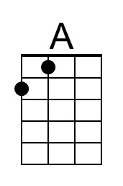
 |  |  |  |  |  | 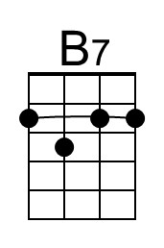
 |  |  |  |  |  | 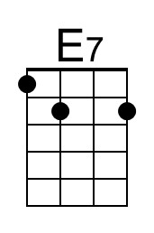
 |  |  |  |  |  | 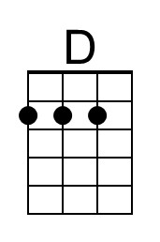
Bari
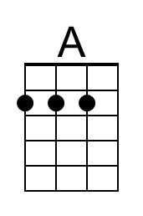 | 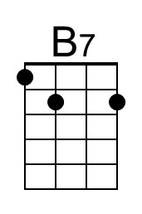 |  | 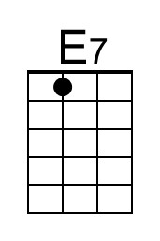 | 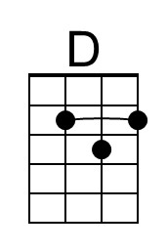

I’d Like To Teach The World To Sing (The New Seekers) (A) – Page 2

A B7
I'd like to build a world a home, and furnish it with love.
E E7 D A
Grow apple trees and honey bees, and snow white turtles doves.
(Echo) that’s the song I hear

A B7
I'd like to teach the world to sing, in perfect harmony.
(Echo) standing hand in hand
E E7 D A
I'd like to hold it in my arms, and keep it compan-y.
(Echo) that’s the song I hear

A B7
I'd like to see the world for once, all standing hand in hand.
(Echo) hand in hand
E E7 D A
And hear them echo through the hills for peace throughout the land.
(Echo) that’s the song I hear

A B7 E
I'd like to teach the world to sing, in perfect harmon-y.
(Echo) perfect harmony
A B7 E
I'd like to teach the world to sing, in perfect harmon-y.
(Echo) perfect harmony

A B7
I'd like to teach the world to sing in perfect harmon-y,
(Echo) perfect harmony
E E7 D A
A song of peace that echos on, and never goes a-way.
( Ritard. )
E E7 D A | A (Hold)
A song of peace that echos on, and never goes a-way.

Note: This is the Outro of the Hillside Singers version, pasted on here because it seems to be a better ending than the New Seekers Outro, which is multiple repetitions of “I’d like to teach the world . . . “, with complex harmonies, eventually just petering out. The chords are largely the same both the version by the Hillside Singers and the version by the New Seekers, although there are some slight differences.
I’d Like To Teach The World To Sing (G)
(B. Backer, B. Davis, R. Cook, R. Greenaway, 1971)
As Recorded by the The New Seekers (1971) (Alt.) (B)
4/4 Time – Tempo 132 bpm

Intro (2 measures) G

G A7
I'd like to build a world a home, and furnish it with love.
D D7 C G
Grow apple trees and honey bees, and snow white turtles doves.

G A7
I'd like to teach the world to sing, in perfect harmony.
(Echo) perfect harmony
D D7 C G
I'd like to hold it in my arms, and keep it compan-y.

G A7
I'd like to see the world for once, all standing hand in hand.
D D7 C G
And hear them echo through the hills for peace throughout the land.
(Echo) that’s the song I hear

G A7 | A7
That’s the song I hear, let the world sing to-day. Bridge
D7 C G
I'd like to teach the world to sing, in perfect harmon-y.
(Echo) peace and love.
D7 C G
I'd like to teach the world to sing, in perfect harmon-y.
(Echo) peace and love.

Instrumental Verse

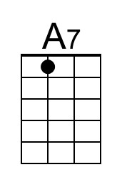
Bari
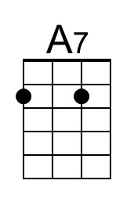

I’d Like To Teach The World To Sing (The New Seekers) (G) – Page 2

G A7
I'd like to build a world a home, and furnish it with love.
D D7 C G
Grow apple trees and honey bees, and snow white turtles doves.
(Echo) that’s the song I hear

G A7
I'd like to teach the world to sing, in perfect harmony.
(Echo) standing hand in hand
D D7 C G
I'd like to hold it in my arms, and keep it compan-y.
(Echo) that’s the song I hear

G A7
I'd like to see the world for once, all standing hand in hand.
(Echo) hand in hand
D D7 C G
And hear them echo through the hills for peace throughout the land.
(Echo) that’s the song I hear

G A7 D
I'd like to teach the world to sing, in perfect harmon-y.
(Echo) perfect harmony
G A7 D
I'd like to teach the world to sing, in perfect harmon-y.
(Echo) perfect harmony

G A7
I'd like to teach the world to sing in perfect harmon-y,
(Echo) perfect harmony
D D7 C G
A song of peace that echos on, and never goes a-way.
( Ritard. )
D D7 C G | G (Hold)
A song of peace that echos on, and never goes a-way.

Note: This is the Outro of the Hillside Singers version, past
ed on here because it seems to be a better ending than the New Seekers Outro, which is multiple repetitions of “I’d like to teach the world . . . “, with complex harmonies, eventually just petering out. The chords are largely the same both the version by the Hillside Singers and the version by the New Seekers, although there are some slight differences.

