I’d Like To Teach The World To Sing (C)
(B. Backer, B. Davis, R. Cook, R. Greenaway, 1971)
As Performed by The Hillside Singers (1971)
4/4 Time – Tempo 100 bpm
Intro (2 measures) C  C D7  I'd like to build a world a home, and furnish it with love.  G7  Grow apple trees and honey bees,  F C  And snow white turtles doves.  C D7  I'd like to teach the world to sing, in perfect harmony.  (Echo) perfect harmony  G7 F C  I'd like to hold it in my arms, and keep it compan-y.  C D7  I'd like to see the world for once, all standing hand in hand.  (Echo) standing hand in hand  G7  And hear them echo through the hills  F C  For peace throughout the land.  1st Bridge  C D7  It's the real thing, what the world wants to-day.  G7 F C  That's the way it will stay, with the real thing.  (Echo) peace and love. |  |  |  |  |  | 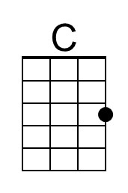
 |  |  |  |  |  | 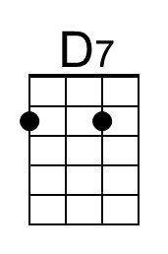
 |  |  |  |  |  | 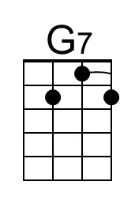
 |  |  |  |  |  | 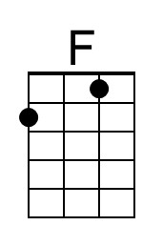
Bari
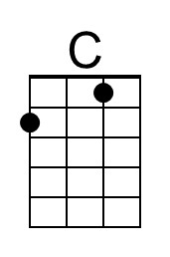 | 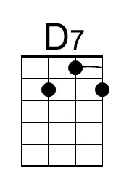 | 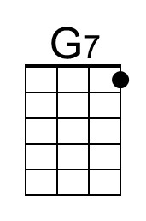 | 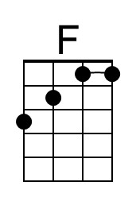

I’d Like To Teach The World To Sing (Hilltop Singers) (C) – Page 2

C D7
I'd like to teach the world to sing in perfect harmony
(Echo) perfect harmony
G7 F C
A song of peace that echos on, and never goes a-way.

2nd Bridge
C
Put your hand in my hand,
D7
Let's begin to-day
G7
With your hand in my hand,
F G7
Help me find a-way.

C D7
I'd like to see the world for once, all standing hand in hand.
(Echo) standing hand in hand
G7 F C
And hear them echo through the hills for peace throughout the land.
(Echo) it’s the real thing

C D7
I'd like to teach the world to sing in perfect harmony
(Echo) perfect harmony
G7 F C
A song of peace that echos on, and never goes a-way.
( Ritard. )
G7 F C | C (Hold)
A song of peace that echos on, and never goes a-way.

I’d Like To Teach The World To Sing (G)
(B. Backer, B. Davis, R. Cook, R. Greenaway, 1971)
As Performed by The Hillside Singers (1971)
4/4 Time – Tempo 100 bpm
Intro (2 measures) G  G A7  I'd like to build a world a home, and furnish it with love.  D7  Grow apple trees and honey bees,  C G  And snow white turtles doves.  G A7  I'd like to teach the world to sing, in perfect harmony.  (Echo) perfect harmony  D7 C G  I'd like to hold it in my arms, and keep it com-pan-y.  G A7  I'd like to see the world for once, all standing hand in hand.  (Echo) standing hand in hand  D7  And hear them echo through the hills  C G  For peace throughout the land.  1st Bridge  G A7  It's the real thing, what the world wants to-day.  D7 C G  That's the way it will stay, with the real thing.  (Echo) peace and love. |  |  |  |  |  |  | 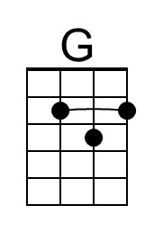
 |  |  |  |  |  |  | 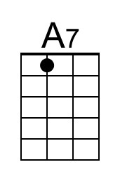
Bari
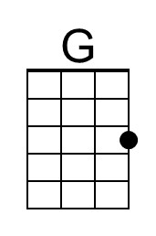 | 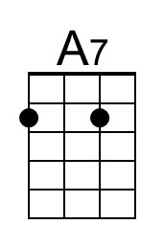
I’d Like To Teach The World To Sing (Hilltop Singers) (G) – Page 2

G A7
I'd like to teach the world to sing, in perfect harmony.
(Echo) perfect harmony
D7 C G
A song of peace that echos on, and never goes a-way.

2nd Bridge
G
Put your hand in my hand,
A7
Let's begin to-day
D7
With your hand in my hand,
C D7
Help me find a-way.

G A7
I'd like to see the world for once, all standing hand in hand
(Echo) standing hand in hand
D7 C G
And hear them echo through the hills for peace throughout the land.
(Echo) it’s the real thing

G A7
I'd like to teach the world to sing, in perfect harmony.
(Echo) perfect harmony
D7 C G
A song of peace that echos on, and never goes a-way.
( Ritard. )
D7 C G | G (Hold)
A song of peace that echos on, and never goes a-way.

