I’d Like To Teach The World To Sing (C → D)
(B. Backer, B. Davis, R. Cook, R. Greenaway)
As Performed by The Hillside Singers

C  I'd like to build a world a home  D7  And furnish it with love  G7  Grow apple trees and honey bees  F C  And snow white turtle doves  C  I'd like to teach the world to sing  D7  In perfect harmony  G7  I'd like to hold it in my arms  F C  And keep it com-pan-y.  C  I'd like to see the world for once  D7  All standing hand in hand  G7  And hear them echo through the hills  F C  For peace throughout the land.  1st Bridge  C  It's the real thing,  D7  What the world wants to-day.  G7  That's the way it will stay,  F C  With the real thing. |  |  |  | C  I'd like to teach the world to sing  D7  In perfect harmony  G7  A song of peace that echos on,  F C  And never goes a-way.  2nd Bridge  C  Put your hand in my hand,  D7  Let's begin to-day  G7  With your hand in my hand,  (Change key)  A A7  Help me find a-way.  D  I'd like to see the world for once  E7  All standing hand in hand  A7  And hear them echo through the hills  G D  For peace throughout the land.  D  I'd like to teach the world to sing  E7  In perfect harmony  A7  A song of peace that echos on,  G D  And never goes a-way. |  |  |  | 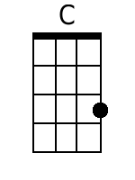
 |  |  |  |  |  |  |  | 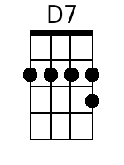
 |  |  |  |  |  |  |  | 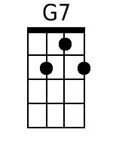
 |  |  |  |  |  |  |  | 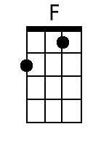
 |  |  |  |  |  |  |  | 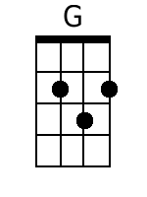
 |  |  |  |  |  |  |  | 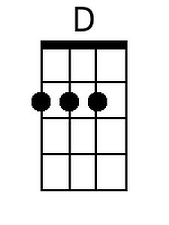
 |  |  |  |  |  |  |  | 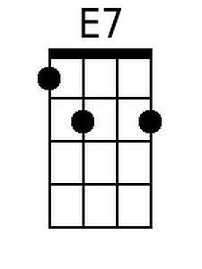
 |  |  |  |  |  |  |  | 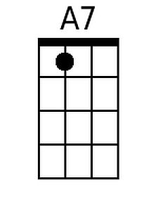
Bari
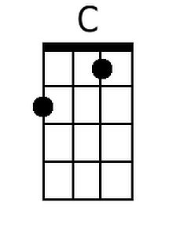 | 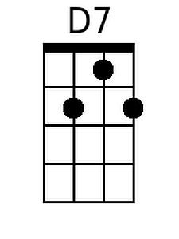 | 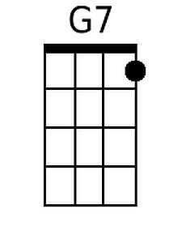 | 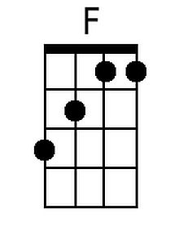 |  | 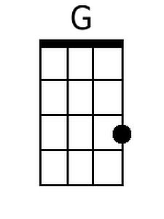 | 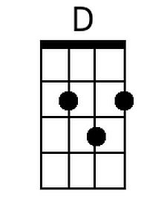 | 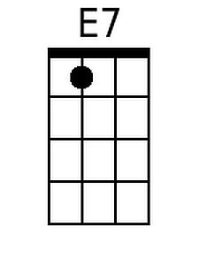 | 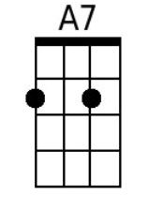

I’d Like To Teach The World To Sing (G → A)
(B. Backer, B. Davis, R. Cook, R. Greenaway)
As Performed by The Hillside Singers

G  I'd like to build a world a home  A7  And furnish it with love  D7  Grow apple trees and honey bees  C G  And snow white turtle doves  G  I'd like to teach the world to sing  A7  In perfect harmony  D7  I'd like to hold it in my arms  C G  And keep it com-pan-y.  G  I'd like to see the world for once  A7  All standing hand in hand  D7  And hear them echo through the hills  C G  For peace throughout the land.  1st Bridge  G  It's the real thing,  A7  What the world wants to-day.  D7  That's the way it will stay,  C G  With the real thing. |  |  |  | G  I'd like to teach the world to sing  A7  In perfect harmony  D7  A song of peace that echos on,  C G  And never goes a-way.  2nd Bridge  G  Put your hand in my hand,  A7  Let's begin to-day  D7  With your hand in my hand,  (Change key)  E E7  Help me find a-way.  A  I'd like to see the world for once  G7  All standing hand in hand  E7  And hear them echo through the hills  D A  For peace throughout the land.  A  I'd like to teach the world to sing  G7  In perfect harmony  E7  A song of peace that echos on,  D A  And never goes a-way.
 |  |  |  |  |  |  |  | 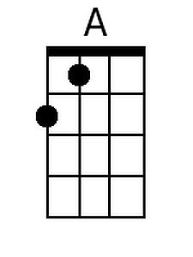
Bari
 |  |  |  |  |  | 