I’d Like To Teach The World To Sing (C → D)
(B. Backer, B. Davis, R. Cook, R. Greenaway, 1971)
As Performed by The Hillside Singers (1971)

Intro (2 measures) C  C D7  I'd like to build a world a home, and furnish it with love.  G7  Grow apple trees and honey bees,  F C  And snow white turtles doves.  C D7  I'd like to teach the world to sing, in perfect harmony.  G7 F C  I'd like to hold it in my arms, and keep it com-pan-y.  C D7  I'd like to see the world for once, all standing hand in hand.  G7  And hear them echo through the hills  F C  For peace throughout the land.  1st Bridge  C D7  It's the real thing, what the world wants to-day.  G7 F C  That's the way it will stay, with the real thing. |  |  |  |  |  |  | 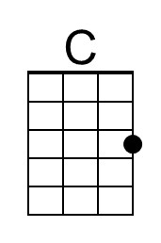 |  | 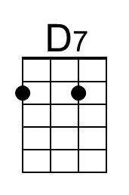
 |  |  |  |  |  |  | 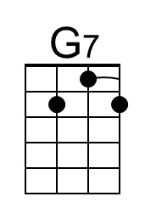 | 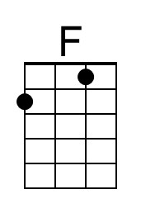
 |  |  |  |  |  |  | 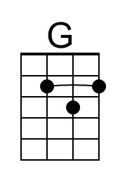 | 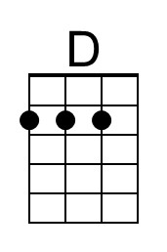
 |  |  |  |  |  |  | 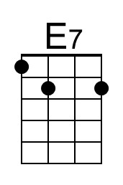 | 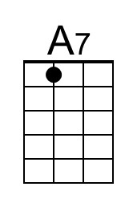
Bari
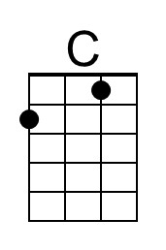 | 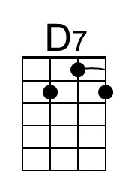 | 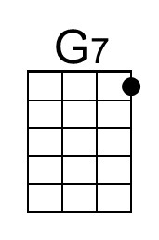 | 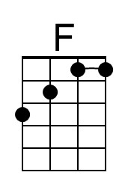 | 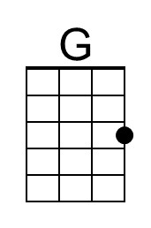 | 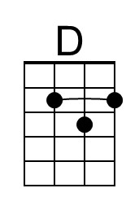 | 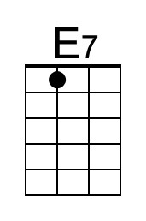 |  | 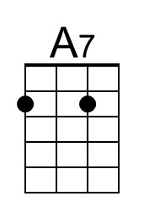

I’d Like To Teach The World To Sing (Hilltop Singers) – Page 2

C D7
I'd like to teach the world to sing in perfect harmony
G7 F C
A song of peace that echos on, and never goes a-way.

2nd Bridge
C
Put your hand in my hand,
D7
Let's begin to-day
G7
With your hand in my hand,
(Change key)
A A7
Help me find a-way.

D E7
I'd like to see the world for once, all standing hand in hand.
A7 G D
And hear them echo through the hills for peace throughout the land.

D E7
I'd like to teach the world to sing in perfect harmony
A7 G D
A song of peace that echos on, and never goes a-way.
( Ritard. )
A7 G D | D (Hold)
A song of peace that echos on, and never goes a-way.

I’d Like To Teach The World To Sing (G → A)
(B. Backer, B. Davis, R. Cook, R. Greenaway, 1971)
As Performed by The Hillside Singers (1971)

Intro (2 measures) G

G A7
I'd like to build a world a home, and furnish it with love.
D7
Grow apple trees and honey bees,
C G
And snow white turtles doves.
G A7
I'd like to teach the world to sing, in perfect harmony.
D7 C G
I'd like to hold it in my arms, and keep it com-pan-y.

G A7
I'd like to see the world for once, all standing hand in hand.
D7
And hear them echo through the hills
C G
For peace throughout the land.

1st Bridge
G A7
It's the real thing, what the world wants to-day.
D7 C G
That's the way it will stay, with the real thing.
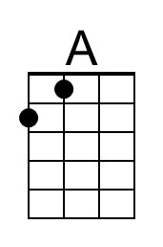
Bari
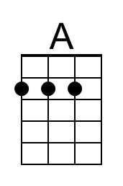

I’d Like To Teach The World To Sing (Hilltop Singers) – Page 2

G A7
I'd like to teach the world to sing, in perfect harmony.
D7 C G
A song of peace that echos on, and never goes a-way.

2nd Bridge
G
Put your hand in my hand,
A7
Let's begin to-day
D7
With your hand in my hand,
(Change key)
E E7
Help me find a-way.

A G7
I'd like to see the world for once, all standing hand in hand
E7 D A
And hear them echo through the hills for peace throughout the land.

A G7
I'd like to teach the world to sing, in perfect harmony.
E7 D A
A song of peace that echos on, and never goes a-way.
( Ritard. )
E7 D A | A (Hold)
A song of peace that echos on, and never goes a-way.

