I’d Like To Teach The World To Sing (C)
(B. Backer, B. Davis, R. Cook, R. Greenaway, 1971)
As Recorded by the The New Seekers (1971)
4/4 Time – Tempo 100 bpm
Intro (2 measures) C  C D7  I'd like to build a world a home, and furnish it with love.  G F G7  Grow apple trees and honey bees, and snow white turtles doves.  C D7  I'd like to teach the world to sing, in perfect harmony.  (Echo) perfect harmony  G F C  I'd like to hold it in my arms, and keep it compan-y.  C D7  I'd like to see the world for once, all standing hand in hand.  G F C  And hear them echo through the hills for peace throughout the land.  Bridge  C D7  That’s the song I hear, let the world sing to-day:  G7 F C G?  I'd like to teach the world to sing, in perfect har-mon-y.  Instrumental Verse |  |  |  |  |  | 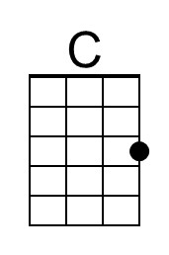
 |  |  |  |  |  | 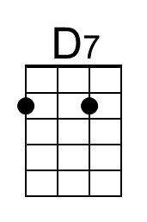
 |  |  |  |  |  | 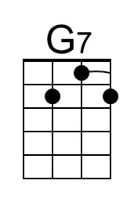
 |  |  |  |  |  | 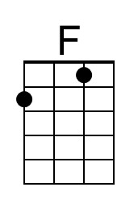
Bari
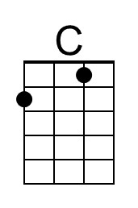 | 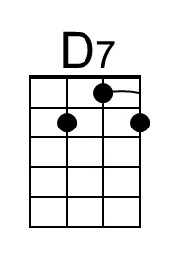 | 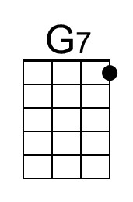 | 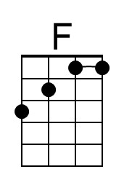

I’d Like To Teach The World To Sing (Hilltop Singers) (C) – Page 2

C D7
I'd like to build a world a home, and furnish it with love.
G7 F C
Grow apple trees and honey bees, and snow white turtles doves.
(Echo) that’s the song I hear

C D7
I'd like to teach the world to sing, in perfect harmony.
(Echo) perfect harmony
G7 F C
I'd like to hold it in my arms, and keep it compan-y.
(Echo) that’s the song I hear

C D7
I'd like to see the world for once, all standing hand in hand.
(Echo) standing hand in hand
G7 F C
And hear them echo through the hills for peace throughout the land.
(Echo) that’s the song I hear

C G - G7
I'd like to teach the world to sing, in perfect harmon-y
(Echo) perfect harmony

C G
I'd like to teach the world to sing in perfect harmon-y
(Echo) perfect harmony
G7 F C
A song of peace that echos on, and never goes a-way.
( Ritard. )
G7 F C | C (Hold)
A song of peace that echos on, and never goes a-way.

Note: This is the Outro of the Hillside Singers version, pasted on here because it seems to be a better ending than the New Seekers Outro.
I’d Like To Teach The World To Sing (G)
(B. Backer, B. Davis, R. Cook, R. Greenaway, 1971)
As Recorded by the The New Seekers (1971)
4/4 Time – Tempo 100 bpm
Intro (2 measures) G  G A7  I'd like to build a world a home, and furnish it with love.  D7  Grow apple trees and honey bees,  C G  And snow white turtles doves.  G A7  I'd like to teach the world to sing, in perfect harmony.  (Echo) perfect harmony  D7 C G  I'd like to hold it in my arms, and keep it com-pan-y.  G A7  I'd like to see the world for once, all standing hand in hand.  (Echo) standing hand in hand  D7  And hear them echo through the hills  C G  For peace throughout the land.  1st Bridge  G A7  That’s the song I hear, Let the world sing to-day.  D7 C G  I'd like to teach the world to sing, in perfect har-mon-y.  (Echo) peace and love. |  |  |  |  |  |  | 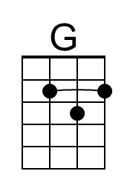
 |  |  |  |  |  |  | 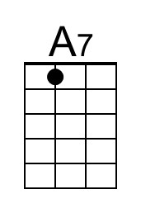
Bari
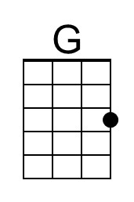 | 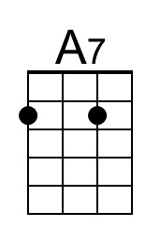
I’d Like To Teach The World To Sing (Hilltop Singers) (G) – Page 2

G A7
I'd like to build a world a home, and furnish it with love.
D7
Grow apple trees and honey bees,
C G
And snow white turtles doves.

G A7
I'd like to teach the world to sing, in perfect harmony.
(Echo) perfect harmony
D7 C G
I'd like to hold it in my arms, and keep it com-pan-y.

G A7
I'd like to see the world for once, all standing hand in hand.
(Echo) standing hand in hand
D7
And hear them echo through the hills
C G
For peace throughout the land.

1st Bridge
G A7
That’s the song I hear, Let the world sing to-day.
D7 C G
I'd like to teach the world to sing, in perfect har-mon-y.
(Echo) peace and love.

G A7
I'd like to teach the world to sing, in perfect harmony.
(Echo) perfect harmony
D7 C G
A song of peace that echos on, and never goes a-way.
( Ritard. )
D7 C G | G (Hold)
A song of peace that echos on, and never goes a-way.

Note: This is the Outro of the Hillside Singers version, pasted on here because it seems to be a better ending than the New Seekers Outro.

