I’d Like To Teach The World To Sing (C)
(B. Backer, B. Davis, R. Cook, R. Greenaway)
As Recorded by the The New Seekers

C  I'd like to build a world a home  D7  And furnish it with love  G7  Grow apple trees and honey bees  F C  And snow white turtle doves  C  I'd like to teach the world to sing  D7  In perfect harmony  G7  I'd like to hold it in my arms  F C  And keep it com-pan-y.  C  I'd like to see the world for once  D7  All standing hand in hand  G7  And hear them echo through the hills  F C  For peace throughout the land. |  |  |  | C  That’s the song I hear  D7  Let the world sing to-day  G7  I'd like to teach the world to sing  F C  In perfect har-mon-y.  Second Time: Go To Outro  Instrumental Verse.  Repeat From Top  Outro: (Repeat and fade)  C  I'd like to teach the world to sing  D7  In perfect harmony.  Optional Outro:  Repeat twice and end on “G” |  |  |  | 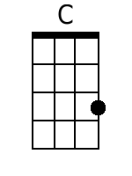
 |  |  |  |  |  |  |  | 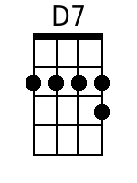
 |  |  |  |  |  |  |  | 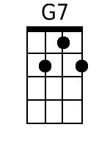
 |  |  |  |  |  |  |  | 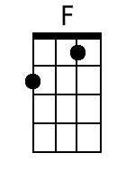
Bari
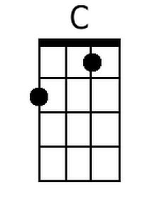 | 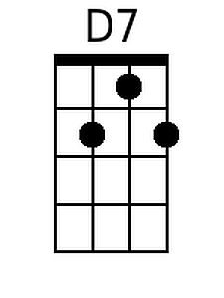 | 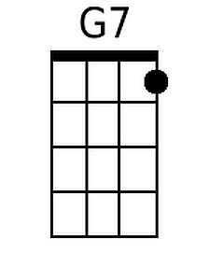 | 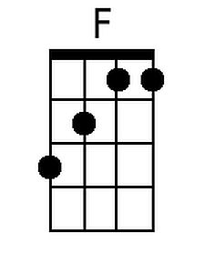

I’d Like To Teach The World To Sing (G)
(B. Backer, B. Davis, R. Cook, R. Greenaway)
As Recorded by the The New Seekers
G  I'd like to build a world a home  A7  And furnish it with love  D7  Grow apple trees and honey bees  C G  And snow white turtle doves  G  I'd like to teach the world to sing  A7  In perfect harmony  D7  I'd like to hold it in my arms  C G  And keep it com-pan-y.  G  I'd like to see the world for once  A7  All standing hand in hand  D7  And hear them echo through the hills  C G  For peace throughout the land. |  |  |  | G  That's the song I hear  A7  Let the world song to-day  D7  I'd like to teach the world to sing  C G  In perfect har-mon-y .  Second Time: Go To Outro  Instrumental Verse.  Repeat From Top  Outro: (Repeat and fade)  G  I'd like to teach the world to sing  A7  In perfect harmony.  Optional Outro:  Repeat twice and end on “G” |  |  |  | 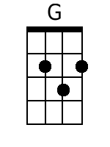
 |  |  |  |  |  |  |  | 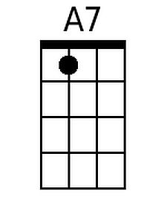
Bari
 | 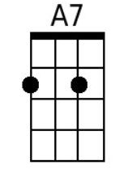 |  | 