I’d Like To Teach The World To Sing (C)
410C
(B. Backer, B. Davis, R. Cook, R. Greenaway, 1971)
As Recorded by the The New Seekers (1971) (Alt.) (B)
4/4 Time – Tempo 132 bpm

Intro (2 measures) C  C D7  I'd like to build a world a home, and furnish it with love.  G G7 F C  Grow apple trees and honey bees, and snow white turtles doves.  C D7  I'd like to teach the world to sing, in perfect harmony.  (Echo) perfect harmony  G G7 F C  I'd like to hold it in my arms, and keep it compan-y.  C D7  I'd like to see the world for once, all standing hand in hand.  G G7 F C  And hear them echo through the hills for peace throughout the land.  (Echo) that’s the song I hear  Bridge  C D7 | D7  That’s the song I hear, let the world sing to-day.  G7 F C  I'd like to teach the world to sing, in perfect harmon-y.  (Echo) peace and love.  G7 F C  I'd like to teach the world to sing, in perfect harmon-y.  (Echo) peace and love.  Instrumental Verse |  |  |  |  |  | 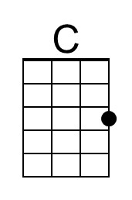
 |  |  |  |  |  | 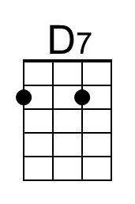
 |  |  |  |  |  | 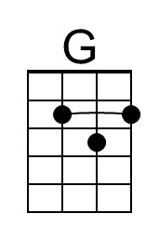
 |  |  |  |  |  | 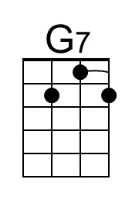
 |  |  |  |  |  | 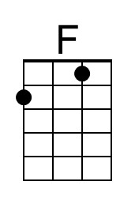
Bari
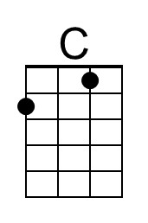 | 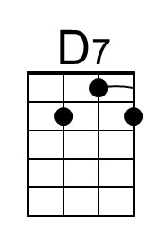 | 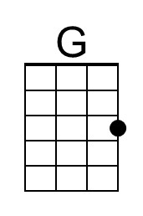 | 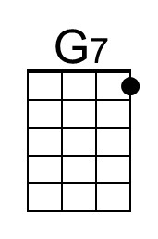 | 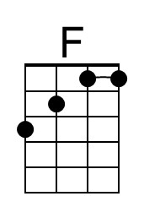

I’d Like To Teach The World To Sing (The New Seekers) (C) – Page 2

C D7
I'd like to build a world a home, and furnish it with love.
G G7 F C
Grow apple trees and honey bees, and snow white turtles doves.
(Echo) that’s the song I hear

C D7
I'd like to teach the world to sing, in perfect harmony.
(Echo) standing hand in hand
G G7 F C
I'd like to hold it in my arms, and keep it compan-y.
(Echo) that’s the song I hear

C D7
I'd like to see the world for once, all standing hand in hand.
(Echo) hand in hand
G G7 F C
And hear them echo through the hills for peace throughout the land.
(Echo) that’s the song I hear

C D7 G
I'd like to teach the world to sing, in perfect harmon-y.
(Echo) perfect harmony
C D7 G
I'd like to teach the world to sing, in perfect harmon-y.
(Echo) perfect harmony

C D7
I'd like to teach the world to sing in perfect harmon-y
(Echo) perfect harmony
G G7 F C
A song of peace that echos on, and never goes a-way.
( Ritard. )
G G7 F C | C (Hold)
A song of peace that echos on, and never goes a-way.

I’d Like To Teach The World To Sing (G)
410G
(B. Backer, B. Davis, R. Cook, R. Greenaway, 1971)
As Recorded by the The New Seekers (1971) (Alt.) (B)
4/4 Time – Tempo 132 bpm

Intro (2 measures) G

G A7
I'd like to build a world a home, and furnish it with love.
D D7 C G
Grow apple trees and honey bees, and snow white turtles doves.

G A7
I'd like to teach the world to sing, in perfect harmony.
(Echo) perfect harmony
D D7 C G
I'd like to hold it in my arms, and keep it compan-y.

G A7
I'd like to see the world for once, all standing hand in hand.
D D7 C G
And hear them echo through the hills for peace throughout the land.
(Echo) that’s the song I hear

G A7 | A7
That’s the song I hear, let the world sing to-day. Bridge
D7 C G
I'd like to teach the world to sing, in perfect harmon-y.
(Echo) peace and love.
D7 C G
I'd like to teach the world to sing, in perfect harmon-y.
(Echo) peace and love.

Instrumental Verse

 |  |  |  |  |  | 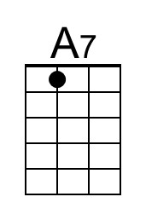
 |  |  |  |  |  | 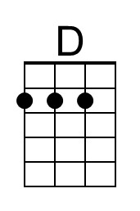
Bari
 | 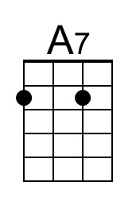 | 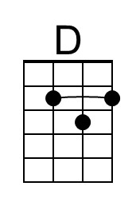

I’d Like To Teach The World To Sing (The New Seekers) (G) – Page 2

G A7
I'd like to build a world a home, and furnish it with love.
D D7 C G
Grow apple trees and honey bees, and snow white turtles doves.
(Echo) that’s the song I hear

G A7
I'd like to teach the world to sing, in perfect harmony.
(Echo) standing hand in hand
D D7 C G
I'd like to hold it in my arms, and keep it compan-y.
(Echo) that’s the song I hear

G A7
I'd like to see the world for once, all standing hand in hand.
(Echo) hand in hand
D D7 C G
And hear them echo through the hills for peace throughout the land.
(Echo) that’s the song I hear

G A7 D
I'd like to teach the world to sing, in perfect harmon-y.
(Echo) perfect harmony
G A7 D
I'd like to teach the world to sing, in perfect harmon-y.
(Echo) perfect harmony

G A7
I'd like to teach the world to sing in perfect harmon-y,
(Echo) perfect harmony
D D7 C G
A song of peace that echos on, and never goes a-way.
( Ritard. )
D D7 C G | G (Hold)
A song of peace that echos on, and never goes a-way.

