**I’ll Be Home For Christmas (Hawaiian)**

C 23

**(K. Gannon & W. Kent; Additional lyrics by Na Leo Pilimehana)**

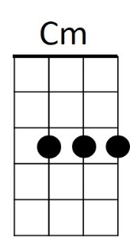**Intro: C Cm G E7 Am7 D7 G D7**

I'll be home for Christmas if only in my dreams



C

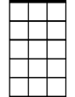

Am7

**G Bbdim Am7 D7 G E7 Am7 E7**

I'll be home for Christmas, you can plan on me

**C D7 G Em A7 Am7 D7**

Please have snow and mistletoe and presents on the tree



G

E7

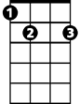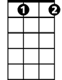

Bb dim

**G Bbdim Am7 D7 G E7 Am7 E7**

Christmas Eve will find me, Where the love light gleams

**C Cm G E7**

I'll be home for Christmas

**A7 D7 G D7**

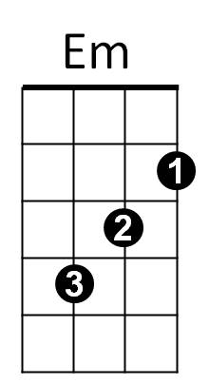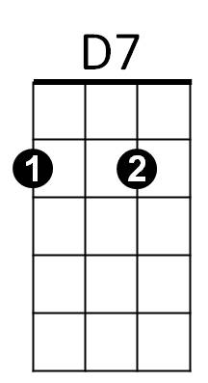If only in my dreams

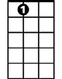

A7

**G Bbdim Am7 D7 G E7 Am7 E7**

I’ll be home for Christmas, that’s where my heart lies

**C D7 G Em**

Palm trees sway as trade winds play

**A7 Am7 D7**

As stars light up the sky

**G Bbdim Am7 D7 G E7 Am7 E7**

**BARITONE**

Christmas Eve will find me, on my Island shore

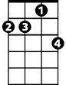

Am7

C

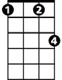

Cm

**C Cm G E7**

I’ll be home for Christmas

**A7 D7 G D7**

Then leave you nevermore

**G Bbdim Am7 D7 G E7 Am7 E7**

I’ll be home for Christmas, we’ll cele-brate the night



E7



G

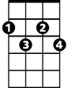

Bb dim

**C D7 G Em**

Wave and sway as guitars play

**A7 Am7 D7**

Hawaiian Lullabies

**G Bbdim Am7 D7 G E7 Am7 E7**

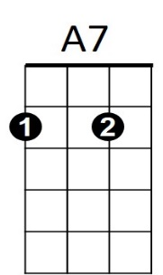Christmas Eve will find me, draped with leis so sweet

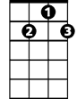

D7

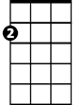

Em

**C Cm G E7**

I’ll be home for Christmas

**A7 D7 G E7**

If only in my dreams

**A7 D7 G**

If only in my dreams