I’m In Love With A Big Blue Frog

(Lester (Les) Braunstein / Mary Allin Travers / Noel Paul Stookey / Peter Yarrow)

**Intro: F F7 Bb Bbm6 F C7 F (C7)**

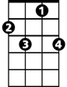

F7

F



**F C7**

I'm in love with a big blue frog, a big blue frog loves me

**F F7 Bb Bbm6 F C7 F. C7**It's not as bad as it appears, he wears glasses and he's six foot three.

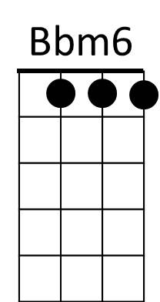 **F C7**



Bb

Well I'm not worried about our kids,I know they'll turn out neat.

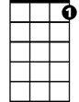

C7

**F F7 Bb Bbm6**They'll be great looking cause they'll have my face,

**F C7 F C7**

Great swimmers cause they'll have his feet!

**F C7**

Well I'm in love with a big blue frog,a big blue frog loves me

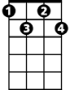

Bdim



F7

**F F7 Bb Bbm6 F C7 F C7**He's not as bad as he appears, he's got rhythm and a Ph D.

**F C7**

Well I know we can make things work, he's got good family sense

**F F7 Bb Bbm6. F C7 F C7**His mother was a frog from Philadel - phia His daddy an enchanted prince.

**F C7**

The neighbors are against it and it's clear to me and it's probably clear to you

**F F7 Bb Bbm6 F C7 F C7**They think value on their property will go right down if the family next door is blue.

**F C7**

Well I'm in love with a big blue frog , a big blue frog loves me

**F F7 Bb Bbm6 F C7 F Bdim F C7 F C7 F**  
I've got it tattooed on my chest It says P.H.R.O.G. (It's frog to me!) P.H.R.O.G.

I'm in Love With a Big Blue Frog lyrics © Warner Chappell Music, Inc

<http://www.traditionalmusic.co.uk/peter-paul-mary/im-in-love-with-a-big-blue-frog-CRD.htm>

(complete with slide whistle, kazoo, and bike horn!)

**BARITONE**

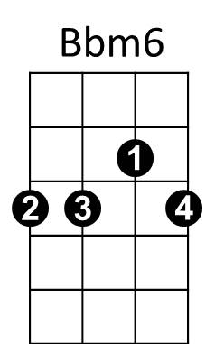

Bdim

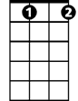

C7

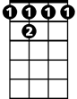

F 7

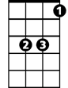

Bb



F