**I’ll Be Home for Christmas**

C 22

**(K. Gannon & W. Kent, 1943)**

**Intro: C Cm G E7 Am7 D7 G D7**

I'll be home for Christ-mas if only in my dreams

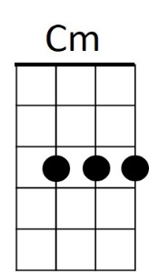



C

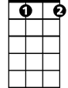

Bb dim



G

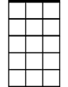

Am7

**G Bbdim Am7 D7**

I'll be home for Christmas,

**G E7 Am7 E7**

You can plan on me

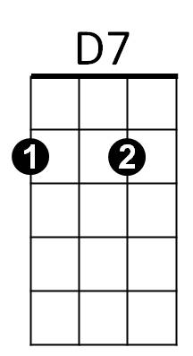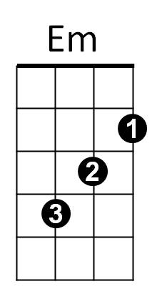**C D7 G Em**

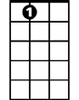

A7

E7

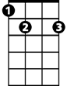

Please have snow and mistletoe

**A7 Am7 D7**

And presents on the tree

**G Bbdim Am7 D7**

Christmas Eve will find me,

**G E7 Am7 E7**

Where the love light gleams

**C Cm G E7**

I'll be home for Christmas

**A7 D7 G D7 (D7 to rollover)**

If only in my dreams

**G7 to Outro**

**Repeat Entire Song**

**BARITONE**



G

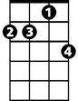

Am7

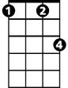

Cm

C



**C Cm G E7**

I’ll be home for Christmas

**A7 D7 G E7**

If only in my dreams

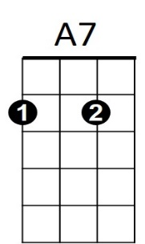 **A7 D7 G**



E7

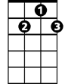

D7

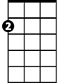

Em

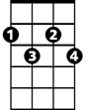

Bbdim

If only in my dreams