I'll Be Seeing You (Sammy Fain and Irving Kahal, 1938) (C)
Version 1

Instrumental Opening  D7 Dm Fm C | G7 |  I'll be looking at the moon, but I'll be seeing you.  C E7 Dm A7 Dm  1. I'll be seeing you, in all the old fa-miliar places  A7 Dm G7 C  That this heart of mine em-braces, all day through  Am Dm  In that small cafe, the park across the way  G7 C G7  The children's carousel, the chestnut trees, the wishing well  C E7 Dm A7 Dm  2. I'll be seeing you, in every lovely summer's day  A7 Dm G7  In every-thing that's light and gay,  Gm A7  I'll always think of you that way.  Dm E7 Am D7  I'll find you in the morning sun, and when the night is new  Dm Fm C Dm  I'll be looking at the moon, but I'll be seeing you.  Repeat 2nd Verse.  Outro: C Dm | Fm | C | |  |  |  |  |  |  | 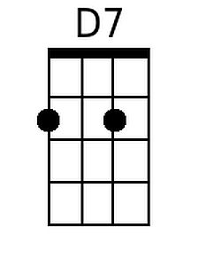 | 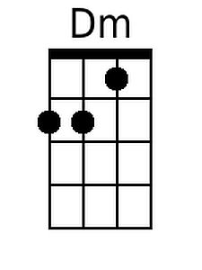
 |  |  |  |  |  |  | 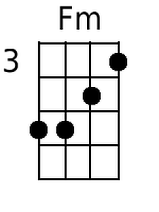 | 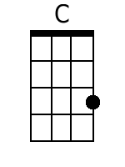
 |  |  |  |  |  |  | 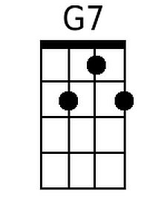 | 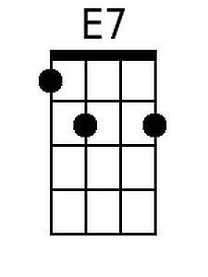
 |  |  |  |  |  |  | 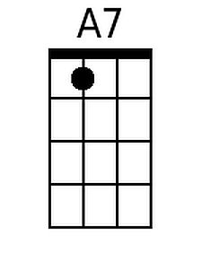 | 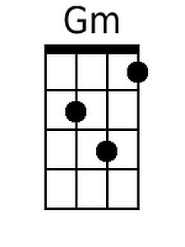
 |  |  |  |  |  |  | 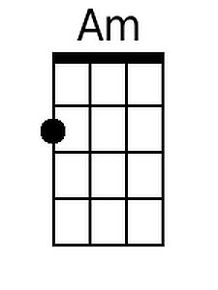
Bari
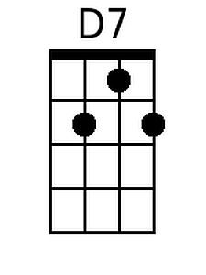 | 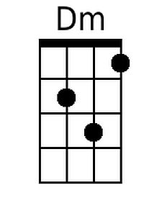 | 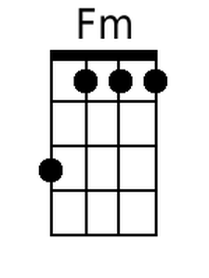 | 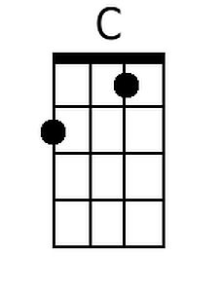 | 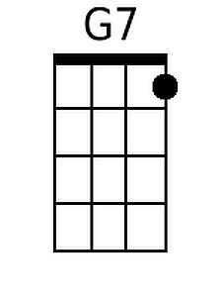 | 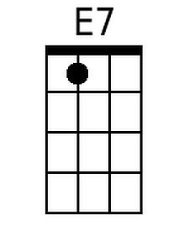 | 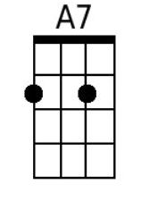 | 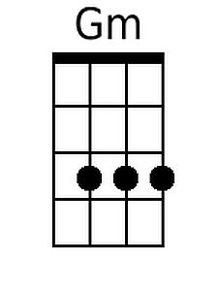 | 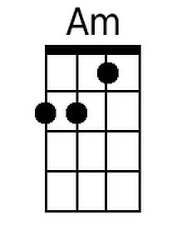

I'll Be Seeing You (Sammy Fain and Irving Kahal, 1938) (F)
Version 1

Instrumental Opening
G7 Gm Bbm F | C7 |
I'll be looking at the moon, but I'll be seeing you.

F A7 Gm D7 Gm
1. I'll be seeing you, in all the old fa-miliar places
D7 Gm C7 F
That this heart of mine em-braces, all day through
Dm Gm
In that small cafe, the park across the way
C7 F C7
The children's carousel, the chestnut trees, the wishing well

F A7 Gm D7 Gm
2. I'll be seeing you, in every lovely summer's day
D7 Gm C7
In every-thing that's light and gay,
Cm D7
I'll always think of you that way.
Gm A7 Dm G7
I'll find you in the morning sun, and when the night is new
Gm Bbm F
I'll be looking at the moon, but I'll be seeing you.

Repeat 2nd Verse.

Outro: F Gm | Bbm | F |

 |  |  |  |  |  |  | 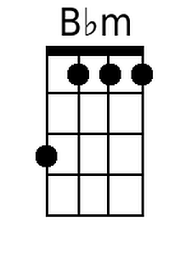 | 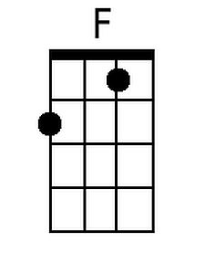
 |  |  |  |  |  |  | 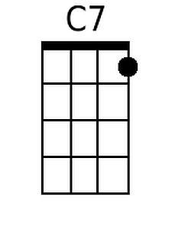
 |  |  |  |  |  |  | 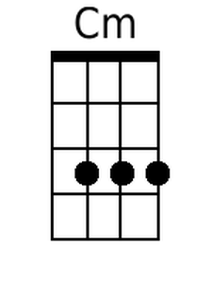
Bari
 |  | 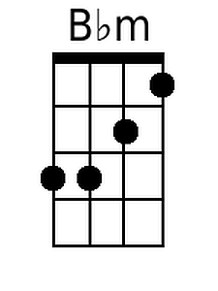 | 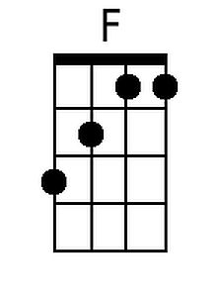 | 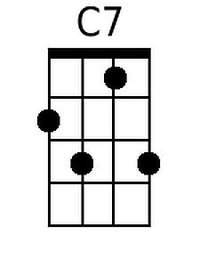 |  |  |  | 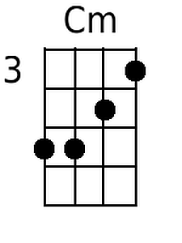

I'll Be Seeing You (Sammy Fain and Irving Kahal, 1938) (G)
Version 1

Intro:
A7 Am Cm G | D7 |
I'll be looking at the moon, but I'll be seeing you.

G B7 Am E7 Am
1. I'll be seeing you, in all the old fa-miliar places
E7 Am D7 G
That this heart of mine em-braces, all day through
Em Am
In that small cafe, the park across the way
D7 G D7
The children's carousel, the chestnut trees, the wishing well

G B7 Am E7 Am
2. I'll be seeing you, in every lovely summer's day
E7 Am D7
In every-thing that's light and gay,
Dm E7
I'll always think of you that way.
Am B7 Em A7
I'll find you in the morning sun, and when the night is new
Am Cm G
I'll be looking at the moon, but I'll be seeing you.

Repeat 2nd Verse.

Outro: G Am | Cm | G |

 |  |  |  |  |  |  |  | 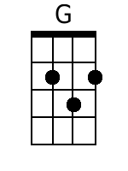
 |  |  |  |  |  |  |  | 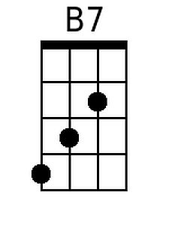
 |  |  |  |  |  |  | 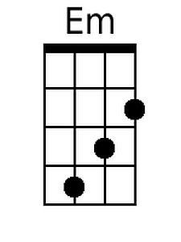
Bari
 |  |  | 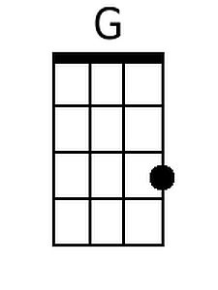 |  | 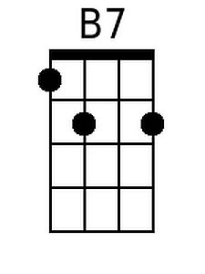 |  |  | 