I'll Be Seeing You (Sammy Fain and Irving Kahal, 1938) (C)
Version 2

Instrumental Opening  Dm E7sus4 E7 Am Am7 D9  I'll find you in the morning sun, and when the night is new  Dm (Dm7) Fm6 C | G7 |  I'll be looking at the moon, but I'll be seeing you.  C E7 Dm A7 Dm A7  1. I'll be seeing you, in all the old fa-miliar places  Dm A7 Dm G7 C  That this heart of mine em-braces, all day through  Am Dm7  In that small cafe, the park across the way  G7 (G7#5) C6 G7#5  The children's carousel, the chestnut trees, the wishing well  C E7 Dm A7 Dm A7  2. I'll be seeing you, in every lovely summer's day  Dm A7 Dm G7  In every-thing that's light and gay,  Gm A7  I'll always think of you that way.  Dm E7sus4 E7 Am Am7 D9  I'll find you in the morning sun, and when the night is new  Dm (Dm7) Fm6 C  I'll be looking at the moon, but I'll be seeing you.  Repeat Instrumental Opening  Repeat 2nd Verse |  |  |  |  |  | 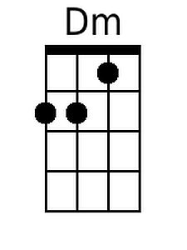 | 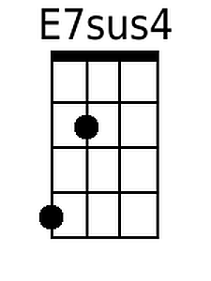 | 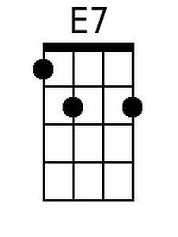
 |  |  |  |  |  | 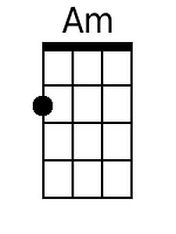 | 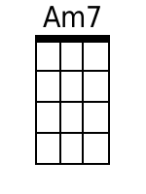 | 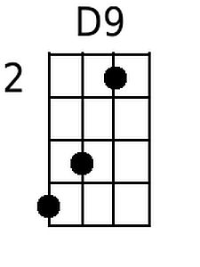
 |  |  |  |  |  | 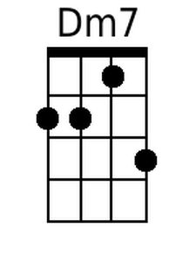 | 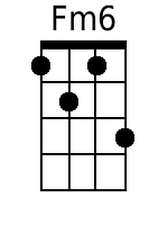 | 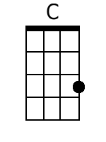
 |  |  |  |  |  | 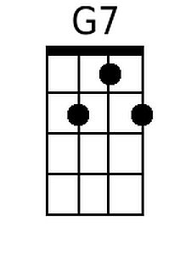 | 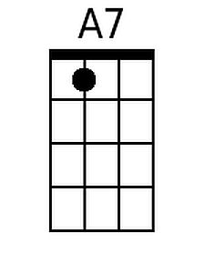 | 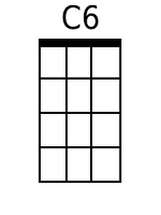
 |  |  |  |  |  | 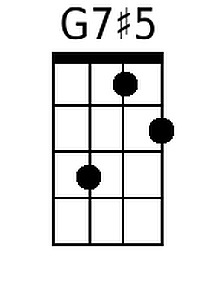 | 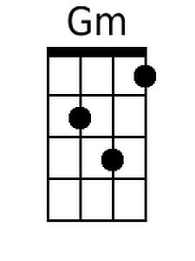
Bari |  |  |  |  |  |  | Substitutions
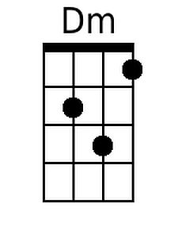 | 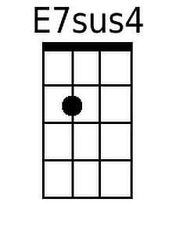 | 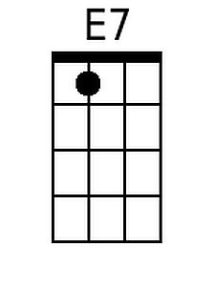 | 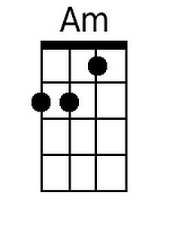 | 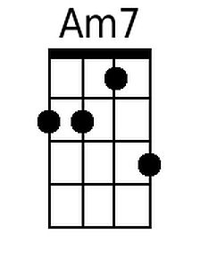 | 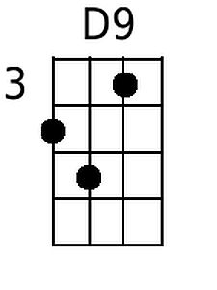 | 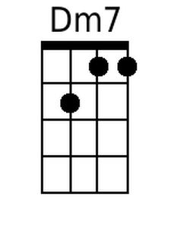 | D9  G7#5 | D7  G7
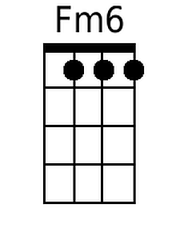 | 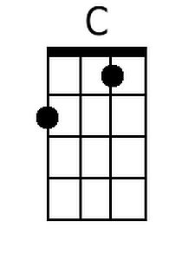 | 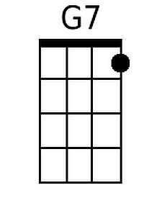 | 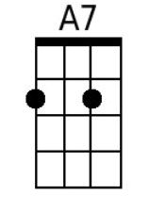 | 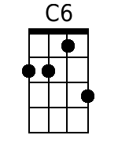 | 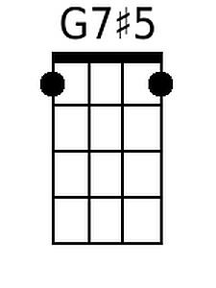 | 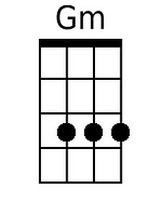 | 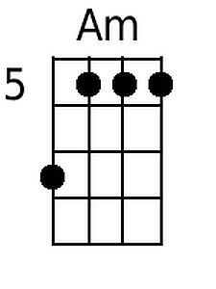 | 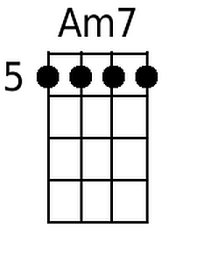

Note: Chords in parentheses are optional.
I'll Be Seeing You (Sammy Fain and Irving Kahal, 1938) (G)
Version 2

Instrumental Opening  Am B7sus4 B7 Em Em7 A9  I'll find you in the morning sun, and when the night is new  Am (Am7) Cm6 G | D7 |  I'll be looking at the moon, but I'll be seeing you.  G B7 Am E7 Am E7  1. I'll be seeing you, in all the old fa-miliar places  Am E7 Am D7 G  That this heart of mine em-braces, all day through  Em Am7  In that small cafe, the park across the way  D7 (D7#5) G6 D7#5  The children's carousel, the chestnut trees, the wishing well  G B7 Am E7 Am E7  2. I'll be seeing you, in every lovely summer's day  Am E7 Am D7  In every-thing that's light and gay,  Dm E7  I'll always think of you that way.  Am B7sus4 B7 Em Em7 A9  I'll find you in the morning sun, and when the night is new  Am (Am7) Cm6 G  I'll be looking at the moon, but I'll be seeing you.  Repeat Instrumental Opening  Repeat 2nd Verse. |  |  |  |  |  |  | 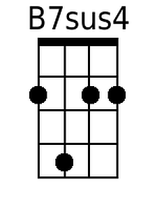 | 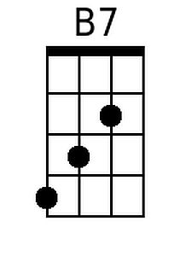
 |  |  |  |  |  | 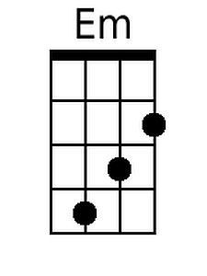 | 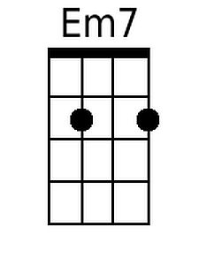 | 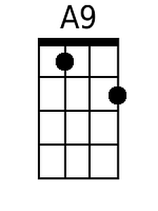
 |  |  |  |  |  |  | 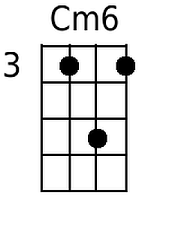 | 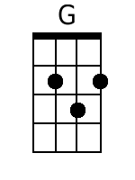
 |  |  |  |  |  | 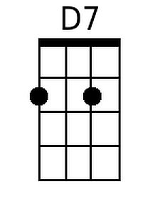 |  | 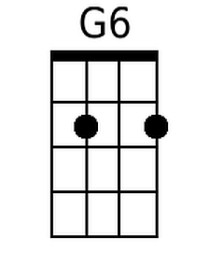
 |  |  |  |  |  | 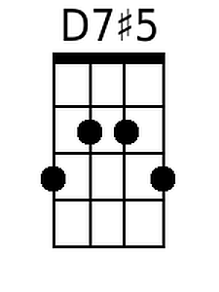
Bari |  |  |  |  |  |  | Substitutions
 | 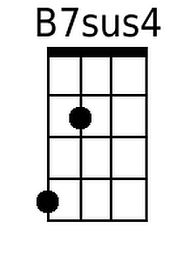 | 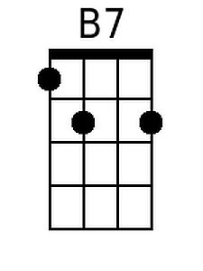 | 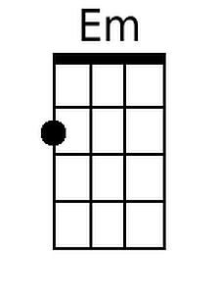 | 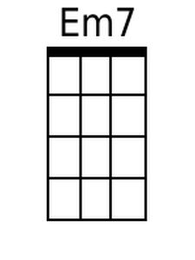 | 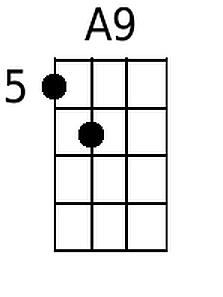 |  | A9  D7#5 | A7  D7
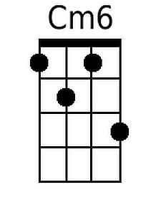 | 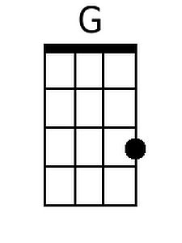 | 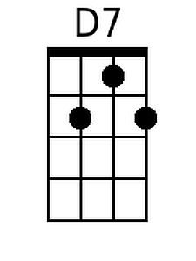 |  | 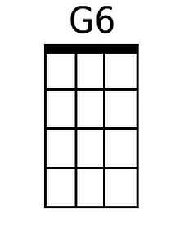 | 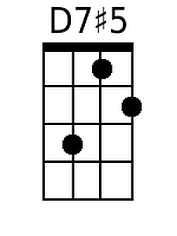

Note: Chords in parentheses are optional.

