
I'll Follow the Sun (John Lennon & Paul McCartney, ca. 1958) (C)
I'll Follow the Sun by The Beatles (1964) (C @ 134)

Intro C G | F C |  G F7 C D  One day you'll look _ to see I've gone  C Em D G7 C G | F C  For to-morrow may rain so _ I'll follow the Sun  G F7 C D  Some day you'll know _ I was the one  C Em D G7 C | C7  But to-morrow may rain so _ I'll follow the sun.  Bridge  Dm Fm C | C7  And now the time has come. And so my love I must go.  Dm Fm C Dm  And though I lose a friend, in the end you will know, Oh,  G F7 C D  One day you'll find _ that I have gone  C Em D G7 C G | F C  But to-morrow may rain so _ I'll follow the sun.  Instrumental 1st Line  G F7 C D  One day you'll look _ to see I've gone  C Em D G7 C | C7  Yes, to-morrow may rain so _ I'll follow the sun. Bridge  Outro  G F7 C D  One day you'll find _ that I have gone  C Em D G7 C G | F C  But to-morrow may rain so _ I'll follow the sun. |  |  |  |  |  |  | 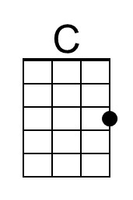 | 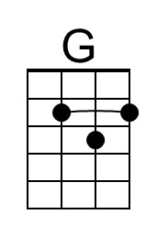
 |  |  |  |  |  |  | 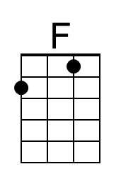 | 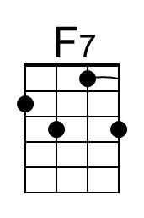
 |  |  |  |  |  |  | 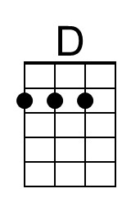 | 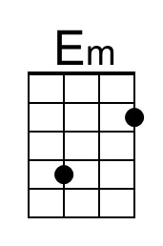
 |  |  |  |  |  |  | 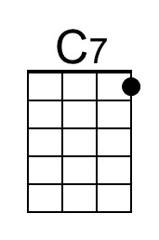 | 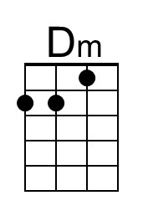
 |  |  |  |  |  |  | 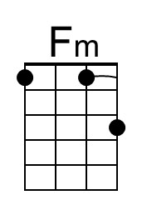
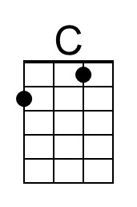 | 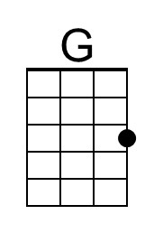 | 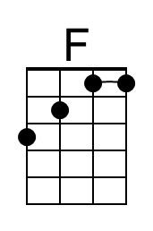 | 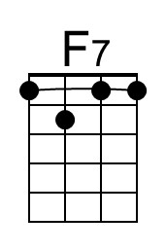 | 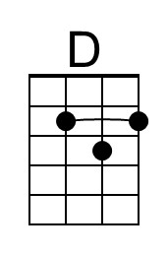 | 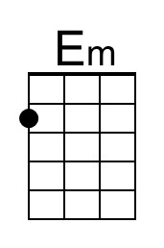 | 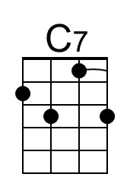 | 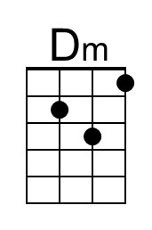 | 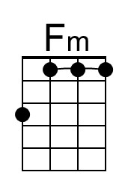

I'll Follow the Sun (John Lennon & Paul McCartney, ca. 1958) (G)
I'll Follow the Sun by The Beatles (1964) (C @ 134)

Intro G D | C G

D C7 G A
One day you'll look _ to see I've gone
G Bm A D7 G D | C G
For to-morrow may rain so _ I'll follow the Sun
D C7 G A
Some day you'll know _ I was the one
G Bm A D7 G | G7
But to-morrow may rain so _ I'll follow the sun.

Bridge
Am Cm G | G7
And now the time has come. And so my love I must go.
Am Cm G Am
And though I lose a friend, in the end you will know, Oh,

D C7 G A
One day you'll find _ that I have gone
G Bm A D7 G D | C G
But to-morrow may rain so _ I'll follow the sun.

Instrumental 1st Line
D C7 G A
One day you'll look _ to see I've gone
G Bm A D7 G | G7
Yes, to-morrow may rain so _ I'll follow the sun. Bridge

Outro
D C7 G A
One day you'll find _ that I have gone
G Bm A D7 G D | C G
But to-morrow may rain so _ I'll follow the sun.

 |  |  |  |  |  |  | 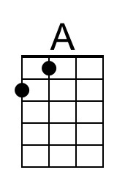 | 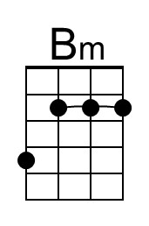
 |  |  |  |  |  |  | 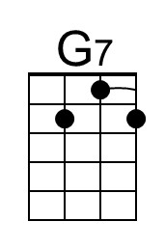 | 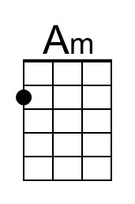
 |  |  |  |  |  |  | 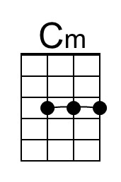
 |  |  |  | 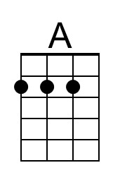 | 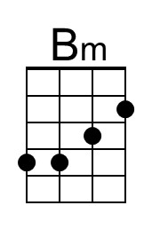 | 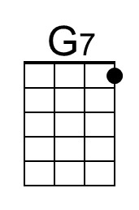 | 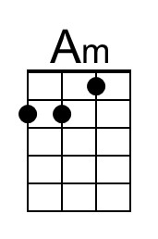 | 