**I'll Have to Say I Love You in a Song (Jim Croce)**

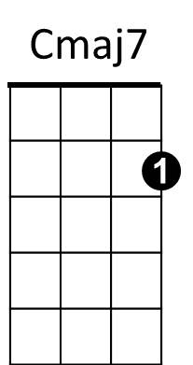**C Cmaj7 Am7 Em7**

Em7

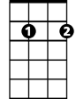

F

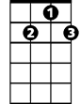

G7

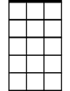

Am7



C

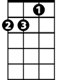

Dm

Well, I know it's kind of late

**Dm G7**

I hope I didn't wake you,

**Cmaj7 Am7 Em7**

But what I got to say can't wait

**Dm G7**

I know you'd understand

**Chorus:**

**F F#dim**

Every time I tried to tell you

**E7 Am F**

The words just came out wrong

**C G7 F C**

So I'll have to say I love you in a song.

**Cmaj7 Am7 Em7**

Yeah, I know it's kind of strange

**Dm G7**

But every time I'm near you,

**Cmaj7 Am7 Em7**

I just run out of things to say

**Dm G7**

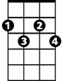

F#dim

E7

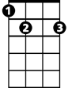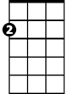

Am

I know you'd understand

**(Chorus)**

**(Instrumental Verse)**

**(Chorus)**

**C Cmaj7 Am7 Em7**

Yeah, I know it's kind of late

**Dm G7**

I hope I didn't wake you,

**Cmaj7 Am7 Em7**

But there's something that I just got to say,

**Dm G7**

I know you'd understand

.

**(Chorus)**

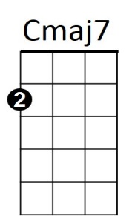

**BARITONE**



F

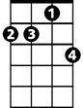

Am7



Am

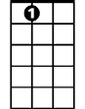

E7

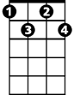

F#dim

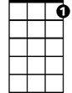

G7

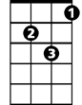

Dm



Em7

C

