**I’ll Never Fall in Love Again (Burt Bacharach and Hal David)**

**C Am**

What do you get when you fall in love?

**F G**

A guy with a pin to burst your bubble

**Em A7**

That's what you get for all your trouble

**F F7 C**

I'll never fall in love agai-n

**F G C**

I'll never fall in love again

**C Am**

What do you get when you kiss a guy?

**F G**

You get enough germs to catch pneumonia

**Em A7**

After you do, he'll never phone ya

**F F7 C**

I'll never fall in love agai-n

**F G C**

Dontcha know that I'll never fall in love again?

**Bridge:**

**C F C**

Don't tell me what it's all about

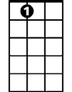

A7

Em

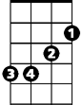

**F C**

'Cause I've been there and I'm glad I'm out

**Em**

Out of those chains, those chains that bind you

**D G**

That is why I'm here to remind you

**C Am**

**BARITONE**

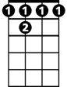

F 7



D



G



F

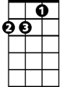

Am

What do you get when you fall in love?

C



**F G**

You only get lies and pain and sorrow

**Em A7**

So far at least until tomorrow

**F F7 C**

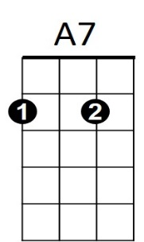I'll never fall in love agai-n

**F G C**

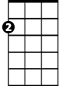

Em

No, no, I'll never fall in love again

**Instrumental Bridge (first two lines)**

**Em**

Out of those chains, those chains that bind you

**D G**

That is why I'm here to remind you

**C Am**

What do you get when you fall in love?

**F G**

You only get lies and pain and sorrow

**Em A7**

So far at least until tomorrow

**F F7 C**

I'll never fall in love agai-n

**F G C**

Dontcha know that I'll never fall in love again?

**F G C**

I'll never fall in love again

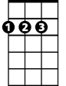

D

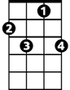

F7

F



Am



C



G