**I'll Remember You (Kui Lee)**

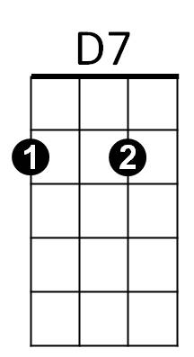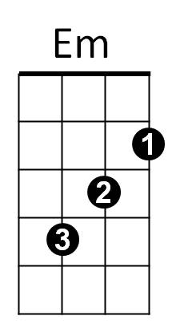**Intro: Chords of Reprise**

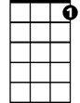

C7

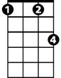

Fm

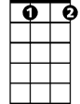

Bbdim

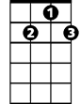

G7



C

F



**C Em**

I'll remember you

**F G7 C Bbdim**

Long after this endless summer has gone

**F Fm**

I'll be lonely, oh so lonely

**F G7 C Bbdim F G7**

Living only to remember you

**C Em**

I'll remember too

**F G7 C Bbdim**

Your voice as soft as the warm summer breeze

**F Fm**

Your sweet laughter, mornings after

**F G7 C C7**

Ever after, (ooo) I'll remember you

**BARITONE**

C

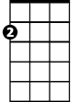

Em



F

**Reprise:**

**C7 F**

To your arms someday

**D7 G7 D7 G7**



G7

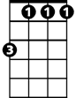

Fm

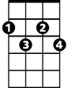

Bbdim

I'll return to stay ~ Till then - I will re-

**C Em**

-member, too

**F G7 C Bbdim**

Every bright star we made wishes upon



D7

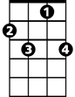

C7

**F Fm**

Love me always, promise always

**F G7 C**

Ooooo ooo, you'll remember too

Ending: **G7 C G7 C F C**

You'll remember too, you’ll remember too-oo-oo