**I'll Take You Home Again Kathleen (Thomas P. Westendorf, 1875) Key C**

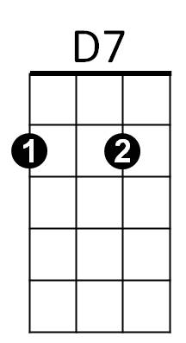 **C G7 C**



C

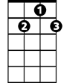

G7

F



I'll take you home again Kathleen

**G7 C**

Across the ocean wild and wide

**G7 C**

To where your heart has ever been

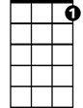

C7

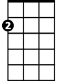

Am

E7

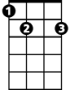

**G7 D7 G7**

Since first you were my bonnie bride

**F G7 C**

The roses all have left your cheek

**G7 C**

I've watched them fade away and die

**E7 Am C**

Your voice is sad when ‘ere you speak

**D7 G7**

And tears bedim your loving eyes

**C G7 C**

**BARITONE**

C



D7

Oh, I will take you back Kathleen



G7

**G7 C**

To where your heart will feel no pain

**C7 F**

And when the fields are fresh and green

**C G7 C**

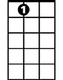

E7

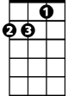

Am



F

I'll take you to your home Kathleen

**C7 F**

And when the fields are fresh and green

**C G7 C**

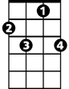

C7

I'll take you to your home Kathleen

**I'll Take You Home Again Kathleen (Thomas P. Westendorf, 1875) Key G**





C



G



A7

**G D7 G**

I'll take you home again Kathleen

**D7 G**

Across the ocean wild and wide

**D7 G**

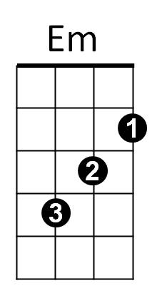To where your heart has ever been



G7

**D7 A7 D7**

Since first you were my bonnie bride

**C D7 G**

The roses all have left your cheek

**D7 G**

I've watched them fade away and die

**B7 Em G**

Your voice is sad when ‘ere you speak

**A7 D7**

And tears bedim your loving eyes

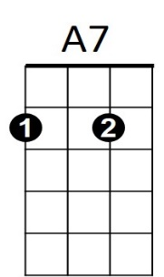 **G D7 G**

**BARITONE**



D7



G

Oh, I will take you back Kathleen

**D7 G**

To where your heart will feel no pain

**G7 C**

And when the fields are fresh and green

**G D7 G**

B7



G7

C



I'll take you to your home Kathleen

**G7 C**

And when the fields are fresh and green

**G D7 G**



Em

I'll take you to your home Kathleen