I'll Tell Me Ma (aka “Belle of Belfast City”) (D)

Intro (4 measures) D A A7 D  Chorus  D A A7 D  I'll tell me ma when I go home, the boys won't leave the girls alone.  D A A7 D  They pull my hair, they stole my comb, but that's all right 'til I go home.  D G D A7  She is handsome, she is pretty, she's the belle of Belfast City.  D G D A A7 D  She is courtin', one, two, three. Please won't you tell me who is she?  D A A7 D  Now Albert Mooney says he loves her, an' all the boys are fighting for her.  D A  Knocking on the door and they're ringing on the bell,  A7 D  Saying, "Oh my true love, are you well?"  D G D A7  Out she comes as white as snow, with rings on her fingers and bells on her toes.  D G  Old Jenny Murphy says she'll die,  D A A7 D  If she doesn't get the fellow with the roving eye. Chorus  D A  Let the wind and the rain and the hail come high,  A7 D  And the snow come shoveling from the sky.  D A7 A D  She's as nice as apple pie, she'll get her own lad by and by!  D G D A7  An' when she gets a lad of her own, she won't tell her ma when she comes home.  D G D A A7 D  Let them all come as they will, but it's Albert Mooney she loves still! Chorus (2x) |  |  |  |  |  |  | 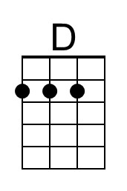
 |  |  |  |  |  |  | 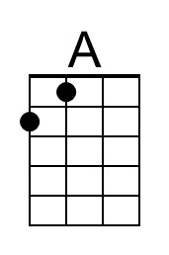
 |  |  |  |  |  |  | 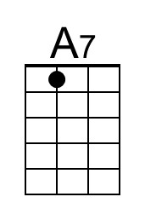
 |  |  |  |  |  |  | 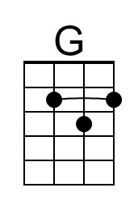
 |  |  | Bari | 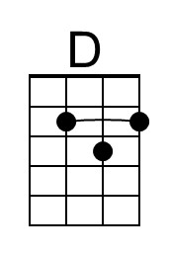 | 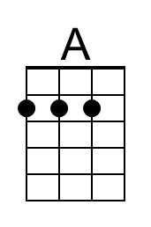 | 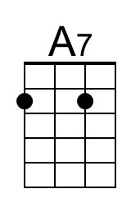 | 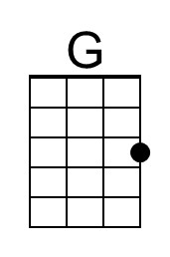

I'll Tell Me Ma (aka “Belle of Belfast City”) (G)

Intro (4 measures) G D D7 G

Chorus
G D D7 G
I'll tell me ma when I go home, the boys won't leave the girls alone.
G D D7 G
They pull my hair, they stole my comb, but that's all right 'til I go home.
G C G D7
She is handsome, she is pretty, she's the belle of Belfast City.
G C G D D7 G
She is courtin', one, two, three. Please won't you tell me who is she?

G D D7 G
Now Albert Mooney says he loves her, an' all the boys are fighting for her.
G D
Knocking on the door and they're ringing on the bell,
D7 G
Saying, "Oh my true love, are you well?"
G C G D7
Out she comes as white as snow, with rings on her fingers and bells on her toes.
G C
Old Jenny Murphy says she'll die,
G D D7 G
If she doesn't get the fellow with the roving eye. Chorus

G D
Let the wind and the rain and the hail come high,
D7 G
And the snow come shoveling from the sky.
G D7 D G
She's as nice as apple pie, she'll get her own lad by and by!
G C G D7
An' when she gets a lad of her own, she won't tell her ma when she comes home.
G C G D D7 G
Let them all come as they will, but it's Albert Mooney she loves still! Chorus (2x)

 |  |  |  |  |  |  | 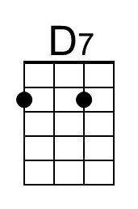
 |  |  |  |  |  |  | 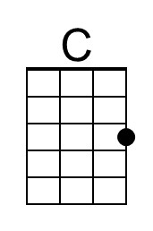
 |  |  | Bari |  |  | 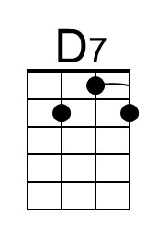 | 