I’m A Believer (Neil Diamond, 1979) (C)
I'm A Believer by Neil Diamond from “September Morn,” 1979 (E @ 160)
I’m A Believer by Neil Diamond from “Just For You,” 1967 (E @ 160)
I’m A Believer by The Monkees, 1966 (G @ 160)
2/2 Time
Intro
C . . F | . . . Gsus4 | C . . . A | . . . Gsus4 |

C G Am | Am
_ I thought love was only true in fairy tales,
C G C | C
_ Meant for someone else, but not for me.
C G Em | Em
_ Paperhouse that’s made to stand with paper nails,
C G C | C
_ Is all I thought that love could ever be.
F Cmaj7 Am F G C
What's the use in tryin’, _ all you get is pain.
F Cmaj7 Am F#dim7 G | G ↓
_ When I needed sunshine I got rain.

Chorus
C F C F
_ Then I saw her face, _ now I'm a be-liever.
C F C F
_ Not a trace _ of doubt in my mind,
C F C A# G | G ↓
_ I'm in love, and I'm a be-liever, I couldn't leave her if I tried.
E . . A | . . . B | E . . A | . . . B |
Not if I tried.

C G Am | Am
_ Thought that love was more or less a givin' thing,
C G C | C
_ Seems the more I gave, the less I got.
C G Em | Em
_ Like a flow’r that grows, love's like a livin’ thing,
C G C | C
_ Livin’ things don't like to be for-got.
F Cmaj7 Am F G C
_Love was out to get me, that's the way it seemed.
F Cmaj7 Am F#dim7 G | G ↓
_ Disap-pointment haunted all my dreams.
I’m A Believer (1979) (C) – Page 2

C F C F
_ Then I saw her face, _ now I'm a be-liever.
C F C F
_ Not a trace _ of doubt in my mind,
C F C F C F C F
I'm in love. I'm a be-liever. I'm in love. I'm a be-liever.
C F C F C F C F | C
I'm in love. I'm a be-liever. I'm in love. I'm a be-liever.

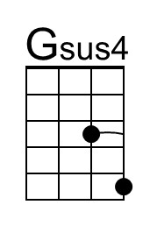 | 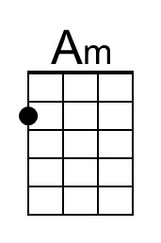 | 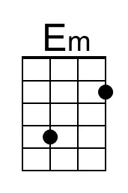 | 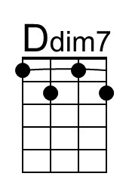 | Bari | 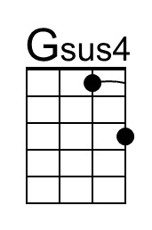 | 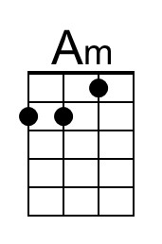 | 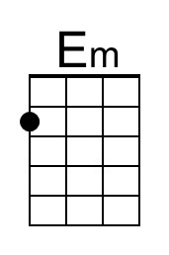 | 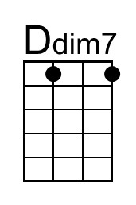

I’m A Believer (Neil Diamond, 1979) (E)
I'm A Believer by Neil Diamond from “September Morn,” 1979 (E @ 160)
I’m A Believer by Neil Diamond from “Just For You,” 1967 (E @ 160)
I’m A Believer by The Monkees, 1966 (G @ 160)
2/2 Time
Intro
E . . A | . . . Bsus4 | E . . . A | . . . Bsus4 |

E B C#m | C#m
_ I thought love was only true in fairy tales,
E B E | E
_ Meant for someone else, but not for me.
E B G#m | G#m
_ Paperhouse that’s made to stand with paper nails,
E B E | E
_ Is all I thought that love could ever be.
A Emaj7 C#m A B E
What's the use in tryin’, _ all you get is pain.
A Emaj7 C#m Bbdim7 B | B ↓
_ When I needed sunshine I got rain.

Chorus
E A E A
_ Then I saw her face, _ now I'm a be-liever.
E A E A
_ Not a trace _ of doubt in my mind,
E A E D B | B ↓
_ I'm in love, and I'm a be-liever, I couldn't leave her if I tried.
E . . A | . . . B | E . . A | . . . B |
Not if I tried.

E B C#m | C#m
_ Thought that love was more or less a givin' thing,
E B E | E
_ Seems the more I gave, the less I got.
E B G#m | G#m
_ Like a flow’r that grows, love's like a livin’ thing,
E B E | E
_ Livin’ things don't like to be for-got.
A Emaj7 C#m A B E
_Love was out to get me, that's the way it seemed.
A Emaj7 C#m Bbdim7 B | B ↓
_ Disap-pointment haunted all my dreams.
I’m A Believer (1979) (E) – Page 2

E A E A
_ Then I saw her face, _ now I'm a be-liever.
E A E A
_ Not a trace _ of doubt in my mind,
E A E A E A E A
I'm in love. I'm a be-liever. I'm in love. I'm a be-liever.
E A E A E A E A | E
I'm in love. I'm a be-liever. I'm in love. I'm a be-liever.

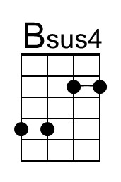 | 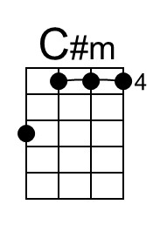 | 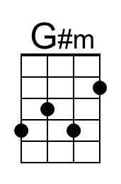 | 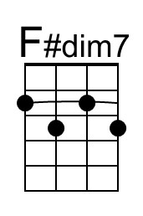 | Bari | 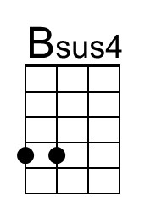 | 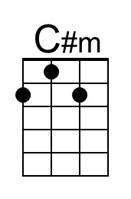 | 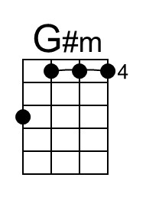 | 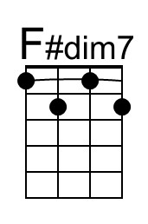

_____________________________________________________________________________________
Notes
Written by Neil Diamond in 1966 while he was a contract songwriter for Aldon Music in New York's Brill Building, it was first recorded by the Monkees whose version had an advance order of 1,051,280 copies and went gold within two days of release. This was a #1 hit, was sung by Micky Dolenz, and later appeared on the second Monkees album, "More of the Monkees."
The contract with Don Kirshner allowed Diamond to record the song as well; he released the first version on his 1967 album "Just For You." He recorded a slightly different version for the album "September Morn" (1979).
Diamond performed and recorded mostly in E (including both 1967 & 1979 versions), but performed in the key of F several times including:
- I’m A Believer from “Hot August Night III – Live at the Greek Theatre,” 2012 (F @ 156)
- I’m A Believer from “Dreams” (F @ 140) [a slow version]
- I’m A Believer from “Classic Diamonds” (F @ 140) [a slow version]
He also performed the song in the key of G:
- I’m A Believer from “Live In America (Live at the Delta Center),” 1993 (G @ 160)
I’m A Believer (Neil Diamond, 1979) (G)
I'm A Believer by Neil Diamond from “September Morn,” 1979 (E @ 160)
I’m A Believer by Neil Diamond from “Just For You,” 1967 (E @ 160)
I’m A Believer by The Monkees, 1966 (G @ 160)
2/2 Time
Intro
G . . C | . . . Dsus4 | G . . . A | . . . Dsus4 |

G D Em | Em
_ I thought love was only true in fairy tales,
G D G | G
_ Meant for someone else, but not for me.
G D Bm | Bm
_ Paperhouse that’s made to stand with paper nails,
G D G | G
_ Is all I thought that love could ever be.
C Gmaj7 Em C D G
What's the use in tryin’, _ all you get is pain.
C Gmaj7 Em C#dim7 D | D ↓
_ When I needed sunshine I got rain.

Chorus
G C G C
_ Then I saw her face, _ now I'm a be-liever.
G C G C
_ Not a trace _ of doubt in my mind,
G C G F D | D ↓
_ I'm in love, and I'm a be-liever, I couldn't leave her if I tried.
E . . A | . . . B | E . . A | . . . B |
Not if I tried.

G D Em | Em
_ Thought that love was more or less a givin' thing,
G D G | G
_ Seems the more I gave, the less I got.
G D Bm | Bm
_ Like a flow’r that grows, love's like a livin’ thing,
G D G | G
_ Livin’ things don't like to be for-got.
C Gmaj7 Em C D G
_Love was out to get me, that's the way it seemed.
C Gmaj7 Em C#dim7 D | D ↓
_ Disap-pointment haunted all my dreams.
I’m A Believer (1979) (G) – Page 2

G C G C
_ Then I saw her face, _ now I'm a be-liever.
G C G C
_ Not a trace _ of doubt in my mind,
G C G C G C G C
I'm in love. I'm a be-liever. I'm in love. I'm a be-liever.
G C G C G C G C | G
I'm in love. I'm a be-liever. I'm in love. I'm a be-liever.

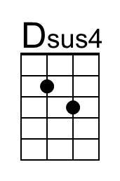 |  | 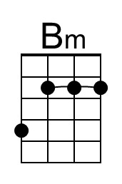 | 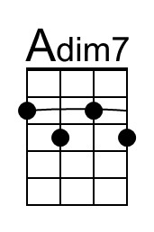 | Bari | 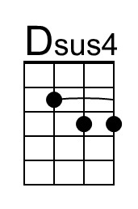 |  | 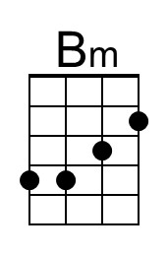 | 