**I'm Going to Go Back There Someday (Paul Williams / Kenny Ascher)**

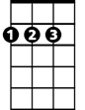

D

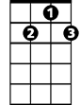

G7

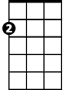

Am



C

**C G7 Am D**

This looks familiar, vaguely familiar,

**C G7 Am D**

Almost unreal, yet, it's too soon to feel yet.

**F G Em7 A**

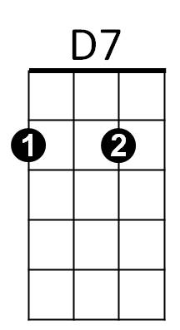Close to my soul, and yet so far away.



G

F

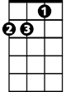

Dm

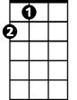

A

Em7

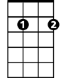

**Dm G7 C F C**

I'm going to go back there someday

**C G7 Am D**

Sun rises, night falls, sometimes the sky calls.

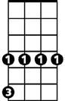

Dbm

**C G7 Am D**

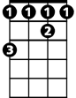

F#

Is that a song there, and do I belong there?

**F G Em7 A**

I've never been there, but I know the way.

**Dm G7 C F C**

I'm going to go back there someday

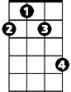

F#m

**Am D G**

Come and go with me, it's more fun to share,

**Am D G**

We'll both be completely at home in midair.

**Dbm F# F#m**

We're flyin', not walkin', on featherless wings.

**G Dm F G7**

**BARITONE**

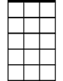

Em7



G

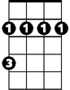

F#m

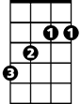

F#



Dbm

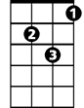

Dm



A



D



D7



F

C



Am

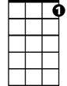

G7

We can hold onto love like invisible strings.

**C G7 Am D**

There's not a word yet for old friends who've just met.

**C G7 Am D**

Part heaven, part space, or have I found my place?

**F G Em A**

You can just visit, but I plan to stay.

**Dm G7 C F C**

I'm going to go back there someday

**Dm G7 C**

I'm going to go back there someday

**I'm Going to Go Back There Someday (Paul Williams / Kenny Ascher)**



A

Em

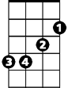

G

**G D7 Em A**

This looks familiar, vaguely familiar,

**G D7 Em A**

Almost unreal, yet, it's too soon to feel yet.

**C D Bm7 E7**

Close to my soul, and yet so far away.

E7

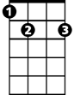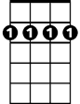

Bm7



D



C

**Am D7 G C G**

I'm going to go back there someday

**G D7 Em A**

Sun rises, night falls, sometimes the sky calls.

**G D7 Em A**



Bm

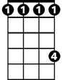

C#

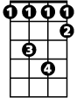

Abm



Am

Is that a song there, and do I belong there?

**C D Bm7 E7**

I've never been there, but I know the way.

**Am D7 G C G**

I'm going to go back there someday

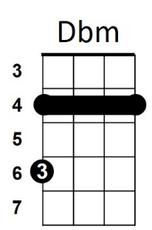

**Em A D**

Come and go with me, it's more fun to share,

**Em A D**

We'll both be completely at home in midair.

**Abm C# Dbm**

We're flyin', not walkin', on featherless wings.

**D Am C D7**

**BARITONE**



Em



D7



G

We can hold onto love like invisible strings.

**G D7 Em A**

There's not a word yet for old friends who've just met.

**G D7 Em A**

Part heaven, part space, or have I found my place?

**C D Bm7 E7**

Bm7



D

C



A

You can just visit, but I plan to stay.

**Am D7 G C G**

I'm going to go back there someday

**Am D7 G**

I'm going to go back there someday



Abm



C#

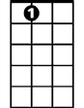

E7



Am

Bm



Dbm