**I'm My Own Grandpa (Dwight B Latham / Moe Jaffe)**

**C**

Now many many years ago



C

**G7**

When I was twenty three

I was married to a widow

**C**

Who was pretty as could be

**C7**

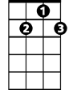

G7

This widow had a grown-up daughter

**F**

Who had hair of red

**D7**

My father fell in love with her

**G7**

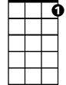

C7

And soon the two were wed

**C**

This made my dad my son-in-law

**G7**

And really changed my life

My daughter was my mother

F



**C**

Cause she was my father's wife

**C7**

To complicate the matter

**F**

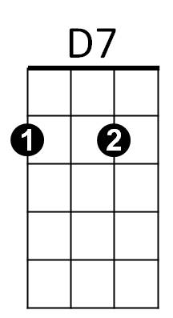Even though it brought me joy

**D7**

I soon became the father

**G7**

Of a bouncing baby boy

**C**

My little baby then became

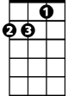

Dm

**G7**

A brother-in-law to dad

And so became my uncle

**C**

Though it made me very sad

**C7**

For if he was my uncle

**F**

That also made him the brother

**D7**

Of the widow's grown-up daughter

**G7**

Who of course was my step-mother

**C**

My father's wife then had a son

**BARITONE**

**G7**

C



That kept them on the run

And he became my grandchild

**C**

For he was my daughter's son

**C7**

My wife is now my mother's mother



G7

**F**

And it makes me blue

**D7**

Because she is my wife

**G7**

She's my grandmother too

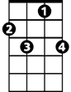

C7

**C**

Now if my wife is my grandmother

**G7**

Then I am her grandchild

And every time I think of it



F

**C**

It nearly drives me wild

**C7**

For now I have become

**F**

The strangest case you ever saw

**D7**



D7

As the husband of my grandmother

**G7**

I am my own grandpa

**Chorus: (2x)**

**C G7 C C7**

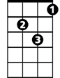

Dm

I'm my own grandpa

**F Dm**

I'm my own grandpa

**C**

It sounds funny I know

**F Dm**

But it really is so

**C G7 C**

I'm my own grandpa