I'm So Lonesome I Could Cry (Hank Williams) (G)
(3/4 time)

G  Hear that lonesome whippoorwill  G7  He sounds too blue to fly  C G  The midnight train is whining low  D7 G  I'm so lonesome I could cry  G  I've never seen a night so long  G7  When time goes crawling by  C G  The moon just went behind a cloud  D7 G  To hide its face and cry  G  Did you ever see a robin weep  G7  When leaves begin to die  C G  That means he's lost the will to live  D7 G  I'm so lonesome I could cry  G  The silence of a falling star  G7  Lights up a purple sky  C G  And as I wonder where you are  D7 G  I'm so lonesome I could cry |  |  |  |  |  |  | 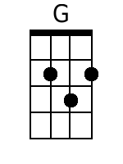
 |  |  |  |  |  |  | 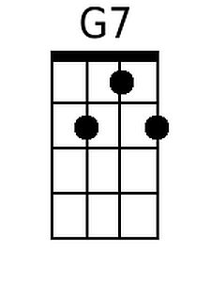
 |  |  |  |  |  |  | 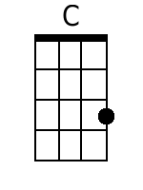
 |  |  |  |  |  |  | 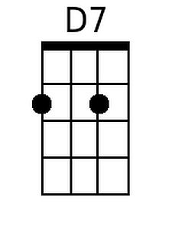
Bari
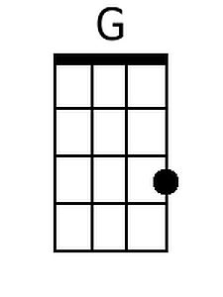 | 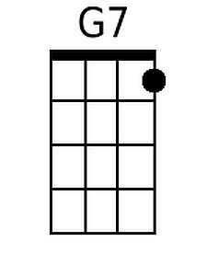 | 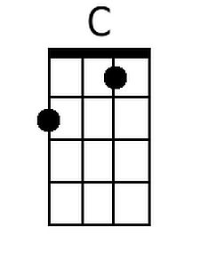 | 