**I'm Thinking Tonight of My Blue Eyes (Ralph Stanley)**

**Intro: Chords for chorus**

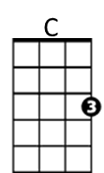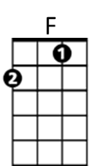

**C F**

'Twould been better for us both had we never

**G G7 C**

In this wide, wicked world, had never met

**F**

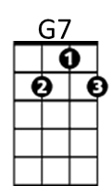For the pleasure we both seemed to gather



G

**G G7 C**

I'm sure, love, I'll never forget

**Chorus:**

**C F**

Oh, I'm thinking tonight of my blue eyes

**G G7 C**

Who is sailing far over the sea

**F**

Oh I'm thinking tonight of him only (Oh, I'm thinking tonight of my blue eyes)*

**G G7 C**

And I wonder if he ever thinks of me

**C F**

Oh, you told me once, dear, that you loved me

**BARITONE**



F

**G G7 C**

C



You vowed that we never would part

**F**

But a link in the chain has been broken

**G G7 C**

Leaving me with a sad and aching heart

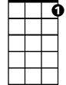

G7



G

**(Chorus)**

**C F**

When the cold, cold grave shall enclose me

**G G7 C**

Will you come dear, and shed just one tear

**F**

And say to the strangers around you

**G G7 C**

A poor heart you have broken lies here

**(Chorus)** * Original line used in first recording

**I'm Thinking Tonight of My Blue Eyes (Ralph Stanley)**

**Intro: Chords for chorus**

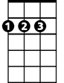

D



**G C**

'Twould been better for us both had we never

**D D7 G**

In this wide, wicked world, had never met

**C**

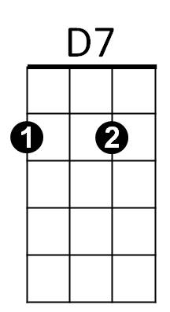For the pleasure we both seemed to gather



G

**D D7 G**

I'm sure, love, I'll never forget

**Chorus:**

**G C**

Oh, I'm thinking tonight of my blue eyes

**D D7 G**

Who is sailing far over the sea

**C**

Oh I'm thinking tonight of him only (Oh, I'm thinking tonight of my blue eyes)*

**D D7 G**

And I wonder if he ever thinks of me

**G C**

Oh, you told me once, dear, that you loved me

**BARITONE**

**D D7 G**

C



D

You vowed that we never would part

**C**

But a link in the chain has been broken

**D D7 G**

Leaving me with a sad and aching heart



G

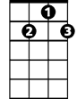

D7

**(Chorus)**

**G C**

When the cold, cold grave shall enclose me

**D D7 G**

Will you come dear, and shed just one tear

**C**

And say to the strangers around you

**D D7 G**

A poor heart you have broken lies here

**(Chorus)** * Original line used in first recording