I've Been Working On My Costume (C)
I've Been Working on My Costume (in F)

C C7 F C  I’ve been working on my costume all the live long day  C D7 G  I’ve been working on my costume, watch out, I’m on my way  G7 C F E7  When you see me at your doorbell, you’ll know what I mean  F C G C  I’ve been working on my costume, be-cause it’s Hallo-ween.  1st Chorus  C F  Little bit of this, little bit of that  G7 C  Itty bitty pillow to make me fat  C F  Wig upon my head, sheet from off my bed  G7 C  All because it’s Hallo-ween  Repeat First Verse.  2nd Chorus  C F  Funny kind of nose, funny kind of beard  G7 C  Don’t know what I am but I look weird  C F  Makeup on my face, powder every place  G7 C  All because it’s Hallo-ween  Repeat Chorus  Spoken: Trick- or - Treat ! ! ! |  |  |  |  |  |  | 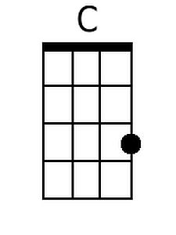
 |  |  |  |  |  |  | 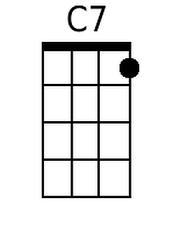
 |  |  |  |  |  |  | 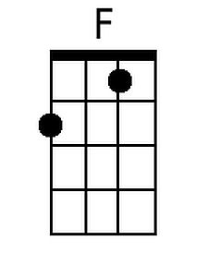
 |  |  |  |  |  |  | 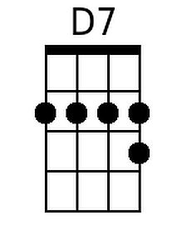
 |  |  |  |  |  |  | 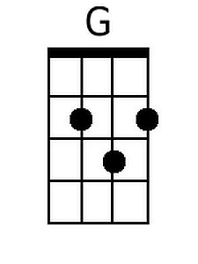
 |  |  |  |  |  |  | 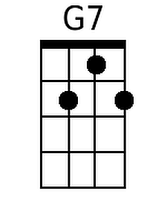
 |  |  |  |  |  |  | 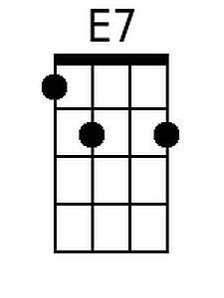
Baritone
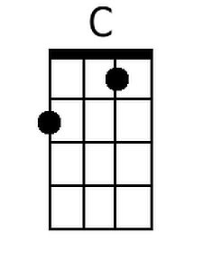 | 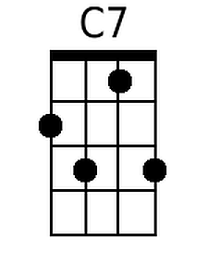 | 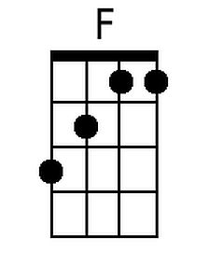 | 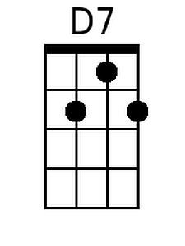 | 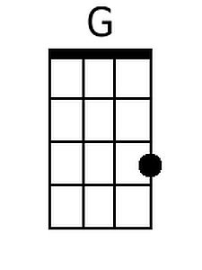 | 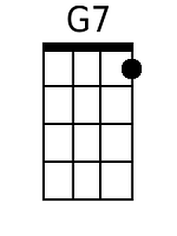 | 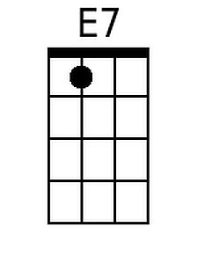

I've Been Working On My Costume (F)
I've Been Working on My Costume (in F)

F F7 Bb F
I've been working on my costume all the live long day
F G7 C
I've been working on my costume, watch out, I'm on my way
C7 F Bb A7
When you see me at your doorbell, you'll know what I mean
Bb F C F
I've been working on my costume, be-cause it's Hallo-ween.

1st Chorus
F Bb
Little bit of this, little bit of that
C7 F
Itty bitty pillow to make me fat
F Bb
Wig upon my head, sheet from off my bed
C7 F
All because it's Hallo-ween

Repeat First Verse.

2nd Chorus
F Bb
Funny kind of nose, funny kind of beard
C7 F
Don't know what I am but I look weird
F Bb
Makeup on my face, powder every place
C7 F
All because it's Hallo-ween

Repeat Chorus

Spoken: Trick- or - Treat ! ! !

 |  |  |  |  |  |  | 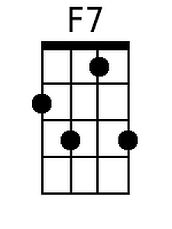
 |  |  |  |  |  |  | 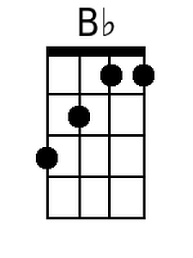
 |  |  |  |  |  |  | 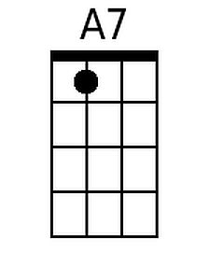
Baritone
 | 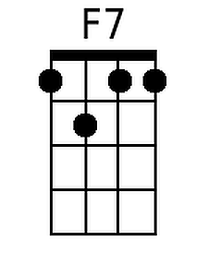 | 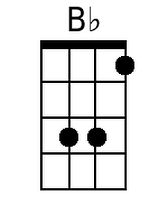 |  |  |  | 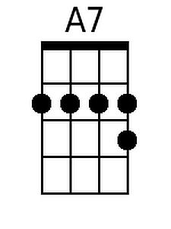

I've Been Working On My Costume (G)
I've Been Working on My Costume (in F)

G G7 C G  I've been working on my costume all the live long day  G A7 D  I've been working on my costume, watch out, I'm on my way  D7 G C B7  When you see me at your doorbell, you'll know what I mean  C G D G  I've been working on my costume, be-cause it's Hallo-ween.  1st Chorus  G C  Little bit of this, little bit of that  D7 G  Itty bitty pillow to make me fat  G C  Wig upon my head, sheet from off my bed  D7 G  All because it's Hallo-ween  Repeat First Verse.  2nd Chorus  G C  Funny kind of nose, funny kind of beard  D7 G  Don't know what I am but I look weird  G C  Makeup on my face, powder every place  D7 G  All because it's Hallo-ween  Repeat Chorus  Spoken: Trick- or - Treat ! ! ! |  |  |  |  |  |  | 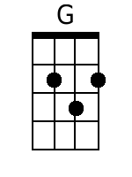
 |  |  |  |  |  |  | 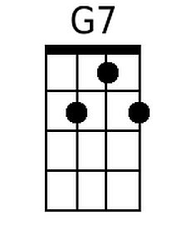
 |  |  |  |  |  |  | 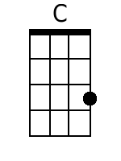
 |  |  |  |  |  |  | 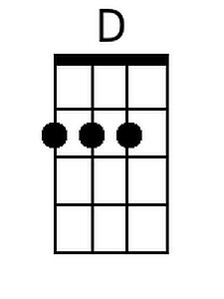
 |  |  |  |  |  |  | 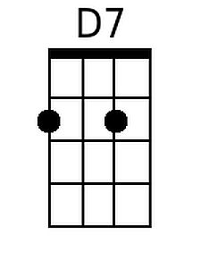
 |  |  |  |  |  |  | 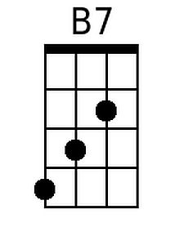
Baritone
 | 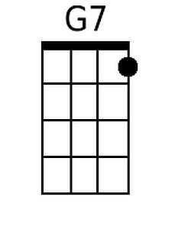 |  | 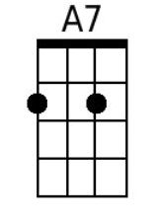 | 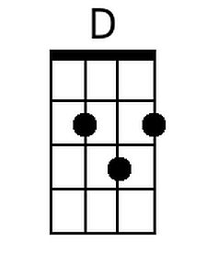 |  | 