**If I Were a Rich Man (Sheldon Harnick and Jerry Bock)**

***Intro: G***



G

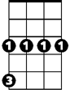

Cm

*Dear God, you made many, many poor people.*

*I realize, of course, that it's no shame to be poor~ But it's no great honor, either.*

*So what would have been so terrible if I had a small fortune?*

**CHORUS:**

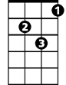

Gm

**G**

If I were a rich man, Daidle deedle daidle, Daidle daidle deedle daidle dum

**Cm Gm A7 D**

All day long I'd biddy biddy bum, if I were a wealthy man

**G**

I wouldn't have to work hard, Daidle deedle daidle, Daidle daidle deedle daidle dum

**Cm Gm D7 G**

If I were a biddy biddy rich, Daidle deedle daidle daidle man

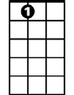

A7

**Cm F7 Bb Gm**

I'd build a big tall house with rooms by the dozen, right in the middle of the town

**Cm F G (E7)**

A fine tin roof with real wooden floors below

**Cm F Bb Gm**

There would be one long staircase just going up, and one even longer coming down,

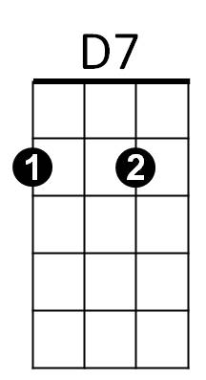 **Cm Gdim D**

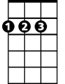

D



Bb

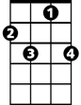

F7

And one more leading nowhere, just for show

**Cm F7**

I'd fill my yard with chicks and turkeys and geese

**Bb Gm**

And ducks for the town to see and hear

**Cm F G (E7)**

Squawking just as noisily as they can

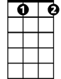

Gdim

F



E7

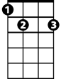

**Cm F**

And each loud "cheep" and "squawk" and "honk" and "quack"

**Bb Gm**

Would land like a trumpet on the ear,

**Cm Gdim D**

As if to say, "Here lives a wealthy man"

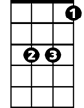

Eb

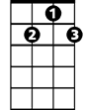

G7

**(Chorus)**

**Cm F7 Bb Gm**

I see my wife, my Golde, looking like a rich man's wife with a proper double chin

**Cm F G (E7)**

Supervising meals to her heart's delight

**Cm F Bb Gm**

I see her putting on airs and strutting like a peacock, Oh what a happy mood she's in

Fm7

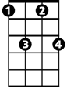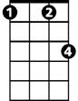

Fm

**Cm Gdim D**

Screaming at the servants, day and night

**(Chorus)**

***G7 Eb***

*The most important men in town will come to fawn on me*

***Cm***

*They will ask me to advise them, like a Solomon the Wise*

***Fm Fm7***

*"If you please, Reb Tevye?" "Pardon me, Reb Tevye?"*

***G***

*Posing problems that would cross a rabbi's eyes*

*Ya va voy, ya va voy voy vum*

**Cm F Bb Gm**

And it won't make one bit of difference if I answer right or wrong

**Cm Gdim D**

When you're rich they think you really know.

**Cm F7 Bb Gm**

If I were rich, I'd have the time that I lack to sit in the synagogue and pray,

**Cm F G (E7)**

And maybe have a seat by the Eastern wall,

**Cm F Bb Gm**

And I'd discuss the holy books with the learned men, seven hours every day

**Cm Gdim D**

That would be the sweetest thing of all ~ Oy!

**G**

If I were a rich man, Daidle deedle daidle, Daidle daidle deedle daidle dum

**Cm Gm A7 D**

All day long I'd biddy biddy bum, if I were a wealthy man

**G**

I wouldn't have to work hard, Daidle deedle daidle, Daidle daidle deedle daidle dum

**Cm Gm**

Lord who made the lion and the lamb,

**Cm Gm**

You decreed I should be what I am

**Cm Gm**

Would it spoil some vast, eternal plan,

**D D7 G**  **D7 G**

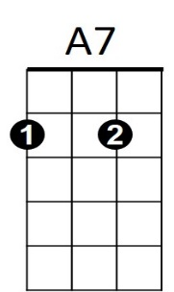If ~ I were a weal-thy man?



D



D7

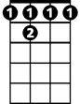

F 7

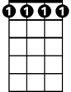

Fm7

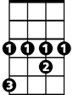

Eb

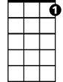

G7

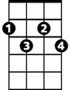

Gdim



E7



Gm



G



Cm



Bb



F

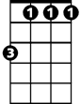

Fm

**BARITONE**