**If You Could Read My Mind (Gordon Lightfoot)**

**G**

F



G

If you could read my mind love –

**F**

What a tale my thoughts could tell

**G**

Just like an old time movie –

**F**

'bout a ghost from a wishin' well

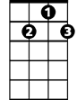

G7



C

**G G7 C**

In a castle dark or a fortress strong

**D Em**

With chains upon my feet -

**C G**

You know that ghost is me

**C G**

And I will never be set free

Em

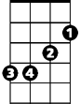

**Am7 D G**

As long as I'm a ghost that you can't see

**G**

If I could read your mind love -

**F**

What a tale your thoughts could tell

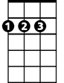

D

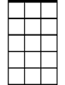

Am7

**G**

Just like a paperback novel -

**F**

The kind that drugstores sell

**G G7**

When you reach the part

**C**

Where the heartaches come

**D Em C G**

The hero would be me - But heroes often fail

**C G**

And you won't read that book again

**Am7 D G**

Because the ending's just too hard to take

**G F G F (melody for first two lines of verse)**

**G G7 C**

I'd walk away - like a movie star

**D Em**

Who gets burned in a three way script

**C G**

Enter number two -

**C G**

A movie queen to play the scene

**Am7 D Em**

Of bringing all the good things out in me

**C G**

But for now love, let's be real

**C G**

I never thought I could act this way

**Am7 D**

And I've got to say that I just don't get it

**C G**

I don't know where we went wrong

**Am7 D G**

But the feelin's gone and I just can't get it back

**G**

If you could read my mind love –

**F**

What a tale my thoughts could tell

**G**

Just like an old time movie –

**F**

'bout a ghost from a wishin' well

**G G7 C**

In a castle dark or a fortress strong

**D Em**

With chains upon my feet -

**C G**

But stories always end

**C G**

And if you read between the lines

**Am7 D Em**

You'll know that I'm just tryin' to understand

**C G**

The feelings that you lack

**C G**

I never thought I could feel this way

**Am7 D**

And I've got to say that I just don't get it

**C G**

I don't know where we went wrong

**Am7 D G**

But the feelin's gone and I just can't get it back

**G F G**

**BARITONE**

C



G



F

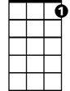

G7

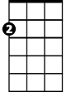

Em

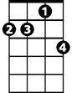

Am7



D