**I'll Follow the Sun (John Lennon / Paul McCartney)**

**Intro: C F**  **C**



C

F



G

**G F C D7**

One day you'll look to see I've gone

**C Am D7 G7 C F C**

For tomorrow may rain so I'll follow the Sun

**G F C D7**

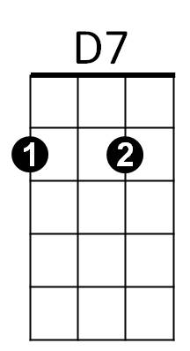Some day you'll know I was the one

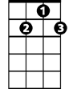

G7

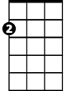

Am

**C Am D7 G7 C C7**

But tomorrow may rain so I'll follow the sun.

**Reprise:**

**F**

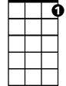

C7

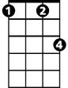

Fm

And now the time has come

**Fm C C7**

And so my love I must go

**F**

And though I lose a friend

**Fm C D7**

In the end you will know, Oh -

**G F C D7**

One day you'll find that I have gone

**BARITONE**

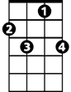

C7

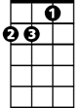

Am



G



F

C



G7



D7

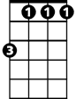

Fm

**C Am D7 G7 C F C**

But tomorrow may rain so I'll follow the Sun

**Solo: G F C D7 (1st line of verse melody)**

**C Am D7 G7 C C7**

Yes, tomorrow may rain so I'll follow the sun.

**(Reprise)**

**Ending:**

**G F C D7**

One day you'll find that I have gone

**C Am D7 G7 C F C**

But tomorrow may rain so I'll follow the Sun