**I’m So Lonesome I Could Cry (Hank Williams) (3/4 time)**

**C**

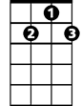

G7

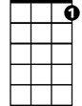

C7

F



C

Hear that lonesome whippoorwill

**C7**

He sounds too blue to fly

**F C**

The midnight train is whining low

**G7 C**

I'm so lonesome I could cry

**C**

I've never seen a night so long

**C7**

When time goes crawling by

**F C**

The moon just went behind a cloud

**G7 C**

To hide its face and cry

**C**

Did you ever see a robin weep

**C7**

**BARITONE**



G7

When leaves begin to die



F

C

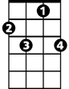

C7

**F C**

That means he's lost the will to live

**G7 C**

I'm so lonesome I could cry

**C**

The silence of a falling star

**C7**

Lights up a purple sky

**F C**

And as I wonder where you are

**G7 C**

I'm so lonesome I could cry