**In My Life (Lennon / McCartney)**

**C G Am C7**

There are places I’ll remember

**F Fm C**

All my life though some have changed

**C G Am C7**

Some forever not for better

**F Fm C**

Some have gone and some remain

**Am Dm**

All these places have their moments

**Bb C**

With lovers and friends I still can recall

**Am Dm**

Some are dead and some are living

**F Fm C**

In my life I’ve loved them all

**C G Am C7**

But of all these friends and lovers

**F Fm C**

There is no one compares with you

**C G Am C7**

And these memories lose their meaning

**BARITONE**

**F Fm C**

When I think of love as something new

**Am Dm**

Though I know I’ll never lose affection

**Bb C**

For people and things that went before

**Am Dm**

I know I’ll often stop and think about them

**F Fm C**

In my life I love you more

**Solo: C G Am C7 / F Fm C 2x**

**Am Dm**

Though I know I’ll never lose affection

**Bb C**

For people and things that went before

**Am Dm**

I know I’ll often stop and think about them

**F Fm C**

In my life I love you more

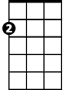

Am

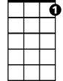

C7



C



G

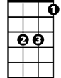

Bb

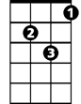

Dm

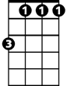

Fm



F

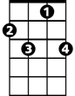

C7

C



G

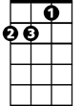

Am



Bb



Dm

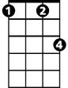

Fm

F

