In the Good Old Summertime (Ren Shields and George Evans, 1902)
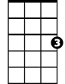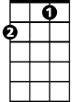3 / 4 Time (Waltz) – Key of C
C7
C
F
C C7
There's a time each year, that we always hold dear,
F C
Good old summer time.
C Cm
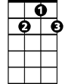With the birds and the trees'es, and sweet scent-ed breez-es,
G
G7
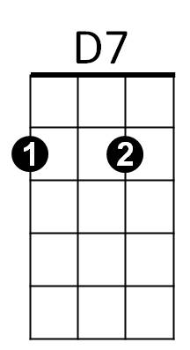
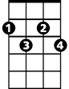G D7 G7
F#dim
Good old summer time.
C
When you day's work is over, then you are in clover,
F C
And life is one beautiful rhyme,
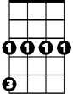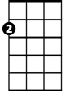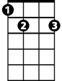 F C F#dim C
Cm
Am
E7
No trouble an-noying, each one is en-joying,
Cm G D7 G7
The good old summer time.

Chorus:
C -C7 F C
In the good old summertime, in the good old summer-time,
E7 Am D7 G7
BARITONE
Strolling thru' a shady lane, with your baby mine.
C
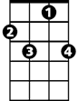 C C7
C7
You hold her hand and she holds yours,
F C
And that's a very good sign
E7 Am D7 G7 C
That she's your tootsie wootsie, in the good, old summer-time.
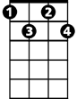
G7
F#dim
D7
F
C C7
To swim in the pool, you'd play "hooky" from school
F C
Good old summer time;
C Cm
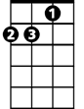You play "ring-a rosie," with Jim, Kate and Josie,
Am
E7
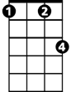G D7 G7
G
Cm
Good old summer time
C
Those days full of pleasure, we now fondly treasure,
F C
When we never thought it a crime
F C F#dim C -Cm
To go stealing cherries, with face brown as berries,
G D7 G7
Good old summer time. Chorus.
In the Good Old Summertime (Ren Shields and George Evans, 1902)
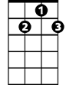3/4 Time (Waltz) - Key of G
G
G7
G G7
There's a time each year, that we always hold dear,
C G
Good old summer time.
G Gm
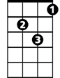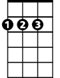With the birds and the trees'es, and sweet scent-ed breez-es,
C
Gm
A7
D
D A7 D7
Good old summer time.
G
When you day's work is over, then you are in clover,
C G
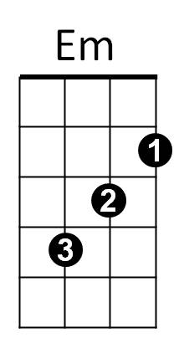
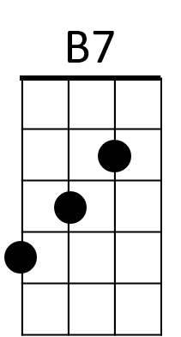
And life is one beautiful rhyme,
C#dim
C G C#dim G
No trouble an-noying, each one is en-joying,
Gm D A7 D7
The good old summer-time.

Chorus:
G G7 C G
In the good old summertime, in the good old summer-time,
B7 Em A7 D7
Strolling thru' a shady lane, with your baby mine.
G G7
BARITONE
You hold her hand and she holds yours,
G
G7
C G
And that's a very good sign
B7 Em A7 D7 G
That she's your tootsie wootsie, in the good old summer-time.

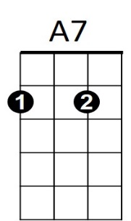
G G7
D
Gm
C
To swim in the pool, you'd play "hooky" from school
C G
Good old summer time;
G Gm
You play "ring-a rosie," with Jim, Kate and Josie,
D A7 D7
Good old summer time.
C#dim
Em
B7
D7
G
Those days full of pleasure, we now fondly treasure,
C G
When we never thought it a crime
C G C#dim G -Gm
To go stealing cherries, with face brown as berries,
D A7 D7
Good old summer time. Chorus

