**In the Good Old Summertime (Ren Shields and George Evans, 1902)**

**3 / 4 Time (Waltz) – Key of C**

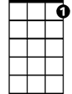

C7

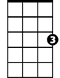

C

F

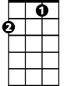

**C C7**

There's a time each year, that we always hold dear,

**F C**

Good old summer time.

**C Cm**

With the birds and the trees'es, and sweet scent-ed breez-es,



G

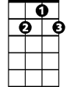

G7

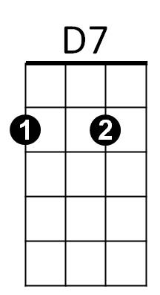**G D7 G7**

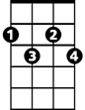

F#dim

Good old summer time.

**C**

When you day's work is over, then you are in clover,

**F C**

And life is one beautiful rhyme,

**F C F#dim C**

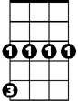

Cm

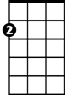

Am

E7

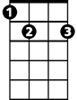

No trouble an-noying, each one is en-joying,

**Cm G D7 G7**

The good old summer time.

**Chorus:**

**C -C7 F C**

In the good old summertime, in the good old summer-time,

**E7 Am D7 G7**

**BARITONE**

Strolling thru' a shady lane, with your baby mine.

C



**C C7**

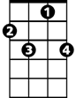

C7

You hold her hand and she holds yours,

**F C**

And that's a very good sign

**E7 Am D7 G7 C**

That she's your tootsie wootsie, in the good, old summer-time.



G7

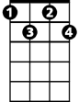

F#dim



D7



F

**C C7**

To swim in the pool, you'd play "hooky" from school

**F C**

Good old summer time;

**C Cm**

You play "ring-a rosie," with Jim, Kate and Josie,

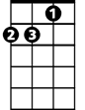

Am

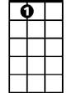

E7

**G D7 G7**



G

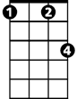

Cm

Good old summer time

**C**

Those days full of pleasure, we now fondly treasure,

**F C**

When we never thought it a crime

**F C F#dim C -Cm**

To go stealing cherries, with face brown as berries,

**G D7 G7**

Good old summer time. **Chorus.**

**In the Good Old Summertime (Ren Shields and George Evans, 1902)**

**3/4 Time (Waltz) - Key of G**



G

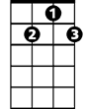

G7

**G G7**

There's a time each year, that we always hold dear,

**C G**

Good old summer time.

**G Gm**

With the birds and the trees'es, and sweet scent-ed breez-es,



C

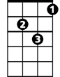

Gm

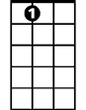

A7

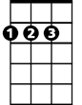

D

**D A7 D7**

Good old summer time.

**G**

When you day's work is over, then you are in clover,

**C G**

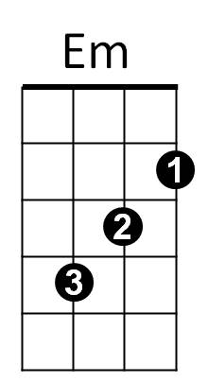And life is one beautiful rhyme,

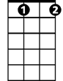

C#dim

**C G C#dim G**

No trouble an-noying, each one is en-joying,

**Gm D A7 D7**

The good old summer-time.

**Chorus:**

**G G7 C G**

In the good old summertime, in the good old summer-time,

**B7 Em A7 D7**

Strolling thru' a shady lane, with your baby mine.

**G G7**

**BARITONE**

You hold her hand and she holds yours,



G



G7

**C G**

And that's a very good sign

**B7 Em A7 D7 G**

That she's your tootsie wootsie, in the good old summer-time.

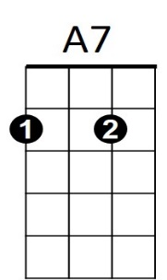 **G G7**



D



Gm

C



To swim in the pool, you'd play "hooky" from school

**C G**

Good old summer time;

**G Gm**

You play "ring-a rosie," with Jim, Kate and Josie,

**D A7 D7**

Good old summer time.



C#dim



Em

B7



D7

**G**

Those days full of pleasure, we now fondly treasure,

**C G**

When we never thought it a crime

**C G C#dim G -Gm**

To go stealing cherries, with face brown as berries,

**D A7 D7**

Good old summer time. **Chorus**