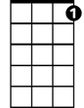
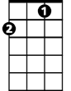
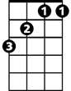
Easter Parade (Irving Berlin 1933)
C7
F
Bb
F C7 F
Never saw you look quite so pretty before
F C7 F
Never saw you dress quite so handsome what’s more
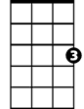
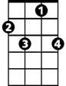
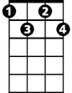
Bb C7 F Bb
C
F7
Bdim
I could hardly wait to keep our date
Gm F C
This lovely Easter Morning
F Bdim C C7
And my heart beat fast as I came through the door
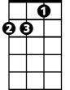
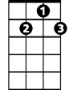
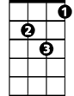
Dm
G7
Gm
F F7 Bb Bdim
In your Easter bonnet, with all the frills upon it
F C7 Dm G7 C7
You’ll be the grandest lady in the Easter pa-rade
F C7 F7 Bb Bdim
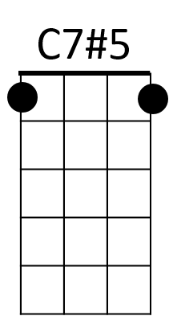
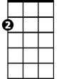
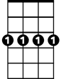
I’ll be all in clover, and when they look you over
Am
Cm7
F C7 Dm G7 C7 F
I’ll be the proudest fellow in the Easter pa-rade

Reprise:
F7 Cm7 F7 Bb
On the avenue, Fifth Avenue
Dm G7
BARITONE
The photographers will snap us
C Bb Am C7 C7#5
And you’ll find that you’re in the rotogravure, Oh,

F C7 F7 Bb Bdim
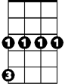
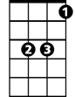
I could write a sonnet a-bout your Easter bonnet
F
Gm
Bb
C7
F C7 Dm G7 C7 F
And of the girl I’m taking to the Easter pa-rade

Repeat from Reprise

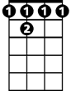
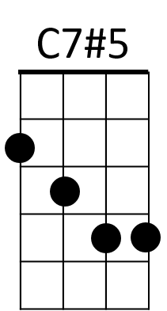
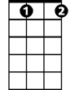
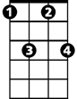
C
Dm
Am
G7
F 7
Bdim
Cm7

