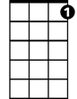
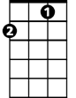
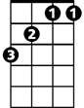
Easter Parade (Irving Berlin 1933)
C7
F
Bb
F C7 F
Never saw you look quite so pretty before
F C7 F
Never saw you dress quite so handsome what’s more
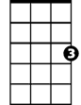
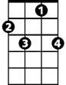
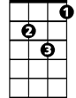
Bb C7 F Bb
C
F7
Gm
I could hardly wait to keep our date\
Gm F C
This lovely Easter Morning
F Gm C Gm C
And my heart beat fast as I came through the door
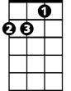
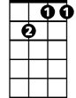
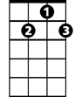
Dm
Gm7
G7
F C7 F F7 Gm7
In your Easter bonnet, with all the frills upon it
F C7 F Dm G7 Gm C7
You’ll be the grandest lady in the Easter pa-rade
F C7 F F7 Gm7
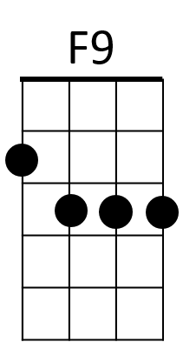
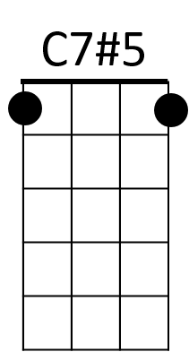
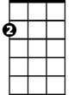
I’ll be all in clover, and when they look you over
Am
F C7 F Dm G7 C7 F F7
I’ll be the proudest fellow in the Easter pa-rade

Reprise:
F9 Bb
On the avenue, Fifth Avenue
Dm G7
BARITONE
The photographers will snap us
C Bb Am C7 C7#5
And you’ll find that you’re in the rotogravure, Oh,

F C7 F F7 Gm7
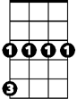
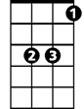
I could write a sonnet a-bout your Easter bonnet
F
Gm
Bb
C7
F C7 F Dm G7 C7 F
And of the girl I’m taking to the Easter pa-rade

Repeat from Reprise

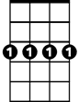
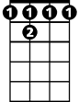
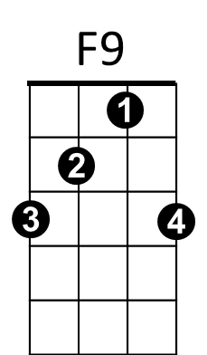
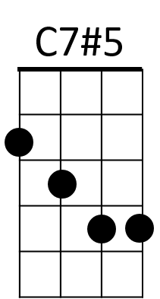
C
Dm
Am
G7
Gm7
F 7

