In the Hall of the Halloween King (Am)
Adaptation by Jennifer Campbell Garthwaite, Ukulele Band of Alabama
(In the style of In The Hall of the Mountain King, by Edvard Grieg)

Song starts quiet and slow.
Gain speed and volume, getting more frenzied as you go,
so you sound like a banshee at the end!

Intro (Chords to 1st verse)  Am  On October thirty one, when the sun goes to set.  Am C  It's the night of Halloween when fun is at its best.  Am  Black cats, ghosts, and princess fair, holding hands everywhere,  Am C  It's the night of Halloween there's magic in the air.  Chorus  E  Witch's shadow on the moon, casting spells, flying high,  E Am E  Spooky shadows everywhere, it's such a scary night.  E  Trick or treating with our friends, bag is full, candy sweet,  E Am E  Trick or treat and smell my feet, give something good to eat!  Am  Vampire with his pointy teeth, glowing eyes, werewolf howl,  Am C  Bats are flying through the air, with monsters on the prowl,  Am  Something grabbing at my feet, spider web, crawling skin,  Am C  Something whispering my name, so let the fun begin. Chorus  Outro  Am ↓ ↓ Am ↓ ↓ Am E Am ↓  Halloween! Halloween! This is Halloween!  Am ↓ ↓ Am ↓ ↓ Am E Am ↓  Halloween! Halloween! This is Halloween!  Am ↓ ↓  Halloween! (Evil monster snarl, howls, banshee screams, cackles) | 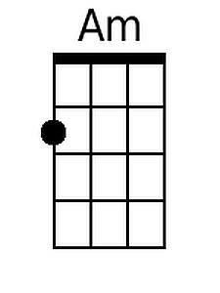
 | 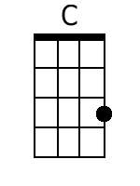
 | 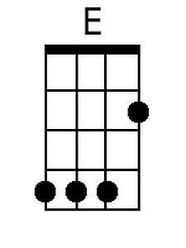
 | Baritone
 | 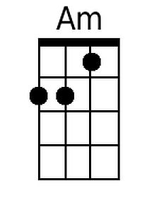
 | 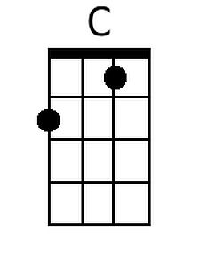
 | 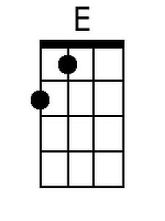


In the Hall of the Halloween King (Em)
Adaptation by Jennifer Campbell Garthwaite, Ukulele Band of Alabama
(In the style of In The Hall of the Mountain King, by Edvard Grieg)

Song starts quiet and slow.
Gain speed and volume, getting more frenzied as you go,
so you sound like a banshee at the end!

Intro (Chords to 1st verse)  Em  On October thirty one, when the sun goes to set.  Em G  It's the night of Halloween when fun is at its best.  Em  Black cats, ghosts, and princess fair, holding hands everywhere,  Em G  It's the night of Halloween there's magic in the air.  Chorus  B  Witch's shadow on the moon, casting spells, flying high,  B Em B  Spooky shadows everywhere, it's such a scary night.  B  Trick or treating with our friends, bag is full, candy sweet,  B Em B  Trick or treat and smell my feet, give something good to eat!  Em  Vampire with his pointy teeth, glowing eyes, werewolf howl,  Em G  Bats are flying through the air, with monsters on the prowl,  Em  Something grabbing at my feet, spider web, crawling skin,  Em G  Something whispering my name, so let the fun begin. Chorus  Outro  Em ↓ ↓ Em ↓ ↓ Em B Em ↓  Halloween! Halloween! This is Halloween!  Em ↓ ↓ Em ↓ ↓ Em B Em ↓  Halloween! Halloween! This is Halloween!  Em ↓ ↓  Halloween! (Evil monster snarl, howls, banshee screams, cackles) | 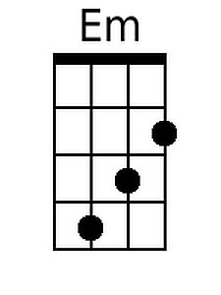
 | 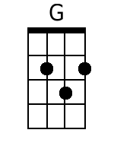
 | 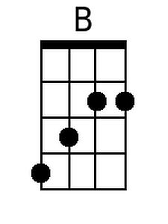
 | Baritone
 | 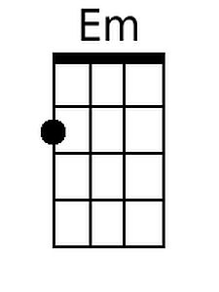
 | 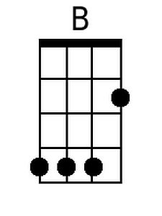
 | 