In the Hall of the Halloween King (Am)
Adaptation by Jennifer Campbell Garthwaite, Ukulele Band of Alabama
(In the style of In The Hall of the Mountain King, by Edvard Grieg)

Intro: Am Am C Am Am C  Am  On October thirty one, when the sun goes to set.  Am C  It's the night of Halloween when fun is at its best.  Am  Black cats, ghosts, and princess fair, holding hands everywhere,  Am C  It's the night of Halloween there's magic in the air.  E  Witch's shadow on the moon, casting spells, flying high,  E Am E  Spooky shadows everywhere, it's such a scary night.  E  Trick or treating with our friends, bag is full, candy sweet,  E Am E  Trick or treat and smell my feet, give something good to eat!  Am  Vampire with his pointy teeth, glowing eyes, werewolf howl,  Am C  Bats are flying through the air, with monsters on the prowl,  Am  Something grabbing at my feet, spider web, crawling skin,  Am C  Something whispering my name, so let the fun begin.  Chorus  Am// Am// Am E Am/  Halloween! Halloween! This is Halloween!  Am// Am// Am E Am/  Halloween! Halloween! This is Halloween!  Am//  Halloween! (Evil monster snarl, howls, banshee screams, cackles) |  |  |  |  |  |  | 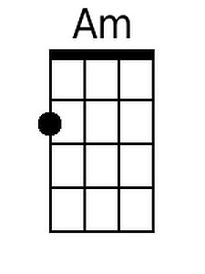
 |  |  |  |  |  |  | 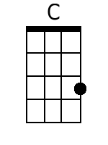
 |  |  |  |  |  |  | 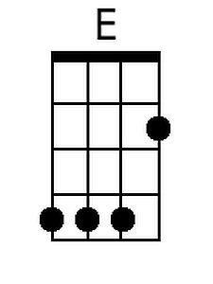
Baritone
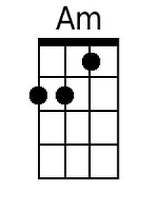 | 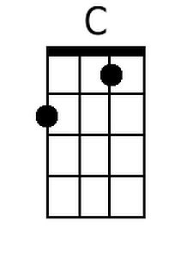 | 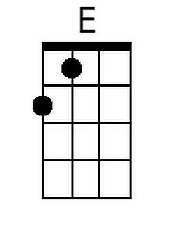

Ukulele Band of Alabama
www.ubalabama.weebly.com
www.facebook.com/ubalabama
In the Hall of the Halloween King (Em)
Adaptation by Jennifer Campbell Garthwaite, Ukulele Band of Alabama
(In the style of In The Hall of the Mountain King, by Edvard Grieg)

Intro: Em Em G Em Em G  Em  On October thirty one, when the sun goes to set.  Em G  It’s the night of Halloween when fun is at its best.  Em  Black cats, ghosts, and princess fair, holding hands everywhere,  Em G  It’s the night of Halloween there’s magic in the air.  B  Witch’s shadow on the moon, casting spells, flying high,  B Em B  Spooky shadows everywhere, it’s such a scary night.  B  Trick or treating with our friends, bag is full, candy sweet,  B Em B  Trick or treat and smell my feet, give something good to eat!  Em  Vampire with his pointy teeth, glowing eyes, werewolf howl,  Em G  Bats are flying through the air, with monsters on the prowl,  Em  Something grabbing at my feet, spider web, crawling skin,  Em G  Something whispering my name, so let the fun begin.  Chorus  Em// Em// Em B Em/  Halloween! Halloween! This is Halloween!  Em// Em// Em B Em/  Halloween! Halloween! This is Halloween!  Em//  Halloween! (Evil monster snarl, howls, banshee screams, cackles) |  |  |  |  |  |  | 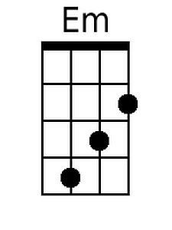
 |  |  |  |  |  |  | 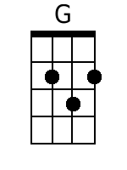
 |  |  |  |  |  |  | 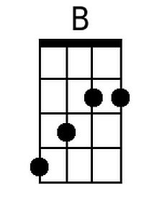
Baritone
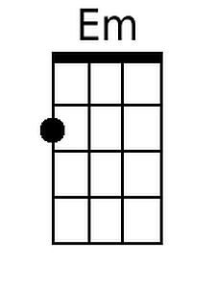 | 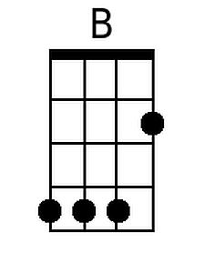 | 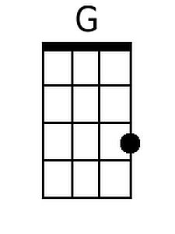

Ukulele Band of Alabama
www.ubalabama.weebly.com
www.facebook.com/ubalabama
In the Hall of the Halloween King (Bm)
Adaptation by Jennifer Campbell Garthwaite, Ukulele Band of Alabama
(In the style of In The Hall of the Mountain King, by Edvard Grieg)

Intro: Bm Bm D Bm Bm D  Bm  On October thirty one, when the sun goes to set.  Bm D  It's the night of Halloween when fun is at its best.  Bm  Black cats, ghosts, and princess fair, holding hands everywhere,  Bm D  It's the night of Halloween there's magic in the air.  F#  Witch's shadow on the moon, casting spells, flying high,  F# Bm F#  Spooky shadows everywhere, it's such a scary night.  F#  Trick or treating with our friends, bag is full, candy sweet,  F# Bm F#  Trick or treat and smell my feet, give something good to eat!  Bm  Vampire with his pointy teeth, glowing eyes, werewolf howl,  Bm D  Bats are flying through the air, with monsters on the prowl,  Bm  Something grabbing at my feet, spider web, crawling skin,  Bm D  Something whispering my name, so let the fun begin.  Chorus  Bm// Bm// Bm F# Bm/  Halloween! Halloween! This is Halloween!  Bm// Bm// Bm F# Bm/  Halloween! Halloween! This is Halloween!  Bm//  Halloween! (Evil monster snarl, howls, banshee screams, cackles) |  |  |  |  |  |  | 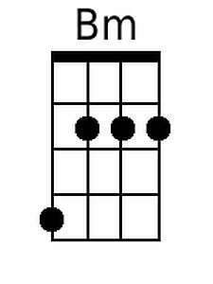
 |  |  |  |  |  |  | 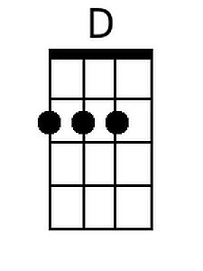
 |  |  |  |  |  |  | 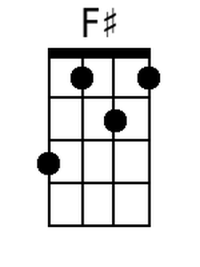
Baritone
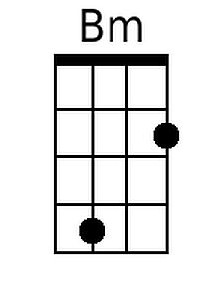 | 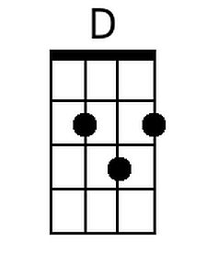 | 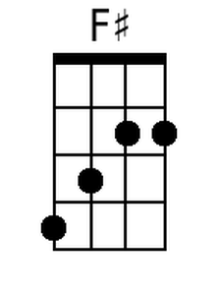

Ukulele Band of Alabama
www.ubalabama.weebly.com
www.facebook.com/ubalabama
In the Hall of the Halloween King (Dm)
Adaptation by Jennifer Campbell Garthwaite, Ukulele Band of Alabama
(In the style of In The Hall of the Mountain King, by Edvard Grieg)

Intro: Dm Dm F Dm Dm F  Dm  On October thirty one, when the sun goes to set.  Dm F  It's the night of Halloween when fun is at its best.  Dm  Black cats, ghosts, and princess fair, holding hands everywhere,  Dm F  It's the night of Halloween there's magic in the air.  A  Witch's shadow on the moon, casting spells, flying high,  A Dm A  Spooky shadows everywhere, it's such a scary night.  A  Trick or treating with our friends, bag is full, candy sweet,  A Dm A  Trick or treat and smell my feet, give something good to eat!  Dm  Vampire with his pointy teeth, glowing eyes, werewolf howl,  Dm F  Bats are flying through the air, with monsters on the prowl,  Dm  Something grabbing at my feet, spider web, crawling skin,  Dm F  Something whispering my name, so let the fun begin.  Chorus  Dm// Dm// Dm A Dm/  Halloween! Halloween! This is Halloween!  Dm// Dm// Dm A Dm/  Halloween! Halloween! This is Halloween!  Dm//  Halloween! (Evil monster snarl, howls, banshee screams, cackles) |  |  |  |  |  |  | 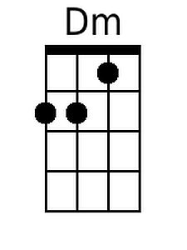
 |  |  |  |  |  |  | 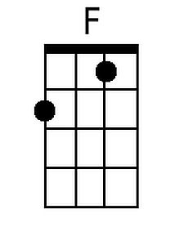
 |  |  |  |  |  |  | 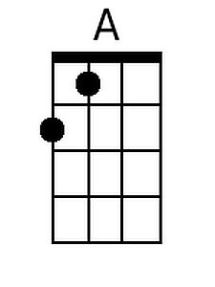
Baritone
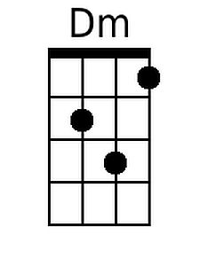 | 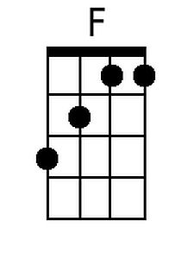 | 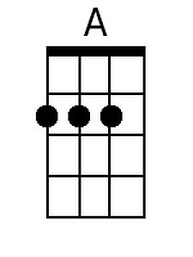

Ukulele Band of Alabama
www.ubalabama.weebly.com
www.facebook.com/ubalabama
In the Hall of the Halloween King (Fm)
Adaptation by Jennifer Campbell Garthwaite, Ukulele Band of Alabama
(In the style of In The Hall of the Mountain King, by Edvard Grieg)

Intro: Fm Fm Ab Fm Fm Ab  Fm  On October thirty one, when the sun goes to set.  Fm Ab  It's the night of Halloween when fun is at its best.  Fm  Black cats, ghosts, and princess fair, holding hands everywhere,  Fm Ab  It's the night of Halloween there's magic in the air.  C  Witch's shadow on the moon, casting spells, flying high,  C Fm C  Spooky shadows everywhere, it's such a scary night.  C  Trick or treating with our friends, bag is full, candy sweet,  C Fm C  Trick or treat and smell my feet, give something good to eat!  Fm  Vampire with his pointy teeth, glowing eyes, werewolf howl,  Fm Ab  Bats are flying through the air, with monsters on the prowl,  Fm  Something grabbing at my feet, spider web, crawling skin,  Fm Ab  Something whispering my name, so let the fun begin.  Chorus  Fm// Fm// Fm C Fm/  Halloween! Halloween! This is Halloween!  Fm// Fm// Fm C Fm/  Halloween! Halloween! This is Halloween!  Fm//  Halloween! (Evil monster snarl, howls, banshee screams, cackles) |  |  |  |  |  |  | 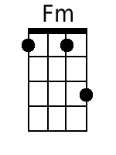
 |  |  |  |  |  |  | 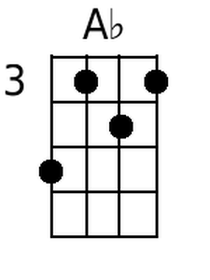
Baritone
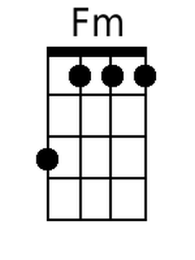 | 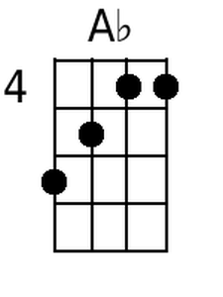

Ukulele Band of Alabama
www.ubalabama.weebly.com
www.facebook.com/ubalabama

