It Came Upon A Midnight Clear
Words: Edmund Hamilton Sears (1849); Music: Richard S. Willis
Ella Fitzgerald, It Came Upon A Midnight Clear from "Ella Fitzgerald's Christmas"

C F C  It came u-pon the midnight clear,  F D7 G - G7  That glorious song of old,  C F C  From angels bending near the earth  F G7 C  To touch their harps of gold;  E7 Am  “Peace on the earth good will to men  G7 D7 G - G7  From heaven's all gracious King -”  C F C  The world in solemn stillness lay  F G7 C  To hear the angels sing.  C F C  Still through the cloven skies they come  F D7 G - G7  With peaceful wings un-furled,  C F C  And still their heavenly music floats  F G7 C  O’er all the weary world;  E7 Am  A-bove its sad and lowly plains  G7 D7 G - G7  They bend on hovering wing,  C F C  And ever o’er its Babel-sounds  F G7 C  The blessed angels sing. | C F C  And ye be-neath life's crushing load,  F D7 G - G7  Whose forms are bending low,  C F C  Who toil a-long the climbing way  F G7 C  With painful steps and slow,  E7 Am  Look now! for glad and golden hours  G7 D7 G - G7  Come swiftly on the wing; -  C F C  Oh, rest be-side the weary road  F G7 C  And hear the angels sing.  C F C  For lo! the days are hastening on  F D7 G - G7  By prophet bards fore-told,  C F C  When, with the ever circling years  F G7 C  Shall come the age of gold;  E7 Am  When Peace shall over all the earth,  G7 D7 G - G7  Its ancient splendors fling,  C F C  And the whole world give back the song,  F G7 C  Which now the angels sing.

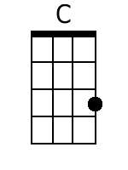 | 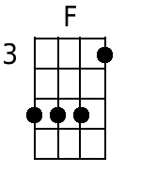 | 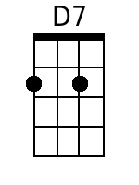 | 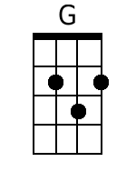 | 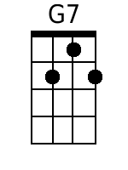 | 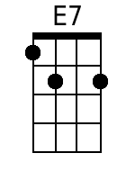 | 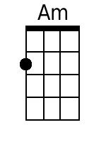

Bari:
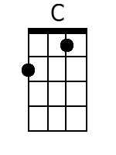 | 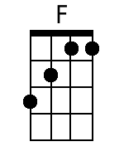 | 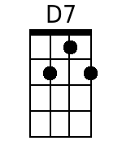 | 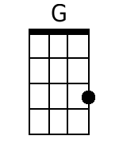 | 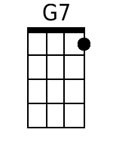 | 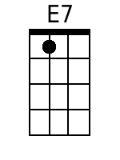 | 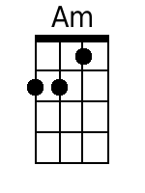

It Came Upon A Midnight Clear
Words: Edmund Hamilton Sears (1849); Music: Richard S. Willis
Ella Fitzgerald, It Came Upon A Midnight Clear from "Ella Fitzgerald's Christmas"

G C G  It came u-pon the midnight clear,  C A7 D - D7  That glorious song of old,  G C G  From angels bending near the earth  C D7 G  To touch their harps of gold;  B7 Em  “Peace on the earth good will to men  D7 A7 D - D7  From heaven's all gracious King -”  G C G  The world in solemn stillness lay  C D7 G  To hear the angels sing.  G C G  Still through the cloven skies they come  C A7 D - D7  With peaceful wings un-furled,  G C G  And still their heavenly music floats  C D7 G  O’er all the weary world;  B7 Em  A-bove its sad and lowly plains  D7 A7 D - D7  They bend on hovering wing,  G C G  And ever o’er its Babel-sounds  C D7 G  The blessed angels sing. | G C G  And ye be-neath life's crushing load,  C A7 D - D7  Whose forms are bending low,  G C G  Who toil a-long the climbing way  C D7 G  With painful steps and slow,  B7 Em  Look now! for glad and golden hours  D7 A7 D - D7  Come swiftly on the wing; -  G C G  Oh, rest be-side the weary road  C D7 G  And hear the angels sing.  G C G  For lo! the days are hastening on  C A7 D - D7  By prophet bards fore-told,  G C G  When, with the ever circling years  C D7 G  Shall come the age of gold;  B7 Em  When Peace shall over all the earth,  D7 A7 D - D7  Its ancient splendors fling,  G C G  And the whole world give back the song,  C D7 G  Which now the angels sing.

 |  | 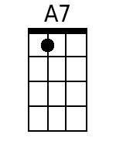 | 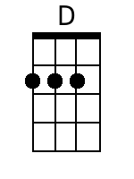 |  | 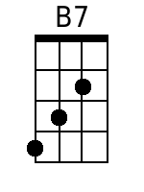 | 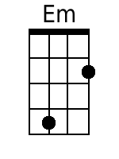

Bari
 |  | 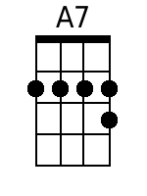 | 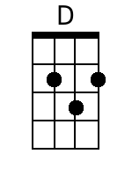 |  | 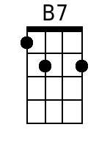 | 